**MINISTRY OF EDUCATION AND TRAINING**

**FPT UNIVERSITY**

Capstone Project Document

**Just Walk Out Library**

|  |  |
| --- | --- |
| **Group 1** | |
| **Group members** | Võ Hồng Hà – SE61394  Nguyễn Tuấn Anh – SE61476  Đặng Nhật Thiên – SE61357 |
| **Supervisor** | Kiều Trọng Khánh |
| **Ext. Supervisor** | N/A |
| **Capstone Project code** | JWL |

- Ho Chi Minh city, April 3rd 2017 -

*This page is intentionally left blank*

Table of Contents

[List of Tables 6](#_Toc479666537)

[List of Figures 7](#_Toc479666538)

[Definitions, Acronyms, and Abbreviations 8](#_Toc479666539)

[A. Introduction 9](#_Toc479666540)

[1. Project Information 9](#_Toc479666541)

[2. Introduction 9](#_Toc479666542)

[3. Current Situation 9](#_Toc479666543)

[3.1 Ho Chi Minh City University of Social Sciences and Humanities library 9](#_Toc479666544)

[3.2 FPT University library 9](#_Toc479666545)

[4. Problem Definition 10](#_Toc479666546)

[5. Proposed Solution 10](#_Toc479666547)

[5.1 Technologies 10](#_Toc479666548)

[5.2 Feature Functions 11](#_Toc479666549)

[5.3 Advantages and Disadvantages 12](#_Toc479666550)

[6. Functional Requirements 12](#_Toc479666551)

[7. Role and Responsibility 13](#_Toc479666552)

[B. Software Project Management Plan 14](#_Toc479666553)

[1. Problem Definition 14](#_Toc479666554)

[1.1. Name of this Capstone Project 14](#_Toc479666555)

[1.2. Problem Abstract 14](#_Toc479666556)

[1.3. Project Overview 14](#_Toc479666557)

[2. Project organization 19](#_Toc479666558)

[2.1. Software Process Model 19](#_Toc479666561)

[2.2. Roles and responsibilities 19](#_Toc479666562)

[2.3. Tools and Techniques 20](#_Toc479666563)

[3. Project Management Plan 21](#_Toc479666564)

[3.1. Software development life cycle 21](#_Toc479666566)

[3.2. Phase Detail 23](#_Toc479666567)

[3.3. All Meeting Minutes 25](#_Toc479666568)

[4. Coding Convention 27](#_Toc479666569)

[C. Software Requirement Specification 28](#_Toc479666570)

[1. User Requirement Specification 28](#_Toc479666571)

[1.1 Unauthorized User Requirement 28](#_Toc479666572)

[1.2 Authorized User Requirement 28](#_Toc479666573)

[1.3 Borrower Requirement 28](#_Toc479666574)

[1.4 Librarian Requirement 28](#_Toc479666575)

[1.5 Admin Requirement 28](#_Toc479666576)

[1.6 Auto Handler Requirement 29](#_Toc479666577)

[2. System Requirement Specification 29](#_Toc479666578)

[2.1 External Interface Requirement 29](#_Toc479666580)

[2.2 System Overview Use Case 30](#_Toc479666581)

[2.3. List of Use Case 32](#_Toc479666588)

[3. Software System Attribute 78](#_Toc479666589)

[3.1 Usability 78](#_Toc479666591)

[3.2 Reliability 78](#_Toc479666592)

[3.3 Availability 79](#_Toc479666593)

[3.4 Security 79](#_Toc479666594)

[3.5 Maintenanability 79](#_Toc479666595)

[3.6 Portability 79](#_Toc479666596)

[3.7 Performance 79](#_Toc479666597)

[3.8 Conceptual Diagram 79](#_Toc479666598)

[D. Software Design Description 80](#_Toc479666599)

[1. Design Overview 80](#_Toc479666600)

[2. System Architectural Design 82](#_Toc479666601)

[2.1 Web Application Architecture Description 82](#_Toc479666602)

[2.2 Web Service Application Architecture Description 84](#_Toc479666603)

[2.3 Mobile Application Description (need help) 85](#_Toc479666604)

[3. Component Diagram 86](#_Toc479666605)

[4. Detailed Description 87](#_Toc479666606)

[4.1 Class Diagram 87](#_Toc479666607)

[4.2 Class Diagram Explanation 89](#_Toc479666608)

[4.3 Interaction Diagram 95](#_Toc479666609)

[5. Interface 101](#_Toc479666610)

[5.1 Component interface TO BE UPDATED AFTER NEW FUNCTIONS 101](#_Toc479666611)

[5.2 User Interface Design 107](#_Toc479666612)

[6. Database Design 136](#_Toc479666613)

[6.1 Entity Relationship Diagram (ERD) 136](#_Toc479666614)

[6.2 Data Dictionary 137](#_Toc479666615)

[7. Algorithms 138](#_Toc479666616)

[7.1 Training Product Algorithms 138](#_Toc479666617)

[7.2 Timsort Algorithms 141](#_Toc479666618)

[7.3 Color Distance Algorithms 141](#_Toc479666619)

[7.4 Detect Best Color Algorithms 141](#_Toc479666620)

[7.5 Search with Picture Algorithms 144](#_Toc479666621)

[7.6 Suggest T-Shirt Size Algorithms 147](#_Toc479666622)

[7.7 Suggest Shirt Size Algorithms 147](#_Toc479666623)

[D. Report No. 5 System Implementation & Test 149](#_Toc479666624)

[1. Introduction 149](#_Toc479666625)

[1.1 Overview 149](#_Toc479666626)

[1.2 Test Approach 149](#_Toc479666627)

[2. Database Relationship Diagram 149](#_Toc479666628)

[2.1 Physical Diagram 150](#_Toc479666629)

[2.2 Data Dictionary 151](#_Toc479666630)

[3. Performance Measures 155](#_Toc479666631)

[3.1 Web Application Loading Speed 155](#_Toc479666632)

[3.2 Mobile API Speed 155](#_Toc479666633)

[4. Test Plans 156](#_Toc479666634)

[4.1 Features to be tested 156](#_Toc479666635)

[4.2 Features not to be tested 157](#_Toc479666636)

[5. System Testing Test Case 157](#_Toc479666637)

[5.1 Communication Diagram 157](#_Toc479666638)

[5.2. System Test Cases 159](#_Toc479666645)

[E. Software User’s Manual 166](#_Toc479666646)

[1. Installation Guide 166](#_Toc479666647)

[1.1. Setting up environment at server side 166](#_Toc479666648)

[1.2. Deployment at server side 166](#_Toc479666649)

[1.3. Deployment at Client Side 170](#_Toc479666650)

[2. User Guide 170](#_Toc479666651)

[2.1. Web application 170](#_Toc479666652)

[2.2. Mobile application 193](#_Toc479666653)

[2.3. Emulator application 202](#_Toc479666654)

[I. Appendix 207](#_Toc479666655)

## List of Tables

[Table 1 : Roles and Responsibilities 13](#_Toc479619511)

[Table 2 : Hardware Requirement for Server 17](#_Toc479619512)

[Table 3 : Hardware Requirement for Mobile 17](#_Toc479619513)

[Table 4 : Hardware Requirement for Mobile 18](#_Toc479619514)

[Table 5 : Software requirements 18](#_Toc479619515)

[Table 6 : Roles and responsibilities 20](#_Toc479619516)

[Table 7: Tools List 20](#_Toc479619517)

[Table 8: Technique List 20](#_Toc479619518)

[Table 9: Software Development Life Cycle Detail 22](#_Toc479619519)

[Table 10: Phase 1 - Infrastructure 23](#_Toc479619520)

[Table 11: Phase 2 - System & Web Application 24](#_Toc479619521)

[Table 12: Phase 3: Web service 24](#_Toc479619522)

[Table 13: Phase 4 - Mobile Application 25](#_Toc479619523)

[Table 18: <Unauthorized User> Login 32](#_Toc479619524)

[Table 19: <Unauthorized User> Activate account 34](#_Toc479619525)

[Table 20: < Authorized User> Overview use case 36](#_Toc479619526)

[Table 21: < Authorized User> Log out 37](#_Toc479619527)

[Table 22: < Passenger> Get NFC card 40](#_Toc479619528)

[Table 23: < Passenger> Add credit 42](#_Toc479619529)

[Table 24: < Passenger> Edit card name 43](#_Toc479619530)

[Table 25: < Passenger> Get outcome report 46](#_Toc479619531)

[Table 26: < Passenger> Find bus 47](#_Toc479619532)

[Table 27: < Passenger> Get route 49](#_Toc479619533)

[Table 28: < Passenger> Get route 50](#_Toc479619534)

[Table 29: < Passenger> Get route 52](#_Toc479619535)

[Table 30: < Passenger> Get route 53](#_Toc479619536)

[Table 31: < Staff > Add card 56](#_Toc479619537)

[Table 32: < Staff > Activate/Deactivate card 58](#_Toc479619538)

[Table 33: < Staff > Search passenger 59](#_Toc479619539)

[Table 34: < Staff > Edit passenger 62](#_Toc479619540)

[Table 35: < Staff > Edit passenger 63](#_Toc479619541)

[Table 36: < Manager > Add ticket type 66](#_Toc479619542)

[Table 37: < Manager > Edit ticket type 68](#_Toc479619543)

[Table 38: < Manager > Delete ticket type 70](#_Toc479619544)

[Table 39: < Manager > Add credit plan 72](#_Toc479619545)

[Table 40: < Manager > Edit credit plan 74](#_Toc479619546)

[Table 41: < Manager > Delete credit plan 76](#_Toc479619547)

[Table 42: < Manager > Get income report 78](#_Toc479619548)

[Table 43: < Manager > Create promotion 80](#_Toc479619549)

[Table 44: < Admin> Search account 81](#_Toc479619550)

[Table 45: < Admin> Add account 84](#_Toc479619551)

[Table 46: < Admin> Edit account 85](#_Toc479619552)

[Table 47: < Auto Handler > Parse bus route 87](#_Toc479619553)

[Table 48: < Auto Handler > Suggest promotion 89](#_Toc479619554)

[Table 49: < Auto Handler > Send notification 90](#_Toc479619555)

[Table 50: < Emulator > Write card 92](#_Toc479619556)

[Table 51: < Emulator > Verify ticket 94](#_Toc479619557)

[Table 52: Conceptual Diagram Data Dictionary 96](#_Toc479619558)

[Table 53: Component Dictionary 99](#_Toc479619559)

## List of Figures

[Figure 1 : Scrum model 19](#_Toc479619560)

[Figure 2 : <Use case> Web application overview 30](#_Toc479619561)

[Figure 3 : <Use case> Mobile application overview 30](#_Toc479619562)

[Figure 4: <Unauthorized User> Overview use case 31](#_Toc479619563)

[Figure 5: <Unauthorized User> Login 31](#_Toc479619564)

[Figure 6: <Unauthorized User> Activate account 33](#_Toc479619565)

[Figure 7: < Authorized User> Overview use case 34](#_Toc479619566)

[Figure 8: < Authorized User> Overview use case 34](#_Toc479619567)

[Figure 9: < Authorized User> Log out 36](#_Toc479619568)

[Figure 10: < Passenger> Overview use case 38](#_Toc479619569)

[Figure 11: < Passenger> Get NFC card 38](#_Toc479619570)

[Figure 12: < Passenger> Add credit 40](#_Toc479619571)

[Figure 13: < Passenger> Edit card name 42](#_Toc479619572)

[Figure 14: < Passenger> Get outcome report 44](#_Toc479619573)

[Figure 15: < Passenger> Find bus 46](#_Toc479619574)

[Figure 16: < Passenger> Get route 48](#_Toc479619575)

[Figure 16: < Passenger> Get route 49](#_Toc479619576)

[Figure 16: < Passenger> Get route 50](#_Toc479619577)

[Figure 16: < Passenger> Get route 52](#_Toc479619578)

[Figure 17: < Staff > Overview use case 54](#_Toc479619579)

[Figure 18: < Staff > Add card 54](#_Toc479619580)

[Figure 19: < Staff > Activate/Deactivate card 56](#_Toc479619581)

[Figure 20: < Staff > Search passenger 58](#_Toc479619582)

[Figure 21: < Staff > Edit passenger 60](#_Toc479619583)

[Figure 21: < Staff > Edit passenger 62](#_Toc479619584)

[Figure 22: < Manager > Overview use case 64](#_Toc479619585)

[Figure 23: < Manager > Add ticket type 64](#_Toc479619586)

[Figure 24: < Manager > Edit ticket type 66](#_Toc479619587)

[Figure 25: < Manager > Delete ticket type 69](#_Toc479619588)

[Figure 26: < Manager > Add credit plan 70](#_Toc479619589)

[Figure 27: < Manager > Edit credit plan 72](#_Toc479619590)

[Figure 28: < Manager > Delete credit plan 74](#_Toc479619591)

[Figure 29: < Manager > Get income report 76](#_Toc479619592)

[Figure 30: < Manager > Create promotion 78](#_Toc479619593)

[Figure 31: < Admin> Overview use case 80](#_Toc479619594)

[Figure 32: < Admin> Search account 80](#_Toc479619595)

[Figure 33: < Admin> Add account 82](#_Toc479619596)

[Figure 34: < Admin> Edit account 84](#_Toc479619597)

[Figure 36: < Auto Handler > Overview use case 85](#_Toc479619598)

[Figure 37: < Auto Handler > Parse bus route 85](#_Toc479619599)

[Figure 38: < Auto Handler > Suggest promotion 87](#_Toc479619600)

[Figure 39: < Auto Handler > Send notification 89](#_Toc479619601)

[Figure 40: < Emulator > Overview use case 91](#_Toc479619602)

[Figure 41: < Emulator > Write card 91](#_Toc479619603)

[Figure 42: < Emulator > Verify ticket 92](#_Toc479619604)

[Figure 43: Conceptual Diagram 95](#_Toc479619605)

[Figure 44: Web Application Architecture 97](#_Toc479619606)

[Figure 44: Mobile Application Architecture 97](#_Toc479619607)

[Figure 45: Component Diagram 98](#_Toc479619608)

[Figure 46: Class Diagram 100](#_Toc479619609)

[Figure 47: <Sequence Diagram> Add Credit 107](#_Toc479619610)

[Figure 48: <Sequence Diagram> Get Cards 107](#_Toc479619611)

# Definitions, Acronyms, and Abbreviations

|  |  |
| --- | --- |
| **Name** | **Definition** |
| JWL | Just Walk Out Library |
| NFC | Near Field Communication |
| RFID | Radio-Frequency IDentification |

# Introduction

## Project Information

* Project name: **Just Walk Out Library**
* Abbreviation: **JWL**
* Product Type: **Web Admin & Mobile App**
* Start Date: **January 5th, 2017**
* End Date: **April, 2017**

## Introduction

For a long time, library has been a reliable place for people to study and borrow books. However, almost every library system nowadays still uses a traditional way for their borrowers to obtain books: a borrower has to carry all the books that he/she wants to the librarian, so that the librarian can record which books that the borrower will borrow; after that, the borrower signs in each form to commit that he/she is borrowing those books. Only after these steps, the borrower can take back his/her library card and bring the books home. Because one librarian can only manage one borrower at a time, these traditional steps can be very painful if the library is currently crowded with borrowers.

Therefore, we build a system to help libraries and their borrowers to solve those problems. Applying this system, they will not only save a huge amount of time in book-borrowing process, but they will also have a better way to manage books.

## Current Situation

In order to have a more thorough view on our current situation, we will look into the book-borrowing procedure in the libraries of Ho Chi Minh City University of Social Sciences and Humanities, and FPT University.

### Ho Chi Minh City University of Social Sciences and Humanities library

1. The borrower gives the library’s card/student’s card to the librarian.
2. The borrower receives the locker’s key to put the bag in.
3. The borrower walks into the room.
4. The borrower finds wanted books.
5. The borrower takes wanted books.
6. The borrower fills in the book-borrowing form.
7. The borrower brings the books and the form to the librarian’s desk.
8. The librarian checks the form and records the books.
9. The librarian gives the books to the borrower.
10. The borrower re-checks the books, takes back the bag, returns the locker’s key, and brings the books home.
11. The librarian arranges the book-borrowing forms in a specific order.

Reference: <http://hcmussh.edu.vn/Resources/Docs/SubDomain/lib/TV.QT10.01%20-%20Quy%20trinh%20phuc%20vu%20muon%20tai%20lieu%20ve%20nha.pdf>

### FPT University library

1. The borrower gives the student card to the librarian.
2. The borrower receives the locker key to put the bag in.
3. The borrower walks into the reading room.
4. The borrower finds and takes wanted books.
5. The borrower goes to the librarian to check out.
6. With each book, the student has to fill in a form with the book’s code, and his/her signature.
7. The librarian checks the forms and books.
8. The librarian scans each book’s barcode to record the student’s borrow list. The alarm is turned off for each scanned book.
9. The librarian returns the student’s card to the student.
10. The process finishes. The student can take the books home.

## Problem Definition

Because of current situation, we found that the traditional process has many advantages and disadvantages below:

* Advantages:
* No technical skills needed.
* Disadvantages:
* Borrowing books need to go through complicated steps, thus durring the rush hour, it might take too much time to wait for checking out for both borrowers and librarians.
* The librarian should work very hard when having many borrowers.
* Paper records are hard to manage and easy to be damaged.
* Librarians may forget to remind borrowers about their deadline.
* Borrowers have to memorize the deadline of their borrowing books.
* It is hard for borrowers to know when a wanted book is available.

## Proposed Solution

Our proposed solution is to build a system named Just Walk out Library (JWL), which uses NFC, QR Code, RFID technologies to create a more easily and efficiently book - borrowing process: Borrowers only need to use smartphones to check in the library and borrow books, the system will automatically match and save the right books to the right borrower. Therefore, our solution helps to reduce librarian’s work in book – borrowing process, let them have more time for other tasks. Furthermore, librarians and borrowers can manage the borrowing books better.

### Technologies

* + **NFC (abbreviated from Near Field Communication):** is a form of contactless communication between devices like smartphones or tablets. Contactless communication allows a user to wave the smartphone over an NFC compatible device to send information without needing to touch the devices together or go through multiple steps to set up a connection. NFC utilizes electromagnetic radio fields while technologies such as Bluetooth and Wi-Fi focus on radio transmissions instead. NFC is supported in card or the smartphone (<http://nearfieldcommunication.org/>).
  + **QR code (abbreviated from Quick Response Code):** is the trademark for a type of [matrix barcode](https://en.wikipedia.org/wiki/Matrix_barcode) (or two-dimensional [barcode](https://en.wikipedia.org/wiki/Barcode)) first designed for the [automotive industry in Japan](https://en.wikipedia.org/wiki/Automotive_industry_in_Japan). A barcode is a machine-readable optical label that contains information about the item to which it is attached. A QR code uses four standardized encoding modes (numeric, alphanumeric, byte/binary, and [kanji](https://en.wikipedia.org/wiki/Kanji)) to efficiently store data; extensions may also be used.
  + **RFID (abbreviated from Radio-Frequency Identification):** The acronym refers to small electronic devices that consist of a small chip and an antenna. The chip typically is capable of carrying 2,000 bytes of data or less. The RFID device serves the same purpose as a bar code or a magnetic strip on the back of a credit card or ATM card; it provides a unique identifier for that object. And, just as a bar code or magnetic strip must be scanned to get the information, the RFID device must be scanned to retrieve the identifying information (<http://www.technovelgy.com/ct/technology-article.asp)>.
  + **iBeacon:** They are essentially tiny, low power computers attached to walls or objects in the physical world. Using proximity technologies, they detect human presence and behavior and trigger pre-programmed actions delivering contextual and personalized experiences (<http://estimote.com>).

### Feature Functions

* **Check in:** JWL application supports both NFC and QR Code. To gain permission to the library, a borrower only needs to open the application on his/her phone, and scan it on our check - in device. He/she will be checked in automatically.
* **Borrow books and check out:** the borrower finds all the books he/she needs on the shelves, and carries them out. The RFID Reader Device and the iBeacons at the gate will automatically recognize that borrower and record the list of books he/she borrows.
* **Ring the alarm:** the alarm will go off if someone
  + - * + Takes the books out without having JWL’s mobile application turned on and a logged in, valid account
        + Exceeds the book limit that they can borrow
        + Does not have enough money to borrow more books
        + Checks in, or borrows books with invalid account
* **Search:** a borrower can search for the books they want by title. The search result will show the book (if it is stored in the library) and its availability (if it is still available to be borrowed).
* **Make wish list:** a borrower can mark a book to his/her wish list so as to receive notification when the book is available again.
  + - **Manage borrowing books:** 
      * A librarian can manage borrowing books: get information of the books, their borrowers, and the borrow status (late or not), and confirm returned books from borrowers. A librarian can also help borrowers to borrow books.
      * A borrower can get information of his/her borrowing books, receive notification when a book is near its deadline, and renew a book’s borrow time.

### Advantages and Disadvantages

* + - **Advantages:**
      * Make the book-borrowing process faster and easier.
      * Reduce the management time.
      * Store the borrower’s record at ease and safely.
      * Quickly search for wanted books.
      * Notify borrower when a wanted book is available.
    - **Disadvantages:**
      * + Scanning issues: there maybe cases that make the RFID reader to scan books incorrectly.

## Functional Requirements

Borrower component:

* Get borrowing/borrowed books.
* Borrow books.
* Get notifications when borrowing books are about to be returned.
* Search for books by name.
* Make wish list about an unavailable book, so that borrower can receive notification when the wanted book is back on shelf.

Librarian component:

* Manage borrowing books: borrow, return books.
* Manage borrowers: insert, update, activate, deactivate accounts.
* Tracking which books a borrower are borrowing.
* Search for books by name.

## Role and Responsibility

|  |  |  |  |  |
| --- | --- | --- | --- | --- |
| **No** | **Full Name** | **Role** | **Position** | **Contact** |
| 1 | Kiều Trọng Khánh | Project Librarian | Supervisor | [Khanhkt@fpt.edu.vn](mailto:khanhkt@fpt.edu.vn) |
| 2 | Võ Hồng Hà | Developer | Leader | [Havhse61394@fpt.edu.vn](mailto:Havhse61394@fpt.edu.vn) |
| 3 | Nguyễn Tuấn Anh | Developer | Member | [Anhntse61476@fpt.edu.vn](mailto:Anhntse61476@fpt.edu.vn) |
| 4 | Đặng Nhật Thiên | Developer | Member | [Thiendnse61357@fpt.edu.vn](mailto:Thiendnse61357@fpt.edu.vn) |

Table : Roles and Responsibilities

# Software Project Management Plan

## Problem Definition

### Name of this Capstone Project

* **Official name**: Just Walk Out Library
* **Vietnamese name**: Thư viện mượn sách tự động
* **Abbreviation**: JWL

### Problem Abstract

We develop JWL system in order to help librarians reduce work overload and give borrowers a much more comfortable experience in acquiring books. The role of this system is to automate the book-borrowing process with the help of RFID, NFC, QR Code, and iBeacon. However, those great technologies could come with below difficulty:

* Those are complicated software and hardware which our team does not have any background knowledge. During the process of doing this research, we spend a good amount of time to study not only the operational principles but also detailed features and requirements. This is our main challenge.

### Project Overview

#### Current Situation

Below are the problems encountered in this project:

* **New technologies:** Our team has no experience in embedded system. Therefore, we need time to do research about each technology, which devices to choose, and how to use them.
* **Traditional habit:** Borrowers have been using traditional way to obtain books for a long time, so libraries should provide proper introduction and assistance for their users to get used to JWL.
* **Devices problem:** RFID/NFC devices may be crashed or damaged after long time using, so backup solution should be prepared and periodically maintenance should be carried out.

#### The Proposed System

* After doing many researches on technology for saving information, we choose RFID, NFC and QR code technologies as these technologies is very capable of resolving the current situations in borrowing book. The basic idea is to use a RFID tag that each tag contains a unique book ID.
* Our system includes two subsystems:
* Mobile Application:
  + - For borrower: to borrow book automatically when he/she steps out of the library.
    - For emulator: to read NFC/QR Code from the borrower’s mobile application.
  + Web Application:
* For Admin: to manage system accounts.
* For librarian: to manage borrowers and their borrowing books.
  + Emulator Application:
* For RFID reader gate:
  + To deliver the data scanned froms borrower’s borrowing books to server
  + To raise alarm.
* For RFID reader of librarian:
  + Provide GUI control for librarian to borrow books for borrowers and return books from borrowers to the library.

##### ***Web Application***

For admins:

* + - * Manage accounts (CRUD).

For librarians:

* Manage borrowers (CRUD).
* Deactivate/activate borrowers.

##### ***Mobile Application***

For borrower:

* Check in user through NFC (uses QR if NFC is not available)
* Get borrower’s information.
* Search books.
* Add books to wish list.
* Track list of borrowing books.
* View history about borrowed books.
* Notify user about:
  + Borrowing books.
  + Book’s deadline.
  + Available books in user’s wish list.

For emulator:

* Scan NFC/QR Code for validation.

##### ***Emulator Application***

For RFID Reader Gate:

* Send data from scanned books to the JWL server.
* Raise alarm when errors occur: robbery, borrowers do not meet requirement to borrow books, or system error.
* Stop alarm manually.

For RFID Reader for Librarian:

* Send data from scanned books to the JWL server.
* Provide GUI control for librarian to help borrower borrow and return books.

#### Boundaries of the System

* The system provides an outstanding solution to support the process of borrowing books in the library. This facilitates an automated book - borrowing process, as a result, implicit and explicit benefit would be brought to both librarians and borrowers:
  + Allow borrower to check in the library by scanning their phone to the RFID reader of the library.
  + Allow borrower to check out with their borrowed books by just walking out of the library.
  + Allow borrower to search for wanted books by title.
  + Allow borrower to add a book to a wish list.
  + Allow librarian to manage borrowers and their borrowed book list.
  + Allow librarian to help borrowers borrow and return books.
  + Allow admin to manage all accounts.
* Any libraries which deployed this system must set up their devices as required below:
  + One RFID tag on each book.
  + RFID reader gate to scan books with RFID tags.
  + Two iBeacons for each RFID reader gate to control borrower’s check out process.
  + Check in device capable of reading NFC and QR Code.
  + Computer system with internet connection.
* Borrowers that use JWL have to make sure that:
  + They open the application when checking in and out of the library.
  + Their phones have Internet and Bluetooth connection turned on.
* The completed system includes:
  + Android mobile application.
  + Website application.
  + RFID reader gate.
  + Two ibeacons.
  + Check in device capable of reading NFC and QR Code.

#### Future Plans

With further research and development, the system can apply the following features:

* The system provides more thorough library management.
* The system provides more ways to search books: by category, book type, position, author, and publisher.
* The system separates RFID robbery scanner gate and RFID book scanner gate to provide a more comfortable experience for borrowers.
* The system provides better description when a borrower checks in so that librarian can identify a borrower better.

#### Development Environment

##### ***Hardware requirements***

* **For web application server**

|  |  |  |
| --- | --- | --- |
| Windows | Minimum Requirements | Recommended |
| Internet Connection | Cable, Wi-Fi (4 Mbps) | Cable, Wi-Fi (8 Mbps) |
| Operating System | Window Server 2008 R2 | Window Server 2012 R2 |
| Computer Processor | Intel® Xeon ® 1.4GHz | Intel® Xeon ® Quad Core |
| Computer Memory | 2GB of RAM | 4GB of RAM or more |

Table : Hardware Requirement for Server

* **For Mobile**

|  |  |  |
| --- | --- | --- |
| Android | Minimum | Recommended |
| Internet Connection | Wi-Fi or 3G (1 Mbps) | Wi-Fi or 3G (8 Mbps) |
| Operating System | Android 4.4.2 | Android 5.0.0 |
| Mobile Processor | Cortex-A7 Dual-Core 1.3GHz | Cortex-A7 Dual-Core 1.3GHz |
| Mobile Memory | 1GB of RAM | 2GB of RAM or more |
| Mobile Feature | NFC, Camera supporting, Google play service version more than 7.0 | NFC, Camera supporting, Google play service version more than 7.0 |

Table : Hardware Requirement for Mobile

* **RFID EMULATOR**

|  |  |  |
| --- | --- | --- |
| Android | Minimum | Recommended |
| Internet Connection | Wi-Fi or 3G (1 Mbps) | Wi-Fi or 3G (8 Mbps) |
| Operating System | Android 4.4.2 | Android 5.0.0 |
| Mobile Processor | Cortex-A7 Dual-Core 1.3GHz | Cortex-A7 Dual-Core 1.3GHz |
| Mobile Memory | 1GB of RAM | 2GB of RAM or more |
| Mobile Feature | NFC, Camera supporting, Google play service version more than 7.0 | NFC, Camera supporting, Google play service version more than 7.0 |

Table : Hardware Requirement for Mobile

##### ***Software requirements***

|  |  |  |
| --- | --- | --- |
| Software | Name / Version | Description |
| Operating system | Window 7 Professional SP1 | Operating system and platform for development |
| Environment | JDK version 1.8.0 update 101 | Specification for developing web application |
| IDE | IntelliJ IDE 2016.3.2, Android Studio v2.2.3, XCode | Use to implement website and Android Mobile App. |
| Design Model tool | StartUML v2.5.1 | Use to create modal and diagrams. |
| DBMS | PostgreSQL 9.4 | Use to create & manage the database for system |
| Document storage | Github | Use to store document |
| Store and manage source code | Github & SourceTree | Use to store all source code |
| Web browser | Chrome 42 or above | Testing browser |

Table : Software requirements

## Project organization



### Software Process Model

This project is developed using Scrum Model. This model is appropriate under consideration of 3 following reasons:

* Those technologies used in this project (RFID, NFC, iBeacon, and QR Code) require much attention in studying. This takes time to concentrate on technologies understanding, we plan to apply them gradually to the system.
* Prototypes are delivered frequently for evaluation.
* Team members can involve more in the development process.



Figure : Scrum model

Reference: <http://skytechnovation.com/scrum-development-model/>

### Roles and responsibilities

|  |  |  |  |
| --- | --- | --- | --- |
| No | Full name | Role in Group | Responsibilities |
| 1 | Kiều Trọng Khánh | Product owner, Project Manager | * Specify user requirements * Control the development process   Provide technical and business analysis support |
| 2 | Võ Hồng Hà | Scrum leader, B.A, Developer, Tester | * Manage process * Design database * Clarify requirements * GUI design * Create test plan * Code   Test |
| 3 | Nguyễn Tuấn Anh | Team member,  B.A, Developer,  Tester | * Design database * Clarify requirements * Prepare and combine documents * Prepare documents * GUI design * Create test plan * Code   Test |
| 4 | Đặng Nhật Thiên | Team member,  B.A, Developer,  Tester | * Design database * Clarify requirements * Prepare documents * GUI design * Create test plan * Code   Test |

Table : Roles and responsibilities

### Tools and Techniques

|  |  |
| --- | --- |
| Tool | Name / version |
| Web server | Tomcat |
| Development tool | IntelliJ IDEA 2016.3.2, Android Studio, Webstorm |
| DBMS | PG Admin 4 |
| Source control | Github & SourceTree |
| Modeling tool | StarUML v5.0.1 |
| Document tool | Microsoft Word 2010 |

Table : Tools List

|  |  |
| --- | --- |
| Technique | Name / version |
| Frontend | HTML5, CSS, ReactJS |
| Backend | Spring Boot |
| Mobile | Android, NFC, RFID, QR Code |

Table : Technique List

## Project Management Plan



### Software development life cycle

|  |  |  |  |  |  |
| --- | --- | --- | --- | --- | --- |
| Phase | Description | Deliverables | Resource needed | Dependencies and Constrains | Risks |
| Infrastructure | - Identify and clarify overall requirements.  - Determine the system architecture.  - Build infrastructure for the project. | - Database xwdesign.  - System main structure. | 20 man-days |  | - Unclear project scope.  - Lack of member share of understand. |
| System  &  Web admin | - Identify software and hardware requirements.  - Implements all web admin modules.  - Design the web UI  - Build the web admin | - Complete web admin for all roles of the system. | 60 man-days | - Depends on “Infrastructure” | - Unclear project scope.  - Lack of experience. |
| Web services | - Identify requirements for mobile app.  - Build required API for mobile app. | - API for mobile app. | 20 man-days | - Depends on “Web admin & System” | - Lack of experience. |
| Mobile apps | - Design the mobile UI  - Build mobile apps for end users and emulator. | - Complete Android Apps | 20 man-days | - Depends on “Web services” | - Lack of experience.  - Lack of RFID, NFC knowledge |

Table : Software Development Life Cycle Detail

### Phase Detail

#### Phase 1: Infrastructure

|  |  |  |
| --- | --- | --- |
| Task | Description | Author |
| 1. Assessment | - Determine requirements.  - Create product backlog. | * HaVH * AnhNT * ThienDN |
| 2. Selection | - Determine system architecture: Spring Boot.  - Determine software design pattern: Repository & Service.  - Determine all core functions. | * HaVH * AnhNT * ThienDN |
| 3. Development | - Create the main structure of project. | * HaVH * AnhNT * ThienDN |
| 4. Review | - Review all completed works and presentation.  - Create sprint backlog. | * HaVH * AnhNT * ThienDN |

Table : Phase 1 - Infrastructure

#### Phase 2: System & Web app

|  |  |  |
| --- | --- | --- |
| Task | Description | Author |
| 1. Assessment | - Determine requirements for System and Web app.  - Update product backlog. | * HaVH * AnhNT * ThienDN |
| 2. Selection | - Determine all functions according to requirements of System and Web app. | * HaVH * AnhNT * ThienDN |
| 3. Development | - Design and build prototype for web UI  - Create conceptual diagram  - Design class diagram  - Design database  - Implement the entire web UI: layouts, detail pages, etc.  - Implement all the functions in controllers.  - Build needed utility classes | * HaVH * AnhNT * ThienDN |
| 4. Review | - Review all completed works and presentation.  - Create sprint backlog. | * HaVH * AnhNT * ThienDN |

Table : Phase 2 - System & Web Application

#### Phase 3: Web service

|  |  |  |
| --- | --- | --- |
| Task | Description | Author |
| 1. Assessment | - Determine requirements for Web service.  - Update product backlog. | * HaVH * AnhNT * ThienDN |
| 2. Selection | - Determine all functions according to requirements of Web service. | * HaVH * AnhNT * ThienDN |
| 3. Development | - Create API for mobile app based on functions on the web app. | * HaVH * AnhNT * ThienDN |
| 4. Review | - Review all completed works and presentation.  - Create sprint backlog. | * HaVH * AnhNT * ThienDN |

Table : Phase 3: Web service

#### Phase 4: Mobile app

|  |  |  |
| --- | --- | --- |
| Task | Description | Author |
| 1. Assessment | - Determine requirements for System and Mobile app.  - Update product backlog. | * HaVH * AnhNT * ThienDN |
| 2. Selection | - Determine all functions according to requirements of Mobile app. | * HaVH * AnhNT * ThienDN |
| 3. Development | - Implement all the functions based on the designed UI and the provided API. | * HaVH * AnhNT * ThienDN |
| 4. Review | - Review all completed works and presentation.  - Create sprint backlog. | * HaVH * AnhNT * ThienDN |

Table : Phase 4 - Mobile Application

### All Meeting Minutes

Meeting minutes are contained in folder “Meeting minutes” in the attached file.

## 

## Coding Convention

**Java:** Using to develop website and web service.

Summary:

* + Naming Convention:
* For variable and function name, use camel case. Eg: minValue, maxValue…
* For class name, use Pascal case. Eg: Book, UserRole…
  + Layout Convention:
* Indent contrinuation one tab stop (four spaces).
* Add at least one blank line between method definitions and property definitions.
  + - Use parentheses to make clauses in an expression apparent.
* Using Java Code Convention from: <http://www.oracle.com/technetwork/java/codeconvtoc-136057.html>

**Android:** Using to develop mobile application

Summary:

* Naming Convention:
  + For variable’s name, use camel case. Eg: minValue, maxValue…
  + For function name, class name, use Pascal case. Eg: AddIncome, AddExpense…
  + For resource file names are written in lowercase\_underscore. Eg: my\_name
  + Declarations Convention:
    - One declaration per line is recommended.
  + Using Android Code Convention from
    - <https://source.android.com/source/code-style.html>

# Software Requirement Specification

## User Requirement Specification

### Unauthorized User Requirement

Unauthorized User is the user who has not logged into this system. Unauthorized User only has one functions.

* Login.

### Authorized User Requirement

Authorized User is the user who has logged into system. Authorized User has two common functions.

* Get profile detail.
* Logout.

### Borrower Requirement

Borrower is the user who goes to the library to search for books. They can either read books at the library or borrow them home. Therefore, their main functions in the system are:

* + Check in.
  + Check out.
  + Borrow books.
* Add books to wish list.
* Search books.
* Get borrowing list.
* Extend borrowing books deadline.

### Librarian Requirement

Librarian is the user who manages the library. They have the following functions:

* Manage borrowers:
  + - * Add borrowers.
      * Update borrowers.
      * Activate/Deactivate borrowers.
* Manage books:
  + - * Add new books.
      * Update books.
      * Delete books.
* Check out borrowers.
* View borrowing book list.
* Search books.

### Admin Requirement

Admin is the user who is responsible for managing accounts for the whole system, has the following function:

* Manage accounts:
  + - * Create account.
      * Update account.
      * Delete account.

### Auto Handler Requirement

Auto Handler is an intermediate entity which facilitates the flow of the whole system by automating the following functions:

* + Check in borrower by QR Code.
  + Check in borrower by NFC.
  + Record borrowers and their borrowed books.
  + Check out borrower.
  + Push notification to borrowers.

## System Requirement Specification



### External Interface Requirement

#### User Interface

* The user interface uses Vietnamese/English language for mobile application and English language mobile application.
* The user interface displays best on 1280x768 resolutions on desktop, and 1080x1920 on mobile.

#### Hardware Interface

* Smartphone with:
  + - * BLE support (Bluetooth 4.0).
      * NFC support.
* RFID Reader and tags use 125 kHz.
* Estimate Beacon.

#### Software Interface

* + Mobile application : Android OS version 4.4 (or 5.0).
  + Estimate cloud for manage beacons.
  + Estimate SDK for connect between mobile application and beacons.

#### Communication Protocol

* + Use HTTP 1.1 to communicate between the web browser and the web server.
  + Use HTTP 1.1 to communicate between the mobile application and the web service.
  + Use BLE protocol for communication between the mobile application and the Estimate beacons.
  + Use NFC protocol for communication between the mobile application and the emulator for check in.
  + Use RFID protocol for communication between tags and reader.

### System Overview Use Case

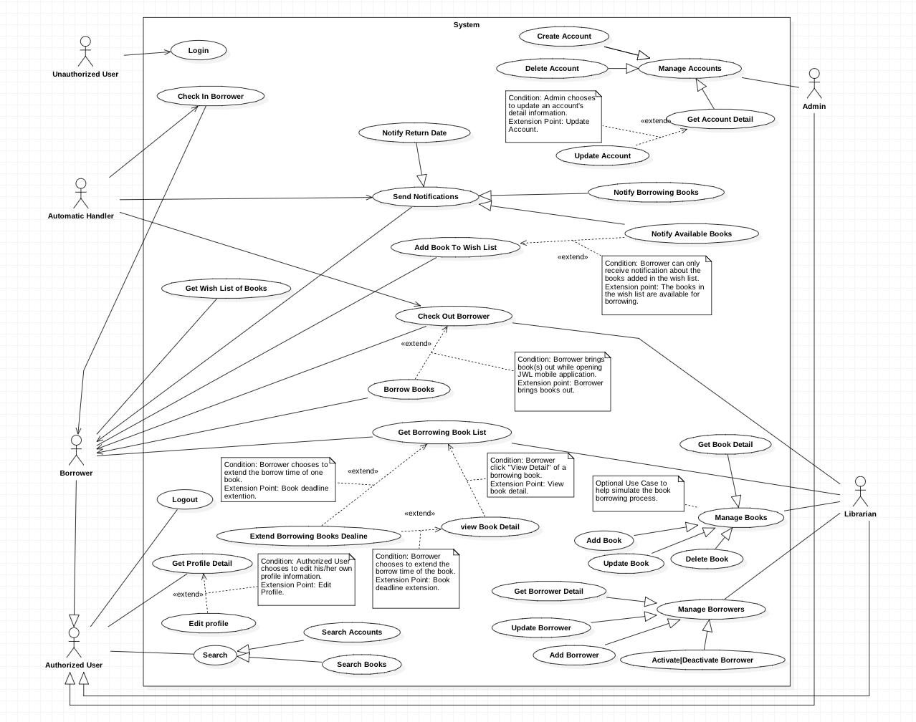

Figure <Use Case> System overview



#### Web Application

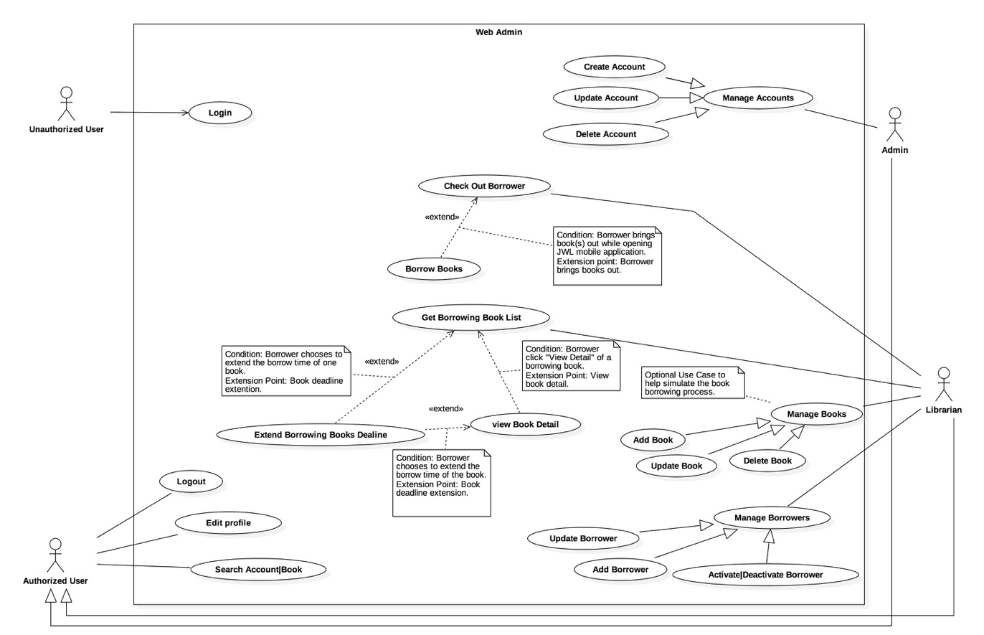

Figure : <Use case> Web overview

#### Mobile Application

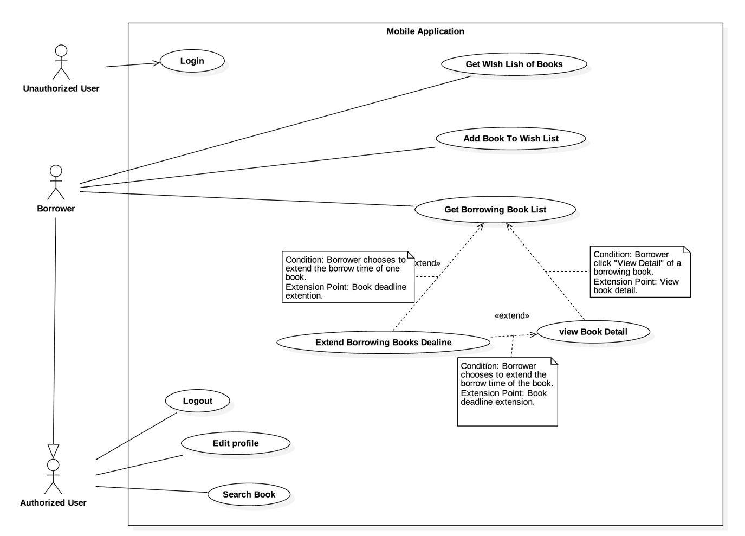

Figure : <Use case> Mobile application overview



### List of Use Case

#### Common Use Case

##### Unauthorized User

###### <Unauthorized User> Overview use case



Figure : <Unauthorized User> Overview Use Case

###### <Unauthorized User> Login



Figure : <Unauthorized User> Login

|  |  |  |  |
| --- | --- | --- | --- |
| **USE CASE – JWL01** | | | |
| **Use Case No.** | JWL01 | **Use Case Version** | 1.0 |
| **Use Case Name** | Login | | |
| **Author** | Nguyen Tuan Anh | | |
| **Date** | February 15, 2017 | **Priority** | Normal |
| **Actor:**   * Unauthorized User.   **Summary:**   * This use case allows Unauthorized User to log into the system with a specific role.   **Goal:**   * Authenticate user, redirect user to a specific view based on the user’s role.   **Triggers:**   * Unauthorized User sends Login command.   **Preconditions:** N/A  **Post Conditions:**   * **Success:** Unauthorized User is logged into the system as Authorized User. * **Fail:** N/A   **Main Success Scenario:**   |  |  |  | | --- | --- | --- | | Step | Actor Action | System Response | | 1 | Unauthorized User inputs user ID and password.  [Alternative 1] |  | | 2 | Unauthorized User sends Login command. | Unauthorized User will be logged into System with their specific role.  The system redirects to the role’s view. |   **Alternative Scenario:**   |  |  |  | | --- | --- | --- | | No. | Actor Action | System Response | | 1 | | Unauthorized user   * Leaves the user ID and password field empty, or * Inputs wrong user ID or password | System displays the error message: “Your user ID or password is invalid.” |   **Exception:** N/A  **Relationships:** This use case will be extended by all other use cases, depending on the Actor’s role in the system.  **Business Rules:**   * System authenticates Actor by checking the user ID and password. * Actor enters password in a free text field which hides the password. * Actor’s password must be encrypted before sending to server. * After logged in to the system, the Actor will be redirected to a specific view:   For web view:   * If the role is “Admin”, the system will display Admin view. * If the role is “Librarian”, the system will display Librarian view.   For mobile application view:  + If the role is “Borrower”, the system will display the mobile application’s view. | | | |

Table : <Unauthorized User> Login

##### Authorized User

###### <Authorized User> Overview Use Case

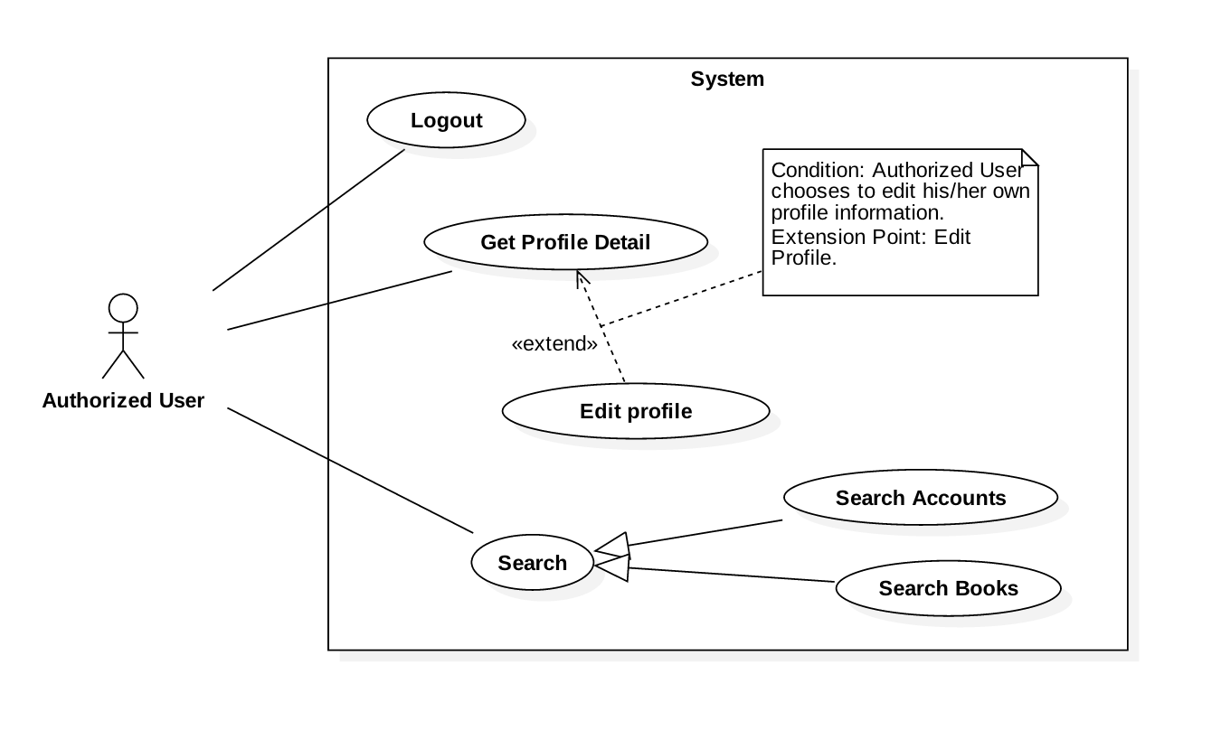

Figure : <Authorized User> Overview Use Case

###### <Authorized User> Get Profile Detail



Figure : <Authorized User> Get Profile Detail

|  |  |  |  |
| --- | --- | --- | --- |
| **USE CASE – JWL02** | | | |
| **Use Case No.** | JWL02 | **Use Case Version** | 1.0 |
| **Use Case Name** | Get Profile Detail | | |
| **Author** | Nguyen Tuan Anh | | |
| **Date** | February 20, 2017 | **Priority** | Normal |
| **Actor:**   * Authorized User.   **Summary:**  This use case allows an Actor to view his/her profile detail information, including:   * + - * User image       * User ID       * Full name       * Date of Birth       * Email       * Address       * Phone number       * Place of Work       * User Role   **Goal:**   * The System shows the Actor his/her profile detail information.   **Triggers:**   * The Actor sends Get Profile Detail command.   **Preconditions:**   * The Actor logged into the system.   **Post Conditions:**   * **Success:** The System shows the Actor his/her profile detail information. * **Fail:** N/A.   **Main Success Scenario:**   |  |  |  | | --- | --- | --- | | Step | Actor Action | System Response | | 1 | Actor sends Get Profile Detail. | System shows the Actor his/her profile detail information:   * “User image”: image * “User ID”: label * “Full name”: label * “Date of Birth”: label * “Email”: label * “Address”: label * “Phone number”: label * “Place of Work”: label * “User Role”: label |   **Alternative Scenario:** N/A  **Exceptions:** N/A  **Relationships:** From this use case, an Actor can [Edit Profile](#_<Authorized_User>_Edit).  **Business Rules:**   * This use case only allows an Actor to get his/her own detail information. | | | |

Table : <Authorized User> Get Profile Detail

###### <Authorized User> Logout



Figure : <Authorized User> Logout

|  |  |  |  |
| --- | --- | --- | --- |
| **USE CASE – JWL03** | | | |
| **Use Case No.** | JWL03 | **Use Case Version** | 1.0 |
| **Use Case Name** | Logout | | |
| **Author** | Nguyen Tuan Anh | | |
| **Date** | February 15, 2017 | **Priority** | Normal |
| **Actor:**   * Authorized User.   **Summary:**   * This use case allows Authorized User to log out off the system and become an Unauthorized User.   **Goal:**   * Invalidate the Authorized User, redirect the User to login view.   **Triggers:**   * Authorized User sends Logout command.   **Preconditions:**   * Actor logged in the system as an Authorized User.   **Post Conditions:**   * **Success:** Authorized User is logged out off the system and becomes Unauthorized User. * **Fail:** N/A   **Main Success Scenario:**   |  |  |  | | --- | --- | --- | | Step | Actor Action | System Response | | 1 | Authorized User sends Logout command.  [ Alternative 1] | System redirects the User to login view. |   **Alternative Scenario:**   |  |  |  | | --- | --- | --- | | No. | Cause | System Response | | 1 | | After at least one month not using the System, User sends any authorized commands. | System automatically redirects the User to login view. |   **Exceptions:** N/A  **Relationships:** N/A  **Business Rules:**   * Authorized User’s session ends after one month of inactivity. | | | |

Table : <Authorized User> Logout

###### <Authorized User> Edit Profile



Figure : <Authorized User> Edit Profile

|  |  |  |  |
| --- | --- | --- | --- |
| **USE CASE – JWL04** | | | |
| **Use Case No.** | JWL04 | **Use Case Version** | 1.0 |
| **Use Case Name** | Edit Profile | | |
| **Author** | Nguyen Tuan Anh | | |
| **Date** | February 16, 2017 | **Priority** | Normal |
| **Actor:**   * Authorized User.   **Summary:**  This use case allows an Actor to edit his/her personal information, including:   * + - * Full name       * Password       * Email       * Address       * Date of birth       * Phone number       * Place of work   **Goal:**   * Update the Actor’s personal information according to the Actor’s input.   **Triggers:**   * The Actor sends Edit Profile command.   **Preconditions:**   * The Actor must be logged into the System.   **Post Conditions:**   * **Success:** The Actor’s personal information is updated in the database. * **Fail:** System displays error messages according to fail reasons (see table **Exception**).   **Main Success Scenario:**   |  |  |  | | --- | --- | --- | | Step | Actor Action | System Response | | 1 | Actor sends Edit Profile command. | System lists out the information of the account:   * “Full name”: free text input * “Password”: free text input that hides user’s password * “Confirm Password”: free text input that hides users’ confirm password * “Date of Birth”: free text input that allows Actor to input day - month - year * “Email”: free text input * “Address”: free text input * “Phone number”: free text input * “Place of Work”: free text input | | 2 | Actor updates information. |  | | 3 | Actor sends Submit command. | * System validates the inputs then updates the account’s profile. * System redirect the Actor to the Get Profile Detail’s view. * System displays a successful message: “Update Successfully.”   [Exception 1, 2, 3, 4, 5, 6, 7] |   **Alternative Scenario:** N/A  **Exception:**   |  |  |  | | --- | --- | --- | | No | Cause | System Response | | 1 | Actor inputs Full Name field with the following wrong format:   * Blank, or all space characters * Longer than 100 characters. | System displays error messages:   * “Full name is required.” * “Full name must not be longer than 100 characters.” | | 2 | Actor inputs Password field with the following wrong format:   * Blank, or all space characters * Shorter than 6 characters * Longer than 50 characters | System displays error messages:   * “Password is required.” * “Password’s length is 6-50 characters.” | | 3 | Actor inputs Confirm Password field that does not match Password field. | System displays error message: “Confirm Password must match Password.” | | 4 | Actor inputs Email field with the following wrong format:   * Blank, or all space characters * Wrong email format (email format: [user.name]@[email.name]). | System displays error messages:   * “Email is required.” * “Wrong Email format. Please input something like your.name@mail.com” | | 5 | Actor inputs Address field with the following wrong format:   * Blank or all space characters * Longer than 250 characters | System displays error messages:   * “Address is required.” * “Address must not be longer than 250 characters.” | | 6 | Actor inputs Phone Number field with the following wrong format:   * Blank or all space characters * Wrong phone number format | System display error messages:   * “Phone Number is required.” * “Phone Number should be like +841692536224 or 01692536224.” | | 7 | Actor inputs Place of Work field with the following wrong format:   * Blank or all space characters * Longer than 100 characters | System displays error message:   * “Place of Work is required.” * “Place of Work must not be longer than 100 characters.” |   **Relationships:** Actor can only Edit Profile from [Get Profile Detail](#_<Authorized_User>_Get).  **Business Rules:**   * Actor’s information must not be blank. * Full name’s and place of work’s length must not be longer than 100 characters. * Password’s length is 6-50 characters. * Confirm password must match input password. * Email must be in format: [user.name]@[email.name]. * Phone number must be in format: +[phone no.] or [phone no.] * Address’s length must not be longer than 250 characters. * Password and Confirm Password must be encrypted before saving to the system. * Actor cannot update username, or user role. * This use case only allows an Actor to update his/her own profile information. | | | |

Table : <Authorized User> Edit Profile

#### Web Application

##### Librarian

###### <Librarian> Overview Use Case

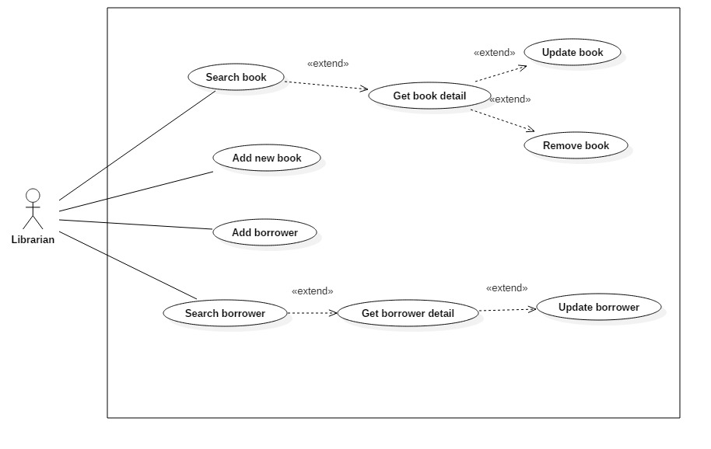

Figure : <Librarian> Overview Use Case

###### <Librarian> Search Book



Figure : <Librarian> Search Book

|  |  |  |  |
| --- | --- | --- | --- |
| **USE CASE – JWL09** | | | |
| **Use Case No.** | JWL09 | **Use Case Version** | 1.0 |
| **Use Case Name** | Search Book | | |
| **Author** | Dang Nhat Thien | | |
| **Date** | February 12, 2017 | **Priority** | Normal |
| **Actor:**   * Librarian   **Summary:**   * This use case allows Librarian to search book in library to view book detail.   **Goal:**   * Librarian can get a list book that match input book’s title.   **Triggers:**   * Librarian send Search command.   **Preconditions:**   * Actor logged in system with role Librarian.   **Post Conditions:**   * **Success:** List of matching books based on search term is showed. * **Fail:** N/A   **Main Success Scenario:**   |  |  |  | | --- | --- | --- | | Step | Actor Action | System Response | | 1.  2. | Librarian inputs wanted book’s title.  Librarian sends Search command. | System loads the result. Information for each book:   * No. * Title * Authors * Publisher * Publish year * Number of copies   [Alternative 1] |   **Alternative Scenario:**   |  |  |  | | --- | --- | --- | | Step | Cause | System Response | | 1 | There is no book that matches the search term. | System shows message: “No book found.” |   **Exceptions:** N/A  **Relationships:** Search book successfully, so librarian should Get book detail. Get book detail is extended from Search book.  **Business Rules:**   * Number of copies will show with format: [Remain] copies / [Total] copies. * Add action button to the last columns, so Librarian can Get book detail. * No: free text input * Book Title: free text input * Publisher: free text input * Description: free text input * Publish year: free text input * Number of pages: free text input * Number of copies: free text input * Book type: free text input, get book type name from book\_tye table. * Position: free text input, get floor, shelf from position table. * ISBN: free text input * Category: free text input, get category name from category table. * Author: free text input, get author name from author table. | | | |

Table : <Librarian> Search Book

###### <Librarian> Add Book

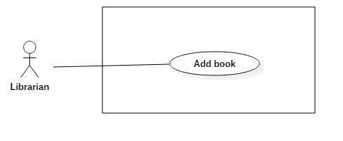

Figure : <Librarian> Add Book

|  |  |  |  |
| --- | --- | --- | --- |
| **USE CASE – JWL10** | | | |
| **Use Case No.** | JWL10 | **Use Case Version** | 1.1 |
| **Use Case Name** | Add Book | | |
| **Author** | Dang Nhat Thien | | |
| **Date** | March 15, 2017 | **Priority** | Normal |
| **Actor:**   * Librarian   **Summary:**   * Librarian adds new book information to the system database when the library obtains new books.   **Goal:**   * New books are available in the library system.   **Triggers:**   * Librarian sends “Add New Book” command.   **Preconditions:**   * Actor logged in system with role Librarian.   **Post Conditions:**   * **Success:** System show message: “Add successfully!” * **Fail:** N/A   **Main Success Scenario:**   |  |  |  | | --- | --- | --- | | Step | Actor Action | System Response | | 1  2  3 | Librarian send Add New Book  command.  Librarian input information.  [Alternative 1,2]  Librarian send “Save” command.  [Alternative 3] | System lists out the information of new Book:   * “Thumbnail”: the image Librarian can click to upload. Only JPG, PNG, JPEG format are accepted. Maximum file size is 3 MB, required. * “Book title”: free text input, required, length 1-50 * “Publisher”: free text input, required, length 1-100 * “Publish year”: free number input, required, max length 4 * “Page number”: free number input, required, length 1-4 * “Description”: free number input, required, length 1-500 * “Floor”: free number input, required, length 2 * “Shelf”: free text input, required, length 2. * “Author: free text input, required, length 1 – 50 * “Book type”: list of book type, required. * “Book category”: list of checkbox, required. * “RFID”: free text input, max length 10, required. * “Add new copy” command. * “Delete copy” command. * “Save” command. * “Cancel” command.   When text change, system verifies input information.  [Exception 1,2,3,4,5,6,7,8,9,10,11,12]  System verifies input information. New Book with all copies of it are saved to database. The system show message “Book [title] has been added!”  [Exception 1,2,3,4,5,6,7, 8, 9, 10, 11,12] |   **Alternative Scenario:**   |  |  |  | | --- | --- | --- | | No | Cause | System Response | | 1 | Librarian send “Add New Copy” command. | This corresponding RFID is display in a list below Book information. [Exception 6]  “RFID” will be clear. | | 2 | Librarian send “Delete Copy” command. | This corresponding RFID is deleted from list. | | 3 | Librarian send “Cancel” command. | System return to main view. |   **Exceptions:**   |  |  |  | | --- | --- | --- | | No | Cause | System Response | | 1 | Librarian inputs Book title field with wrong format. | System displays error message: “Book title’s length must be 1 - 50 characters.” | | 2 | Librarian inputs Publisher field with wrong format. | System displays error message: “Publisher’s length must be 1-100 characters.” | | 3 | Librarian inputs Publish year field with wrong format. | System displays error message: “Publish year must be a positive integer number and max length is 4” | | 4 | Librarian inputs Page number field with wrong format. | System displays error message: “Page must be a positive integer number and max length is 4” | | 5 | Librarian inputs Description field with wrong format. | System displays error message: “Description’s length is 1 - 500 characters” | | 6 | Librarian inputs RFID field with wrong format. | System displays error message: “RFID’s length is 10 characters.” | | 7 | Librarian send Save command with no RFID is added. | System display error message: “Please input at least one RFID.” | | 8 | Librarian inputs Floor field with wrong format. | System displays error message: “Floor must be a positive integer number and max length is 2” | | 9 | Librarian inputs Shelf field with wrong format. | System display error message: “Shelf length is 2 characters” | | 10 | Librarian inputs Author field with wrong format. | System display error message: “Author length is 1 – 50 characters”. | | 11 | Librarian pick up wrong format file. | System display error message: “Image extension are JPG, JPEG, PNG only and maximum size 3MB” | | 12 | Librarian does not pick up an image. | System display error message: “Please choose a thumbnail for book.” |   **Relationships:** Add successfully a new book so librarian can search, update, remove this.  **Business Rules:**   * “Book title”: free text input, length 1-50. * “Publisher”: free text input, length 1-100. * “Publish year”: free text input, length 4. * “Page Number”: free text input, length 1-4. * “Description”: free text input, length 1-500. * “RFID”: free text input, length 10. * “Floor”: free text input, length 2. * “Shelf”: free text input, length 2. * “Author”: free text input, length 1-50. * RFID must be added whenever Add New Book. * Floor and Shelf are two attributes of Position. | | | |

Table : <Librarian> Add Book

###### <Librarian> Get Book Detail

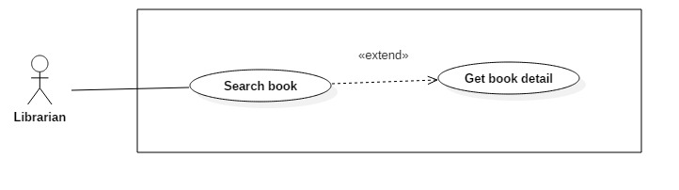

Figure : <Librarian> Get Book Detail

|  |  |  |  |
| --- | --- | --- | --- |
| **USE CASE – JWL11** | | | |
| **Use Case No.** | JWL11 | **Use Case Version** | 1.0 |
| **Use Case Name** | Get Book Detail | | |
| **Author** | Dang Nhat Thien | | |
| **Date** | March 16, 2017 | **Priority** | Low |
| **Actor:**   * Librarian   **Summary:**   * This use case allows Librarian to view book detail, so Librarian can Update/Delete book.   **Goal:**   * Full information of book is displayed.   **Triggers:**   * Librarian sends View Book Detail command.   **Preconditions:**   * Actor logged in system with role Librarian. * Librarian find out the Book want to view detail via Search Book.   **Post Conditions:**   * **Success:** System show all information of a specific Borrower. * **Fail:** N/A.   **Main Success Scenario:**   |  |  |  | | --- | --- | --- | | Step | Actor Action | System Response | | 1 | Librarian sends View Book Detail. | System lists out the information of the book:   * Thumbnail * Title * Publisher * Publish year * Page number * Description * Position * Author * Book type * Book category * Caution money * Max number of late days * List of copies that are being borrowed |   **Alternative Scenario:** N/A  **Exception:** N/A  **Relationships:** Librarian must find out the Book want to view detail via Search Book  **Business Rules:** N/A | | | |

Table : <Librarian> Get Book Detail

###### <Librarian> Update Book

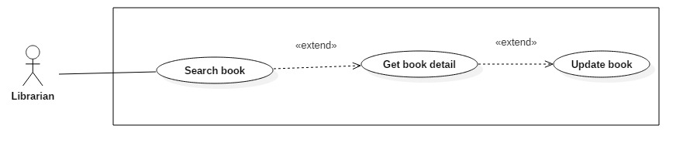Figure : <Librarian> Update Book

|  |  |  |  |
| --- | --- | --- | --- |
| **USE CASE – JWL12** | | | |
| **Use Case No.** | JWL12 | **Use Case Version** | 1.1 |
| **Use Case Name** | Update Book | | |
| **Author** | Dang Nhat Thien | | |
| **Date** | March 15, 2017 | **Priority** | Normal |
| **Actor:**   * Librarian   **Summary:**   * This use case allows Librarian to update information of books.   **Goal:**   * Book’s information will be updated.   **Triggers:**   * Librarian send Update Book command.   **Preconditions:**   * Actor logged in system with role Librarian. * Librarian find out the Book want to update.   **Post Conditions:**   * **Success: S**ystem show message: “Update successfully!” * **Fail:** N/A   **Main Success Scenario:**   |  |  |  | | --- | --- | --- | | Step | Actor Action | System Response | | 1  2  3 | Librarian sends Update Book  command from a Book Detail.  Librarian input information.  [Alternative 1,2]  Librarian send “Save” command.  [Alternative 3] | System lists out the information of new Book:   * “Thumbnail”: Image Librarian can click on to upload. Only JPG, PNG, JPEG format are accepted. Maximum file size is 3 MB, required. * “Book title”: free text input, required, length 1-50 * “Publisher”: free text input, required, length 1-100 * “Publish year”: free number input, required, max length 4 * “Page number”: free number input, required, length 1-4 * “Description”: free number input, required, length 1-500 * “Floor”: free number input, required, length 2 * “Shelf”: free text input, required, length 2. * “Author: free text input, required, length 1 – 50 * “Book type”: list of book type, required. * “Book category”: list of checkbox, required. * “RFID”: free text input, max length 10, required. * “Add new copy” command. * “Delete copy” command. * “Save” command. * “Cancel” command.   When text change, system verifies input information.  [Exception 1,2,3,4,5,6,7,8,9,10,11,12]  System verifies input information. New Book with all copies of it are saved to database. The system show message “Book [title] has been added!”  [Exception 1,2,3,4,5,6,7, 8, 9, 10, 11,12] |   **Alternative Scenario:**   |  |  |  | | --- | --- | --- | | No | Cause | System Response | | 1 | Librarian send “Add New Copy” command. | This corresponding RFID is display in a list below Book information. [Exception 6]  “RFID” will be clear. | | 2 | Librarian send “Delete Copy” command. | This corresponding RFID is deleted from list. | | 3 | Librarian send “Cancel” command. | System return to main view. |   **Exceptions:**   |  |  |  | | --- | --- | --- | | No | Cause | System Response | | 1 | Librarian inputs Book title field with wrong format. | System displays error message: “Book title’s length must be 1 - 50 characters.” | | 2 | Librarian inputs Publisher field with wrong format. | System displays error message: “Publisher’s length must be 1-100 characters.” | | 3 | Librarian inputs Publish year field with wrong format. | System displays error message: “Publish year must be a positive integer number and max length is 4” | | 4 | Librarian inputs Page number field with wrong format. | System displays error message: “Page must be a positive integer number and max length is 4” | | 5 | Librarian inputs Description field with wrong format. | System displays error message: “Description’s length is 1 - 500 characters” | | 6 | Librarian inputs RFID field with wrong format. | System displays error message: “RFID’s length is 10 characters.” | | 7 | Librarian send Save command with no RFID is added. | System display error message: “Please input at least one RFID.” | | 8 | Librarian inputs Floor field with wrong format. | System displays error message: “Floor must be a positive integer number and max length is 2” | | 9 | Librarian inputs Shelf field with wrong format. | System display error message: “Shelf length is 2 characters” | | 10 | Librarian inputs Author field with wrong format. | System display error message: “Author length is 1 – 50 characters”. | | 11 | Librarian pick up wrong format file. | System display error message: “Image extension are JPG, JPEG, PNG only and maximum size 3MB” | | 12 | Librarian does not pick up an image. | System display error message: “Please choose a thumbnail for book.” |   **Relationships:** Librarian must find out a book then get book detail.  **Business Rules:**   * “Book title”: free text input, length 1-50. * “Publisher”: free text input, length 1-100. * “Publish year”: free text input, length 4. * “Page Number”: free text input, length 1-4. * “Description”: free text input, length 1-500. * “RFID”: free text input, length 10. * “Floor”: free text input, length 2. * “Shelf”: free text input, length 2. * “Author”: free text input, length 1-50. * RFID must be added whenever Add New Book. * Floor and Shelf are two attributes of Position. | | | |

Table : <Librarian> Update Book

###### <Librarian> Remove Book

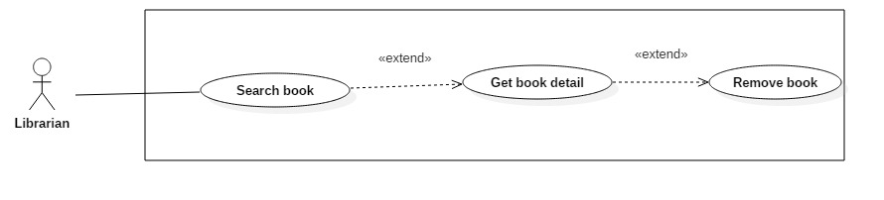

Figure : <Librarian> Remove Book

|  |  |  |  |
| --- | --- | --- | --- |
| **USE CASE – JWL13** | | | |
| **Use Case No.** | JWL13 | **Use Case Version** | 1.1 |
| **Use Case Name** | Remove Book | | |
| **Author** | Dang Nhat Thien | | |
| **Date** | March 15, 2017 | **Priority** | Normal |
| **Actor:**   * Librarian   **Summary:**   * This use case allows Librarian to remove books when all copies of books are unusable or the Library does not provide books anymore.   **Goal:**   * Librarian remove book and all of copies. The books and copies are not available in the library system. Borrowers can’t search and borrow.   **Triggers:**   * Librarian send Remove Book command.   **Preconditions:**   * Actor logged in system with role Librarian. * Librarian find out the Book want to remove via [<Librarian> Search Book](#_<Librarian>_Search_Book) * The book must be available in the library system.   **Post Conditions:**   * **Success:** System show message: “Removed successfully!” * **Fail:** N/A   **Main Success Scenario:**   |  |  |  | | --- | --- | --- | | Step | Actor Action | System Response | | 1  2 | Librarian send “Remove” Book  Command on a specific book.  Librarian send “Yes” command.  [Alternative 1] | System displays confirmation message: “Are you sure to remove this book?”.  System removes the book and show message: “Removed successfully!”  [Exception 1] |   **Alternative Scenario:**   |  |  |  | | --- | --- | --- | | No | Cause | System Response | | 1 | Librarian send “Cancel” command. | System return to main view. |   **Exceptions:**   |  |  |  | | --- | --- | --- | | No | Cause | System Response | | 1 | The book is being borrowed. | System displays error message: “Book is being borrowed. Can’t be removed!” |   **Relationships:** Librarian must find out a book via[<Librarian> Search Book](#_<Librarian>_Search_Book) to remove.  **Business Rules:**   * Book have copy is borrowing can’t be removed. * If book has been borrowed, change status to “false”. | | | |

Table : <Librarian> Remove Book

###### <Librarian> Add Borrower



Figure : <Librarian> Add Borrower

|  |  |  |  |
| --- | --- | --- | --- |
| **USE CASE – JWL14** | | | |
| **Use Case No.** | JWL14 | **Use Case Version** | 1.0 |
| **Use Case Name** | Add Borrower | | |
| **Author** | Dang Nhat Thien | | |
| **Date** | February 13, 2017 | **Priority** | Normal |
| **Actor:**   * Librarian   **Summary:**   * This use case allows Librarian to create an account for Borrower when someone ask to subscribe the library.   **Goal:**   * New account for borrower is created with status: “Activate”.   **Triggers:**   * Librarian sends Create Borrower command.   **Preconditions:**   * Actor logged in system with role Librarian.   **Post Conditions:**   * **Success:** Show success message: “Added successfully!”. * **Fail:** N/A   **Main Success Scenario:**   |  |  |  | | --- | --- | --- | | Step | Actor Action | System Response | | 1 | Librarian sends Create Borrower  command. | System lists out the information of the new account:   * “User Image”: Image Librarian can click on to upload. Only JPG, PNG, JPEG format are accepted. Maximum file size is 3 MB, required. * “User ID”: free text input, length 6-15 * “Full Name”: free text input, length 1-100 * “Email”: free text input * “Address”: free text input, length 1-250 * “Date of Birth”: view that allows Librarian to pick day – month - year * “Phone number”: free text input, length 8-12 * “Place of Work”: free text input: length 6-50 | | 2 | Librarian input the information. | System validate the corresponding field whenever text changed.  [Exception 1, 2, 3, 4, 5, 6, 7, 8, 9] | | 3 | Librarian sends “Save” command. | System validates the input then create a new borrower.  System displays a successful message: “New Borrower: [User Id] is added.”  [Exception 1, 2, 3, 4, 5, 6, 7, 8, 9] |   **Alternative Scenario:** N/A  **Exceptions:**   |  |  |  | | --- | --- | --- | | No | Cause | System Response | | 1 | Librarian pick up wrong format file. | System display error message: “Image extension are JPG, JPEG, PNG only and maximum size 3MB” | | 2 | Librarian does not pick up an image. | System display error message: “Please choose a picture for Borrower.” | | 3 | Librarian inputs User Id field with wrong format. | System displays error message: “User Id length is 6-15 characters.” | | 4 | Librarian inputs Full Name field with wrong format. | System displays error message: “Full name length is 1-100 characters.” | | 5 | Librarian inputs Email field with wrong format. | System displays error message: “Wrong Email format. Please input something like abc@somemail.com” | | 6 | Librarian inputs Address field with wrong format. | System displays error message: “Address length is 1-125 characters.” | | 7 | Librarian don’t pick up a Date of Birth. | System displays error message: “Have to pick up a Date of Birth for borrower.” | | 8 | Librarian inputs Phone Number field with wrong format. | System displays error message: “Phone Number should be all numbers at 8-12 length.” | | 9 | Librarian inputs Place of Work field with wrong format. | System displays error message: “Place of Work length is 6-50 characters.” |   **Relationships:** Librarian create success a borrower account, so borrower should login to the system with borrower role.  **Business Rules:**   * Password is a random string has length is 4. User can change password from phone when login first time. * Email format: abc@somemail.com | | | |

Table : <Librarian> Add Borrower

###### <Librarian> Search Borrower



Figure : <Librarian> Search Borrower

|  |  |  |  |
| --- | --- | --- | --- |
| **USE CASE – JWL15** | | | |
| **Use Case No.** | JWL15 | **Use Case Version** | 1.0 |
| **Use Case Name** | Search Borrower | | |
| **Author** | Dang Nhat Thien | | |
| **Date** | February 13, 2017 | **Priority** | Normal |
| **Actor:**   * Librarian   **Summary:**   * This use case allows Librarian to search for a borrower to view his/her detail information, including his/her borrowing books.   **Goal:**   * Librarian can get a list of borrowers that match input userID.   **Triggers:**   * Librarian send Search Borrower command.   **Preconditions:**   * Actor logged in system with role Librarian.   **Post Conditions:**   * **Success:** List of matching borrowers based on search term is showed. * **Fail:** N/A   **Main Success Scenario:**   |  |  |  | | --- | --- | --- | | Step | Actor Action | System Response | | 1  2 | Librarian inputs wanted userID.  Librarian send Search command. | System loads the result. Information for each Borrower:   * No. * UserID * Full name * Email * Is in Library * Is activated   [Alternative 1] |   **Alternative Scenario:**   |  |  |  | | --- | --- | --- | | Step | Cause | System Response | | 1 | There is no borrower that matches the search term. | System shows message: “We could not find any borrowers with userID like [search term]” |   **Exceptions:** N/A  **Relationships:** Search book successfully, so librarian can Get book detail. Get book detail is extended from Search book.  **Business Rules:**   * UserId: free text input, get from account table. * Email: text, get from profile table. * Is in Library: text (True/False), get from account table. * Is activate: text (True/False), get from account table. * View detail command. | | | |

Table : <Librarian> Search Borrower

###### <Librarian> Get Borrower Detail

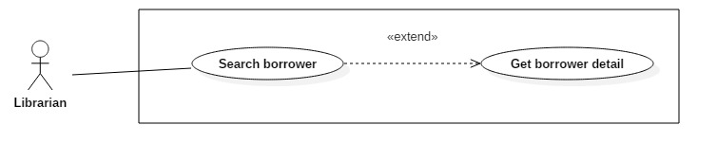

Figure : <Librarian> Get borrower detail.

|  |  |  |  |
| --- | --- | --- | --- |
| **USE CASE – JWL16** | | | |
| **Use Case No.** | JWL16 | **Use Case Version** | 1.0 |
| **Use Case Name** | Get Borrower Detail | | |
| **Author** | Dang Nhat Thien | | |
| **Date** | March 16, 2017 | **Priority** | Low |
| **Actor:**   * Librarian   **Summary:**   * This use case allows Librarian to view borrower’s detail. So Librarian can Update borrower’s profile.   **Goal:**   * Full information of borrower is displayed.   **Triggers:**   * Librarian sends View Profile Detail command.   **Preconditions:**   * Actor logged in system with role Librarian. * Librarian find out the Borrower want to view detail via [<Librarian> Search Borrower](#_<Librarian>_Search_Borrower)   **Post Conditions:**   * **Success:** System show all information of a specific Borrower. * **Fail:** N/A.   **Main Success Scenario:**   |  |  |  | | --- | --- | --- | | Step | Actor Action | System Response | | 1 | Librarian sends View Borrower Detail. | System lists out the information of the account:   * User Id * Full name * Date of birth * Email * Address * Phone number * Place of work * Status |   **Alternative Scenario:** N/A  **Exception:** N/A  **Relationships:** Librarian must find out the Borrower want to view detail via [<Librarian> Search Borrower](#_<Librarian>_Search_Borrower). After get borrower detail, Librarian can Update borrower.   * Get borrower detail is extended from Search book. * Update borrower is extended from Get borrower detail.   **Business Rules:**   * User Id: free text, get from user-id - account table. * Full name: free text, get from fullname - account table. * Date of birth: free text, get from date\_of\_birth - profile table. * Email: free text, get from email - profile table. * Address: free text, get from address - profile table. * Phone number: free text, get from phone\_no - profile table. * Place of work: free text, get from place\_of\_word – profile table. * Status: free text, get from is\_activated – account table. | | | |

Table : <Librarian> Get borrower detail.

###### <Librarian> Update Borrower

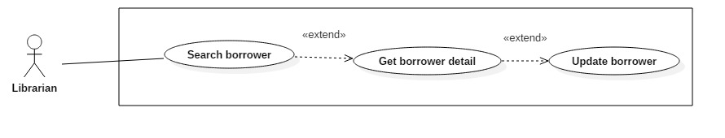

Figure : <Librarian> Update Borrower

|  |  |  |  |
| --- | --- | --- | --- |
| **USE CASE – JWL17** | | | |
| **Use Case No.** | JWL17 | **Use Case Version** | 1.1 |
| **Use Case Name** | Update Borrower Information | | |
| **Author** | Dang Nhat Thien | | |
| **Date** | March 16, 2017 | **Priority** | Low |
| **Actor:**   * Librarian   **Summary:**   * This use case allows Librarian to update borrower’s information.   **Goal:**   * Borrower’s information is changed.   **Triggers:**   * Librarian sends Update command.   **Preconditions:**   * Actor logged in system with role Librarian.   **Post Conditions:**   * **Success:** A message is displayed: “Update successfully!”. * **Fail:** N/A.   **Main Success Scenario:**   |  |  |  | | --- | --- | --- | | Step | Actor Action | System Response | | 1 | Librarian sends Update Account command on a specific account. | System lists out the information of the new account:   * “User Image”: Image Librarian can click on to upload. Only JPG, PNG, JPEG format are accepted. Maximum file size is 3 MB, required. * “User ID”: free text input, length 6-15 * “Full Name”: free text input, length 1-100 * “Password”: free text input that hides the input text, length 6-50 * “Confirm Password”: free text input that hides the input text, length 6-50 * “Email”: free text input * “Address”: free text input, length 1-250 * “Date of Birth”: view that allows Librarian to pick day – month - year * “Phone number”: free text input, length 8-12   “Place of Work”: free text input: length 6-50 | | 2 | Librarian updates information. | System validate the corresponding field whenever text changed.  [Exception 1, 2, 3, 4, 5, 6, 7, 8, 9, 10, 11] | | 3 | Librarian sends Submit command. | System validates the input then update borrower.  System displays a successful message: “Update successfully!”  [Exception 1, 2, 3, 4, 5, 6, 7, 8, 9, 10, 11] |   **Alternative Scenario:** N/A  **Exception:**   |  |  |  | | --- | --- | --- | | No | Cause | System Response | | 1 | Librarian pick up wrong format file. | System display error message: “Image extension are JPG, JPEG, PNG only and maximum size 3MB” | | 2 | Librarian does not pick up an image. | System display error message: “Please choose a picture for Borrower.” | | 3 | Librarian inputs User Id field with wrong format. | System displays error message: “User Id length is 6-15 characters.” | | 4 | Librarian inputs Full Name field with wrong format. | System displays error message: “Full name length is 1-100 characters.” | | 5 | Librarian inputs Password field with wrong format. | System displays error message: “Password length is 6-50 characters.” | | 6 | Librarian inputs Confirm Password field which does not match the Password. | System displays error message: “Confirm Password must match Password.” | | 7 | Librarian inputs Email field with wrong format. | System displays error message: “Wrong Email format. Please input something like abc@somemail.com” | | 8 | Librarian inputs Address field with wrong format. | System displays error message: “Address length is 1-125 characters.” | | 9 | Librarian don’t pick up a Date of Birth. | System displays error message: “Have to pick up a Date of Birth for borrower.” | | 10 | Librarian inputs Phone Number field with wrong format. | System displays error message: “Phone Number should be all numbers at 8-12 length.” | | 11 | Librarian inputs Place of Work field with wrong format. | System displays error message: “Place of Work length is 6-50 characters.” |   **Relationships:** Librarian must find out the Borrower want to update via [<Librarian> Search Borrower](#_<Librarian>_Search_Borrower)  **Business Rules:**   * Password must be encrypted before saving to the system. * Email format: something like abc@somemail.com. | | | |

Table : <Librarian> Update Borrower

#### Mobile Application

##### Borrower

###### <Borrower> Overview Use Case

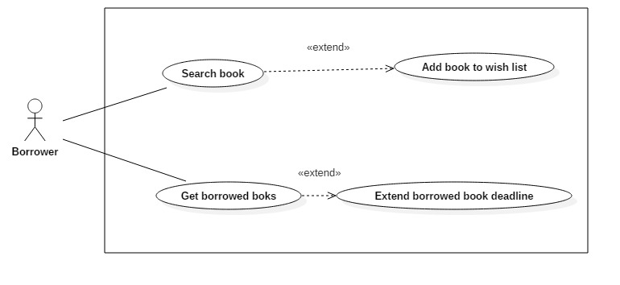

Figure : <Borrower> Overview Use Case

###### <Borrower> Search Book



Figure : <Borrower> Search Book

|  |  |  |  |
| --- | --- | --- | --- |
| **USE CASE – JWL17** | | | |
| **Use Case No.** | JWL17 | **Use Case Version** | 1.1 |
| **Use Case Name** | Search Book | | |
| **Author** | Dang Nhat Thien | | |
| **Date** | March 16, 2017 | **Priority** | Normal |
| **Actor:**   * Borrower   **Summary:**   * This use case allows Borrowers to search book. So that borrowers can view status of book, add book to wish list.   **Goal:**   * A list books that match input book’s name is displayed.   **Triggers:** Borrower send Search Command.  **Preconditions:**   * Actor logged in system with role Borrower.   **Post Conditions:**   * **Success:** List of matching books based on search term is showed. * **Fail:** A Dialog will be showed and display message: “Search fail. Please check your internet connection”.   **Main Success Scenario:**   |  |  |  | | --- | --- | --- | | Step | Actor Action | System Response | | 1 | Borrower inputs wanted book’s name.  Then send Search Command | System loads the result. Information for each account:   * Book Title * Position * Author * Is available   [Alternative 1]: There is no book that matches the search term.  [Exception 1]: Internet connection is lost. |   **Alternative Scenario:**   |  |  |  | | --- | --- | --- | | Step | Cause | System Response | | 1 | There is no book that matches the search term. | System shows message: “Không tìm thấy sách.” |   **Exceptions:**   |  |  |  | | --- | --- | --- | | No | Cause | System Response | | 1 | Internet connection is lost. | System show error message via Dialog. |   **Relationships:** Search successfully so Borrower can add book to wish list if Book is not available at that time.  **Business Rules:**   * Search return the most matched book with the search term. * Book Title: free text * Position: free text, get floor, shelf from position table. * Author: free text, get author name from author table. * Is available: Available if total book copies is more than number of borrowing books. If not, it’s not available. | | | |

Table : Borrower> Search Book

###### <Borrower> Add Book To Wish List

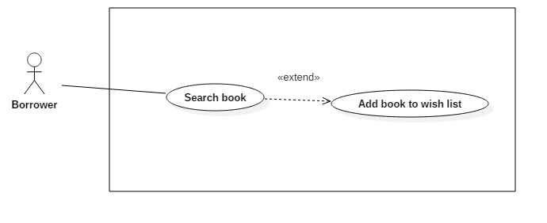

Figure : <Borrower> Add book to wish list

|  |  |  |  |
| --- | --- | --- | --- |
| **USE CASE – JWL18** | | | |
| **Use Case No.** | JWL18 | **Use Case Version** | 1.1 |
| **Use Case Name** | Add Book To Wish List | | |
| **Author** | Dang Nhat Thien | | |
| **Date** | March 16, 2017 | **Priority** | Normal |
| **Actor:**   * Borrower   **Summary:**   * Borrower Add Book To Wish List if a book is not available, so that when a book copy of that book is returned, Borrower will receive notification.   **Goal:**   * The book is saved as wish book of specific Borrower.   **Triggers:** Borrower send “Add Book To Wish List” command.  **Preconditions:**   * Actor logged in system with role Borrower. * Borrower find out the book. * Book is not available.   **Post Conditions:**   * **Success:** The system shows successful icon to the actor. * **Fail:** A dialog will be showed and display message: “Có lỗi xảy ra.”.   **Main Success Scenario:**   |  |  |  | | --- | --- | --- | | Step | Actor Action | System Response | | 1 | Borrower sends “Add To Wish List” command | * System save sto database and displays success message.   [Exception 1] Lost Internet Connection |   **Alternative Scenario:** N/A  **Exceptions:**   |  |  |  | | --- | --- | --- | | No | Cause | System Response | | 1 | Lost Internet Connection | System shows error message via Dialog. |   **Relationships:** Borrower must search book via Search book before.  **Business Rules:**   * Borrower can only add books which are currently not available to wish list. * Borrower id and book id is store in wish\_book table. * After adding book to wish list, borrower can receive notification when someone return this book. After sending notification, row has the borrower and book is deleted from wish\_book table. | | | |

Table : <Borrower> Add book to wish list

###### <Borrower> Get Borrowed Books



Figure : <Borrower> Get Borrowed Books

|  |  |  |  |
| --- | --- | --- | --- |
| **USE CASE – JWL19** | | | |
| **Use Case No.** | JWL19 | **Use Case Version** | 1.1 |
| **Use Case Name** | Get Borrowed Books | | |
| **Author** | Dang Nhat Thien | | |
| **Date** | March 16, 2017 | **Priority** | Normal |
| **Actor:**   * Borrower.   **Summary:**   * Borrower get list borrowed books to view their information, check deadline, and renew books.   **Goal:**   * List borrowed books is displayed.   **Triggers:** Borrower send “Get borrowed books” command.  **Preconditions:**   * Actor logged in system with role Borrower.   **Post Conditions:**   * **Success:** List borrowed books is displayed. * **Fail:** A dialog will be showed and display message: “Lỗi kết nối. Vui lòng kiểm tra internet”.   **Main Success Scenario:**   |  |  |  | | --- | --- | --- | | Step | Actor Action | System Response | | 1 | Borrower sends “Get borrowed books” command. | System shows list borrowed books.  [Exception 1] Lost Internet Connection. |   **Alternative Scenario:** N/A  **Exceptions:**   |  |  |  | | --- | --- | --- | | No | Cause | System Response | | 1 | Lost Internet Connection | System show error message via Dialog. |   **Relationships:** After Get Borrowed Books, Borrower can Extend Borrower Book Deadline.  **Business Rules:** N/A | | | |

Table : <Borrower> Get Borrowed Books

###### <Borrower> Extend Borrowed Book Deadline

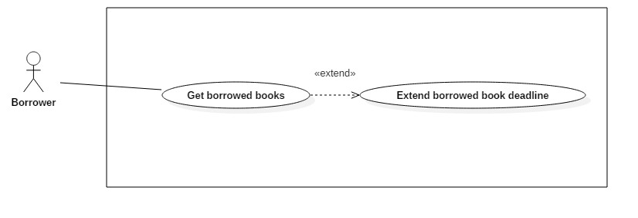

Figure : <Borrower> Extend Borrowed Book Deadline

|  |  |  |  |
| --- | --- | --- | --- |
| **USE CASE – JWL20** | | | |
| **Use Case No.** | JWL20 | **Use Case Version** | 1.1 |
| **Use Case Name** | Extend Borrowed Book Deadline | | |
| **Author** | Dang Nhat Thien | | |
| **Date** | March 16, 2017 | **Priority** | Normal |
| **Actor:**   * Borrower   **Summary:**   * Borrower wants to have more time reading a book, so he/she extend the book’s borrow time.   **Goal:**   * Book Deadline will be extended to a fixed number of days.   **Triggers:** N/A  **Preconditions:**   * Actor logged in system with role Borrower. * Book is not overdue the max number of late days of the library’s policy.   **Post Conditions:**   * **Success:** A dialog will be showed and display message: “Sách [tựa sách] đã được gia hạn đến ngày [ngày]!” * **Fail:** A dialog will be showed and display message: “Lỗi kết nối. Vui long kiểm tra lại internet!”.   **Main Success Scenario:**   |  |  |  | | --- | --- | --- | | Step | Actor Action | System Response | | 1 | After get list borrowed books, Borrower click on “Renew” button in Book detail. | System return new deadline and show success message.  [Exception 1] Lost Internet Connection. |   **Alternative Scenario:** N/A  **Exceptions:**   |  |  |  | | --- | --- | --- | | No | Cause | System Response | | 1 | Lost Internet Connection | System display error message. |   **Relationships:** Borrower can Extend Borrower Book Deadline after get Borrowed Booksvia [<Borrower> Get Borrowed Books](#_<Borrower>_Get_Borrowed)  **Business Rules:**  Book only can be extended when:   * Three or less days before deadline, or * After deadline, but book is not overdue the max number of late days in the library’s policy | | | |

Table : <Borrower> Extend Borrowed Book Deadline

##### Automatic Handler

###### <Automatic Handler> Overview Use Case

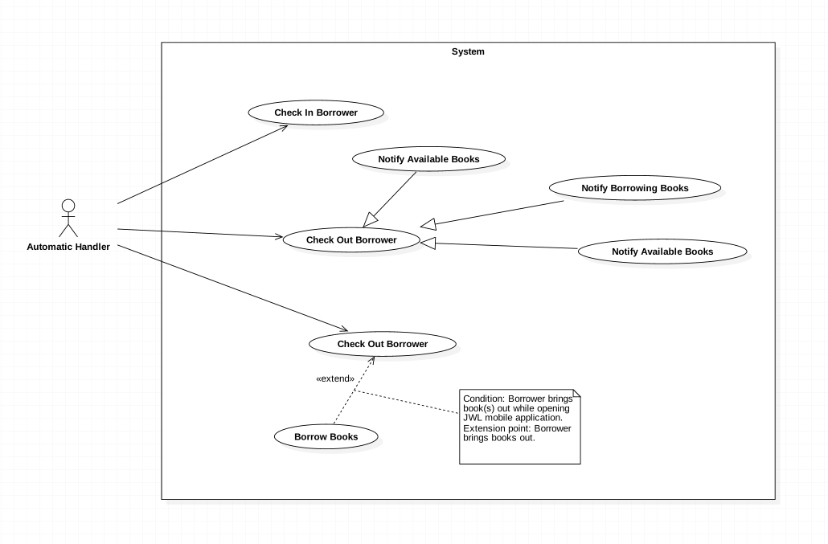

Figure : <Automatic Handler> Overview Use Case

###### <Automatic Handler> Check in Borrower



Figure : <Automatic Handler> Check in Borrower

|  |  |  |  |
| --- | --- | --- | --- |
| **USE CASE – JWL21** | | | |
| **Use Case No.** | JWL21 | **Use Case Version** | 2.0 |
| **Use Case Name** | Check in Borrower | | |
| **Author** | Vo Hong Ha | | |
| **Date** | February 13, 2017 | **Priority** | High |
| **Actor:**   * Automatic Handler   **Summary:**   * This use case allows Automatic Handler to check the attendance of those want to enter the library.   **Goal:**   * Authenticate the borrowers’ information.   **Triggers:**   * Automatic Handler checks the information of borrowers when they scan smartphone at the entrance.   **Preconditions:**   * Borrower scans NFC/QR code through the emulator.   **Post Conditions:**   * **Success:** The message will show on the application. * **Fail:** N/A   **Main Success Scenario:**   |  |  |  | | --- | --- | --- | | Step | Actor Action | System Response | | 1 | Automatic Handler check the information. | System response the message of result “Bạn đang ở trong thư viện.” |   **Alternative Scenario:** N/A  **Exceptions:** N/A  **Relationships:** N/A  **Business Rules:**   * Automatic Handler gets the information of NFC/QR code from the emulator then sends to the system. * Automatic Handler receives the response of the system, then plays sound and displays notification in comparable with that response. | | | |

Table : <Automatic Handler> Check in Borrower

###### <Automatic Handler> Notify return date



Figure : <Automatic Handler> Notify return date

|  |  |  |  |
| --- | --- | --- | --- |
| **USE CASE – JWL22** | | | |
| **Use Case No.** | JWL22 | **Use Case Version** | 1.0 |
| **Use Case Name** | Notify return date | | |
| **Author** | Vo Hong Ha | | |
| **Date** | February 13, 2017 | **Priority** | Normal |
| **Actor:**   * Automatic Handler   **Summary:**   * This use case allows Automatic Handler to send a notification to borrower about the return date of books   **Goal:**   * Borrowers are noticed 3 days prior to the return date.   **Triggers:**   * Automatic Handler send a notification to the borrower.   **Preconditions:**   * Borrower has borrowed books that have 3 days remaining.   **Post Conditions:**   * **Success:** Notification will be sent to the borrowers on the mobile application. * **Fail:** N/A   **Main Success Scenario:**   |  |  |  | | --- | --- | --- | | Step | Actor Action | System Response | | 1 | Automatic Handler send notification on noticed day. | System push a notification on the application of mobile phone:  “3 days remaining for [bookTitle]” |   **Alternative Scenario:** N/A  **Exceptions:** N/A  **Relationships:** N/A  **Business Rules:**   * The second notification will be sent on the return date in the case that the book was not returned until that date. | | | |

Table : <Automatic Handler> Notify return date

###### <Automatic Handler> Notify Borrowing Books



Figure : <Automatic Handler> Notify Borrowing Books

|  |  |  |  |
| --- | --- | --- | --- |
| **USE CASE – JWL23** | | | |
| **Use Case No.** | JWL23 | **Use Case Version** | 1.0 |
| **Use Case Name** | Notify Borrowing Books | | |
| **Author** | Vo Hong Ha | | |
| **Date** | February 13, 2017 | **Priority** | Normal |
| **Actor:**   * Automatic Handler   **Summary:**   * This use case allows Automatic Handler to send a notification to borrowers about the borrowed book after they borrow   **Goal:**   * Borrowers are noticed those books which they have borrowed   **Triggers:**   * Automatic Handler notices the list of borrowed book   **Preconditions:**   * Borrower borrow books and check out successfully.   **Post Conditions:**   * **Success:** Notification will be sent with a list of borrowed book * **Fail:** N/A   **Main Success Scenario:**   |  |  |  | | --- | --- | --- | | Step | Actor Action | System Response | | 1 | Automatic Handler send notification right after Borrower check out. | System push a notification on the application of mobile phone:  “You have check out successfully. The list of book is as follow.” |   **Alternative Scenario:** In the case the borrowers don’t check out with books, the notification will not be sent.  **Exceptions:** N/A  **Relationships:** N/A  **Business Rules:** N/A | | | |

Table : <Automatic Handler> Notify Borrowing Books

###### <Automatic Handler> Notify Available Books



Figure : <Automatic Handler> Notify Available Books

|  |  |  |  |
| --- | --- | --- | --- |
| **USE CASE – JWL24** | | | |
| **Use Case No.** | JWL24 | **Use Case Version** | 1.0 |
| **Use Case Name** | Notify Available Books | | |
| **Author** | Vo Hong Ha | | |
| **Date** | February 13, 2017 | **Priority** | Normal |
| **Actor:**   * Automatic Handler   **Summary:**   * This use case allows Automatic Handler to send a notification to borrowers about the available book according to borrower’s wish list.   **Goal:**   * Borrowers are noticed those books which are available in the library.   **Triggers:**   * Automatic Handler notices the available books.   **Preconditions:**   * Borrowers have add that books to their wish list and those books are available on the library.   **Post Conditions:**   * **Success:** Notification about the available books will be sent. * **Fail:** N/A   **Main Success Scenario:**   |  |  |  | | --- | --- | --- | | Step | Actor Action | System Response | | 1 | Automatic Handler send notification about available books. | System push a notification on the application of mobile phone:  “Some books of your wish list have available” |   **Alternative Scenario:** N/A  **Exceptions:** N/A  **Relationships:** N/A  **Business Rules:** N/A | | | |

Table : <Automatic Handler> Notify Available Books

###### <Automatic Handler> Check out Borrower



Figure : <Automatic Handler> Check out Borrower

|  |  |  |  |
| --- | --- | --- | --- |
| **USE CASE – JWL25** | | | |
| **Use Case No.** | JWL25 | **Use Case Version** | 1.0 |
| **Use Case Name** | Check out Borrower | | |
| **Author** | Vo Hong Ha | | |
| **Date** | February 13, 2017 | **Priority** | High |
| **Actor:**   * Automatic Handler   **Summary:**   * This use case allows Automatic Handler to check out the borrower.   **Goal:**   * Check the borrowers who get out of the library.   **Triggers:**   * N/A.   **Preconditions:**   * N/A.   **Post Conditions:**   * **Success:** N/A. * **Fail:** N/A   **Main Success Scenario:**   |  |  |  | | --- | --- | --- | | Step | Actor Action | System Response | | 1 | Automatic Handler check the borrower with RFID reader. | N/A |   **Alternative Scenario:** N/A  **Exceptions:** N/A  **Relationships:** N/A  **Business Rules:** N/A | | | |

Table : <Automatic Handler> Check out Borrower

###### <Automatic Handler> Check out Borrow Books



Figure : <Automatic Handler> Check out Borrow Books

|  |  |  |  |
| --- | --- | --- | --- |
| **USE CASE – JWL26** | | | |
| **Use Case No.** | JWL26 | **Use Case Version** | 1.0 |
| **Use Case Name** | Check out Borrow Books | | |
| **Author** | Vo Hong Ha | | |
| **Date** | February 13, 2017 | **Priority** | High |
| **Actor:**   * Automatic Handler   **Summary:**   * This use case allows Automatic Handler to check out the borrower’s books.   **Goal:**   * Check out the borrower whether they get out with books.   **Triggers:**   * RFID Reader scan the books of the Borrower.   **Preconditions:**   * The books have RFID tag.   **Post Conditions:**   * **Success:** N/A. * **Fail:** N/A   **Main Success Scenario:**   |  |  |  | | --- | --- | --- | | Step | Actor Action | System Response | | 1 | Automatic Handler scan the books with RFID reader. | Add the books to the borrowed list. |   **Alternative Scenario:** N/A  **Exceptions:** N/A  **Relationships:** N/A  **Business Rules:** N/A | | | |

Table : <Automatic Handler> Check out Borrow Books

## Software System Attribute



### Usability

* The Android application for emulator requires 10 minutes training for staff.
* The Android application for passenger will take 15-20 minutes to get used to the mobile system completely.

### Reliability

* The number of sending notification failure is 1 time per 1000 notifications.
* Timer tasks run at configured time with 100% execution rate.

### Availability

* System is available 24 hours per day and 7 days per week.
* System should take at most 5 hours per month for backup or repairing.

### Security

* Privacy: Each role of user has a specific permission to interact with system.
* System always checks authorization and authenticated before doing anything.
* Only admin can grant permission to other roles.

### Maintenanability

* The system is divided into separated modules.
* The code is easy to maintain and upgrade.

### Portability

* The web application is running on Heroku environment.
* Mobile application for passenger and emulator runs on Android API greater than 4.1.
* Providing easy installation.

### Performance

* Web appication handles the task within 5 seconds.

### Conceptual Diagram

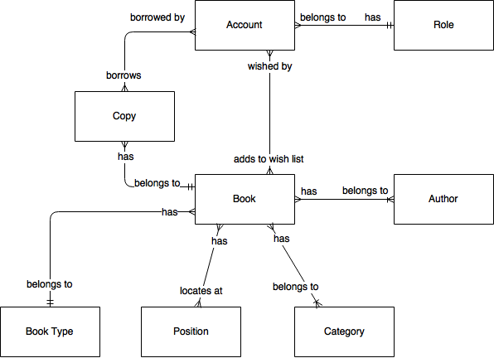

Figure : Conceptual Diagram

**Data Dictionary:**

|  |  |
| --- | --- |
| Entity Name | Description |
| Account | Contains all information of users in the system. |
| Role | The system role of an account. |
| Book | Contains all information of books in the system. |
| Copy | Contains all information of copies of books. |
| Author | Contains all information of authors of books in the system. |
| Category | Contains all information of book’s categories, for example, Math, Literature, Physics, Software Engineering, … |
| Book Type | Contains all information of book’s types, for example, text book or reference book. |
| Position | Contains all information of physical positions of books in the system. |

Table : Conceptual Diagram Data Dictionary

# Software Design Description

## Design Overview

* The architectural design describes the overall architecture of the system and the architecture of each main component and subsystem.
* The detailed design describes static and dynamic structure for each component and functions. It includes class diagrams, class explanations and sequence diagrams for each use cases.
* The database design describes the relationships between entities and details of each entity.
* Document overview:
* Section 1: gives an overall description of the system architecture design.
* Section 2: gives component diagrams that describe the connection and integration of the system.
* Section 3: gives the detail design description, which includes class diagram, class explanation, and sequence diagram to details the application functions.
* Section 4: gives the interface design description, which includes component interface, web application interface and mobile application design.
* Section 5: describe a fully attributed Entity Relationship Diagram.
* Section 6: describe the algorithms that apply to the system.

## System Architectural Design

### Web Application Architecture Description

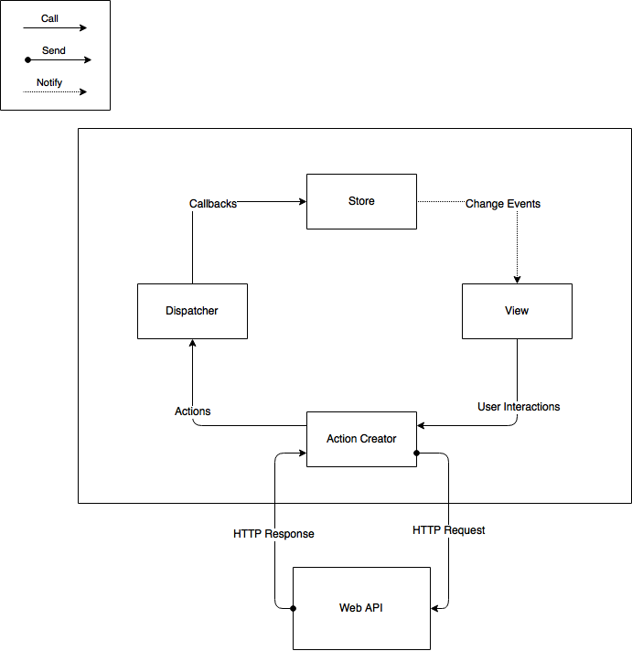

Figure : Web Application Architecture

The web application uses React (<https://facebook.github.io/react/)> with Flux (<https://facebook.github.io/flux/>) as its architecture. Flux creates a unidirectional data flow for web applications built with React. We choose this architecture for a couple of reasons:

* Performance: The web application’s render performance is dramatically improved thanks to React. React renders the web application with the help of its virtual DOM. Each React view component has a render method, which will update the virtual DOM. React then compares the updated virtual DOM with a virtual DOM snapshot that was taken right before the update. By doing so, React figures out exactly which virtual DOM objects have change, and only updates those different objects on the real DOM.
* Simplicity: the whole web application is simple to develop and maintain, because the data always flows in one direction. There is no need to handle event listener for each web component like in MVC application. This architecture also separates frontend from backend, so developers are able to work independently.
* Reusability and Testability: The architecture divides the application into components. This increases reusability and testability.

### Web Service Application Architecture Description

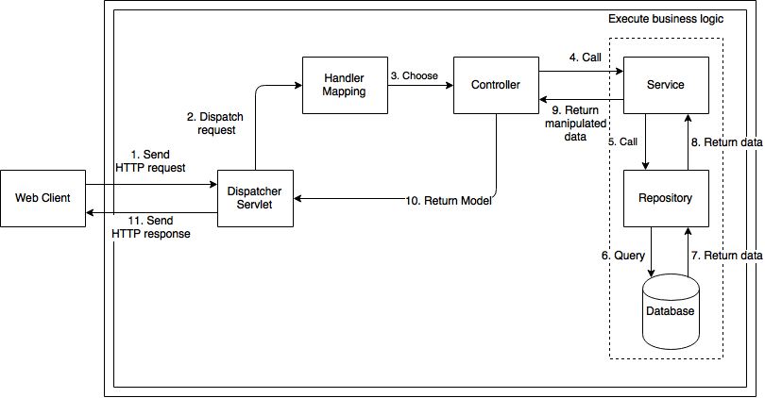

Figure : Web Service Architecture

The Web Service Application Architecture uses Spring MVC architecture (<https://docs.spring.io/spring/docs/current/spring-framework-reference/html/mvc.html>). We choose this Spring MVC for the following advantages:

* MVC: The application will be divided into three clear parts: Model – View – Controller, thus makes it easier for developing, testing, and maintaining.
* Availability: Spring MVC framework supports automatic mapping from Dispatcher Servlet to Controller, Controller to Model map with wanted data, and many more advantages. Therefore, the development process is greatly reduced.

### Mobile Application Description



Figure 36: Mobile Application Architecture

Mobile application architecture will use MVVM. There is couple of reasons choosing this architect:

* It minimizes the number of dependency, helps increase loose coupling between application.
* The View is passive and will be notified to update data.
* The View Model will contain complex view logic; it also has no information about View. This helps increase reusability of View Model.
* The Model is where business logic sits in; it also performs API requests to backend application.
* Develop Mobile Application using MVVM have increase productivity and reduce side effects.

## Component Diagram

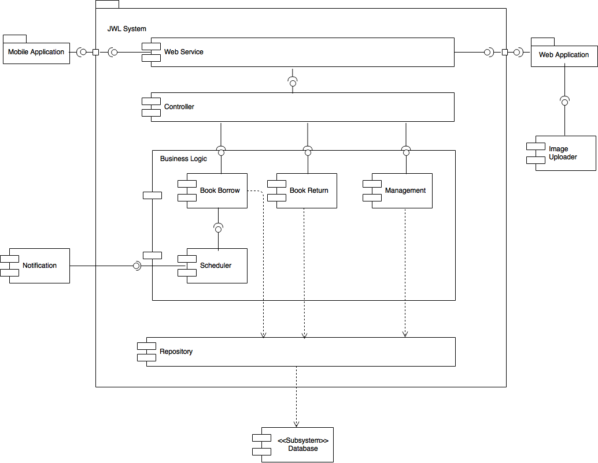

Figure : Web Service Architecture

|  |  |
| --- | --- |
| **Name** | **Description** |
| JWL System | Just Walk Out Library System |
| Web Service | Provides API for Mobile and Web application to interact with the system |
| Business Logic | Handles system’s business operations |
| Controller | Handles HTTP requests |
| Management | Manages system data |
| Book Borrow | Handles borrowing books process, including: check in, initiate borrow process, scan books, check out |
| Book Return | Handles return books process by librarian |
| Scheduler | Runs background job and call Notification |
| Repository | Abstract data layer to interact with database system |
| Database System | Stores data of the system |
| Notification | External Component to send message to Mobile application |
| Image Uploader | External Component to upload image and create image url |
| Table : Component Dictionary | |

## Detailed Description

### Class Diagram

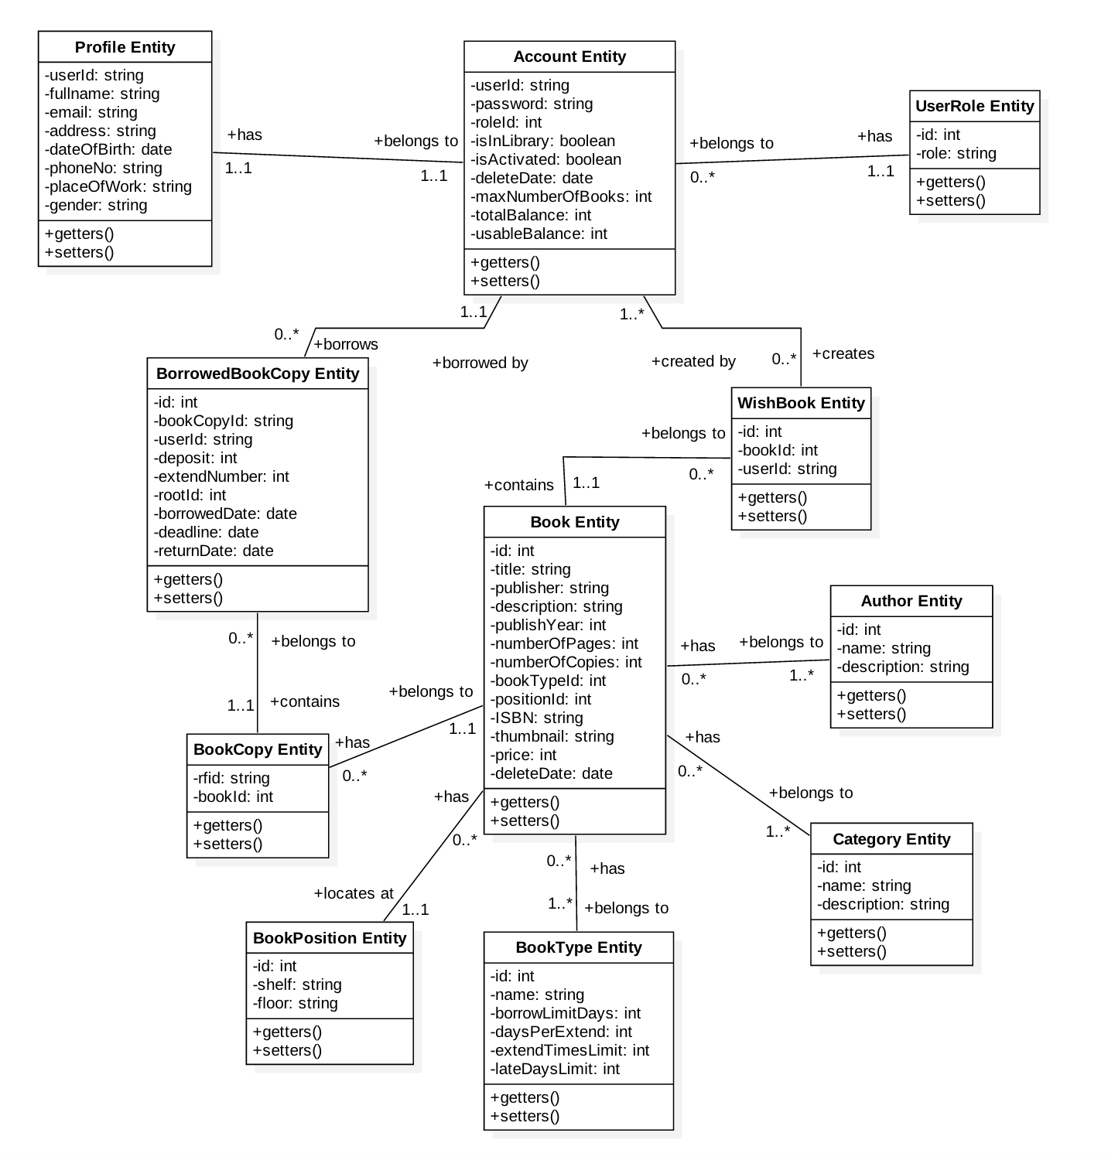

Figure : Web Service Architecture

|  |  |  |
| --- | --- | --- |
| **Class name** | **Mapping column with conceptual diagram** | **Description** |
| Profile Entity | Profile | Contains the detail information of accounts of the system’s users. |
| Account Entity | Account | Contains the frequently accessed information of accounts of the system’s users. |
| UserRole Entity | User Role | Contains the information of users’ roles. |
| Book Entity | Book | Contains the information of books in the system. |
| BorrowedBookCopy Entity | Borrowed Book Copy | Contains the informtaion of copies that are borrowed by system’s users. |
| BookCopy Entity | Book Copy | Contains the information of copies of the system’s books. |
| WishBook Entity | Wish Book | Contains the information of books that the system’s users put in their wishlist. |
| Author Entity | Author | Contains the information of author in the system. |
| Category Entity | Category | Contains the information of category of the system’s book. Example of category are math, literature, or IT. |
| BookType Entity | Book Type | Contains the information of type of the system’s book. Example of book type are reference book, or textbook. |
| BookPosition Entity | Book Position | Contains the information of book position in the library. Example of book position is floor 1, shelf A. |
| Table : Class Diagram Dictionary | | |

### Class Diagram Explanation

#### Profile

**Attributes**

|  |  |  |  |
| --- | --- | --- | --- |
| **Attribute** | **Type** | **Visibility** | **Description** |
| userId | String | Private | Unique id of an account. |
| fullname | String | Private | Full name of an account. |
| email | String | Private | Email of an account. |
| address | String | Private | Home address of an account. |
| dateOfBirth | Date | Private | Date of birth of an account. |
| phoneNo | String | Private | Contact phone number of an account. |
| placeOfWork | String | Private | Company/School name of an account. |
| gender | String | Private | Gender of an account. |
| Table : Profile class attributes explanation | | | |

**Methods**

|  |  |  |  |
| --- | --- | --- | --- |
| **Method** | **Return type** | **Visibility** | **Description** |
| Getter | Attribute type | Public | Get attribute value |
| Setter | Void | Public | Set value of attribute |
| Table : Profile class methods explanation | | | |

#### Account

**Attributes**

|  |  |  |  |
| --- | --- | --- | --- |
| **Attribute** | **Type** | **Visibility** | **Description** |
| userId | String | Private | Unique id of an account. |
| password | String | Private | Password of an account. |
| roleId | Integer | Private | Id of user role. |
| isInLibrary | Boolean | Private | Show if an account is in library or not. |
| isActivated | Boolean | Private | Show if an account is activated or deactivated. |
| deleteDate | Date | Private | The Date that an account is deleted. |
| maxNumberOfBooks | Integer | Private | The max number of books an account can borrow. |
| totalBalance | Integer | Private | Total balance of an account. |
| usableBalance | Integer | Private | Balance of an account after that account borrows book(s). This attribute is calculated by *totalBalance – borrowedBookCopy’s deposit* |
| Table : Account class attributes explanation | | | |

**Methods**

|  |  |  |  |
| --- | --- | --- | --- |
| **Method** | **Return type** | **Visibility** | **Description** |
| Getter | Attribute type | Public | Get attribute value |
| Setter | Void | Public | Set value of attribute |
| Table : Account method methods explanation | | | |

#### UserRole

**Attributes**

|  |  |  |  |
| --- | --- | --- | --- |
| **Attribute** | **Type** | **Visibility** | **Description** |
| id | Integer | Private | Unique id of user role. |
| role | String | Private | Name of user role. |
| Table : UserRole class attributes explanation | | | |

**Methods**

|  |  |  |  |
| --- | --- | --- | --- |
| **Method** | **Return type** | **Visibility** | **Description** |
| Getter | Attribute type | Public | Get attribute value |
| Setter | Void | Public | Set value of attribute |
| Table : UserRole class methods explanation | | | |

#### Book

**Attributes**

|  |  |  |  |
| --- | --- | --- | --- |
| **Attribute** | **Type** | **Visibility** | **Description** |
| id | Integer | Private | Unique id of a book. |
| title | String | Private | Title of a book. |
| publisher | String | Private | The publisher’s name of a book. |
| description | String | Private | Description for a book. |
| publishYear | Integer | Private | The year that the book is publish. |
| numberOfPages | Integer | Private | Total pages of a book. |
| numberOfCopies | Integer | Private | Total copies of a book in the library. |
| bookTypeId | Integer | Private | Id of book type that a book belongs to. |
| positionId | Integer | Private | Id of position that a book locates at. |
| ISBM | String | Private | ISBM of a book. |
| thumbnail | String | Private | Image url of a book. |
| price | Integer | Private | Value of a book. |
| deleteDate | Date | Private | The date that a book is deleted. |
| Table : Book class attributes explanation | | | |

**Methods**

|  |  |  |  |
| --- | --- | --- | --- |
| **Method** | **Return type** | **Visibility** | **Description** |
| Getter | Attribute type | Public | Get attribute value |
| Setter | Void | Public | Set value of attribute |
| Table : Book class methods explanation | | | |

#### WishBook

**Attributes**

|  |  |  |  |
| --- | --- | --- | --- |
| **Attribute** | **Type** | **Visibility** | **Description** |
| id | Integer | Private | Unique id of a wishbook. |
| bookId | Integer | Private | Id of the book that a wishbook contains. |
| userId | String | Private | Id of the account that creates the wishbook. |
| Table : Wishbook class attributes explanation | | | |

**Methods**

|  |  |  |  |
| --- | --- | --- | --- |
| **Method** | **Return type** | **Visibility** | **Description** |
| Getter | Attribute type | Public | Get attribute value |
| Setter | Void | Public | Set value of attribute |
| Table : Wishbook class methods description | | | |

#### BorrowedBookCopy

**Attributes**

|  |  |  |  |
| --- | --- | --- | --- |
| **Attribute** | **Type** | **Visibility** | **Description** |
| id | Integer | Private | Unique id of a borrowedBookCopy. |
| bookCopyId | String | Private | Id of the bookCopy that a borrowedBookCopy belongs to. |
| userId | String | Private | Id of the account that borrows the bookCopy. |
| deposit | Integer | Private | Total balance that an account has to deposit to borrow a book. This attribute is calculated by *(book’s price + total fine price of that book)* |
| extendNumber | Integer | Private | The time that an account extends a bookCopy’s borrow period. |
| rootId | Integer | Private | Id of the before-extened borrowedBookCopy. |
| borrowedDate | Date | Private | The date that an account borrows a bookCopy. |
| deadline | Date | Private | The date that an account has to return the bookCopy. |
| returnDate | Date | Private | The date that an account returns the bookCopy. |
| Table : BorrowedBookCopy class attributes explanation | | | |

**Methods**

|  |  |  |  |
| --- | --- | --- | --- |
| **Method** | **Return type** | **Visibility** | **Description** |
| Getter | Attribute type | Public | Get attribute value |
| Setter | Void | Public | Set value of attribute |
| Table : BorrowedBookCopy class methods explanation | | | |

#### BookCopy

**Attributes**

|  |  |  |  |
| --- | --- | --- | --- |
| **Attribute** | **Type** | **Visibility** | **Description** |
| rfid | String | Private | Unique id of a bookCopy. |
| bookId | Integer | Private | Id of the book that a bookCopy belongs to. |
| Table : BookCopy class attributes explanation | | | |

**Methods**

|  |  |  |  |
| --- | --- | --- | --- |
| **Method** | **Return type** | **Visibility** | **Description** |
| Getter | Attribute type | Public | Get attribute value |
| Setter | Void | Public | Set value of attribute |
| Table : BookCopy class methods explanation | | | |

#### Author

**Attributes**

|  |  |  |  |
| --- | --- | --- | --- |
| **Attribute** | **Type** | **Visibility** | **Description** |
| id | Integer | Private | Unique id of an author. |
| name | String | Private | Name of an author. |
| description | String | Private | Description of an author. |
| Table : Author class attributes explanation | | | |

**Methods**

|  |  |  |  |
| --- | --- | --- | --- |
| **Method** | **Return type** | **Visibility** | **Description** |
| Getter | Attribute type | Public | Get attribute value |
| Setter | Void | Public | Set value of attribute |
| Table : Author class methods explanation | | | |

#### Category

**Attributes**

|  |  |  |  |
| --- | --- | --- | --- |
| **Attribute** | **Type** | **Visibility** | **Description** |
| id | Integer | Private | Unique id of a category. |
| name | String | Private | Name of a category. |
| description | String | Private | Description of a category. |
| Table : Category class attributes explanation | | | |

**Methods**

|  |  |  |  |
| --- | --- | --- | --- |
| **Method** | **Return type** | **Visibility** | **Description** |
| Getter | Attribute type | Public | Get attribute value |
| Setter | Void | Public | Set value of attribute |
| Table : Category class methods explanation | | | |

#### BookType

**Attributes**

|  |  |  |  |
| --- | --- | --- | --- |
| **Attribute** | **Type** | **Visibility** | **Description** |
| id | Integer | Private | Unique id of a bookType. |
| name | String | Private | Type of a bookType. |
| borrowLimitDays | Integer | Private | The number of days that a borrower can keep a book. |
| daysPerExtend | Integer | Private | The number of days a borrower can keep a book if he/she extends the book’s borrow period. |
| extendTimesLimit | Integer | Private | The number of times a borrower can extends a book’s borrow period. |
| lateDaysLimit | Integer | Private | The max days that an account can be late in returning a book. |
| Table : BookType class attributes explanation | | | |

**Methods**

|  |  |  |  |
| --- | --- | --- | --- |
| **Method** | **Return type** | **Visibility** | **Description** |
| Getter | Attribute type | Public | Get attribute value |
| Setter | Void | Public | Set value of attribute |
| Table : BookType class methods explanation | | | |

#### BookPosition

**Attributes**

|  |  |  |  |
| --- | --- | --- | --- |
| **Attribute** | **Type** | **Visibility** | **Description** |
| id | Integer | Private | Unique id of a bookPostion. |
| shelf | String | Private | Name of a shelf in the library. |
| floor | String | Private | Name of a floor in the library. |
| Table : BookPosition class attributes explanation | | | |

**Methods**

|  |  |  |  |
| --- | --- | --- | --- |
| **Method** | **Return type** | **Visibility** | **Description** |
| Getter | Attribute type | Public | Get attribute value |
| Setter | Void | Public | Set value of attribute |
| Table : BookPosition class methods explanation | | | |

### Interaction Diagram

#### Mobile Application

##### Unauthorized User

###### <Unauthorized User> Login

Summary: these diagrams show the process of unauthorized user login into the system using mobile application.

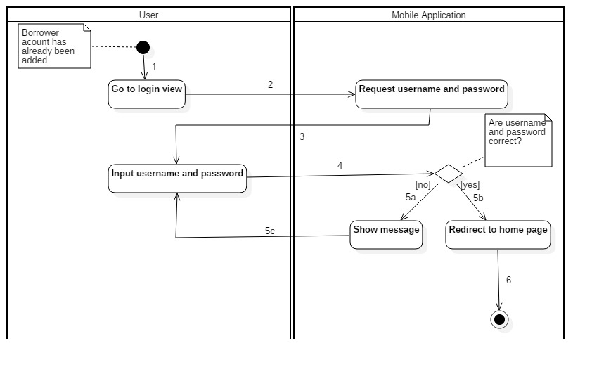

Figure : Activity Diagram - <Unauthorized User> Login

|  |  |  |
| --- | --- | --- |
| 1. Start | 2. Go to Login view | 3. Request username and password |
| 4. Input username and password | 5a. Correct username and password | 5b. Incorrect username and password |
| 5c. Input username and password again | 6. Redirect to home page and finish |  |

Table : <Unauthorized User> Login

##### Borrower

###### <Borrower> Check in with NFC

Summary: This diagram shows the process of borrower checking in the library by their smart phone with NFC turned on.

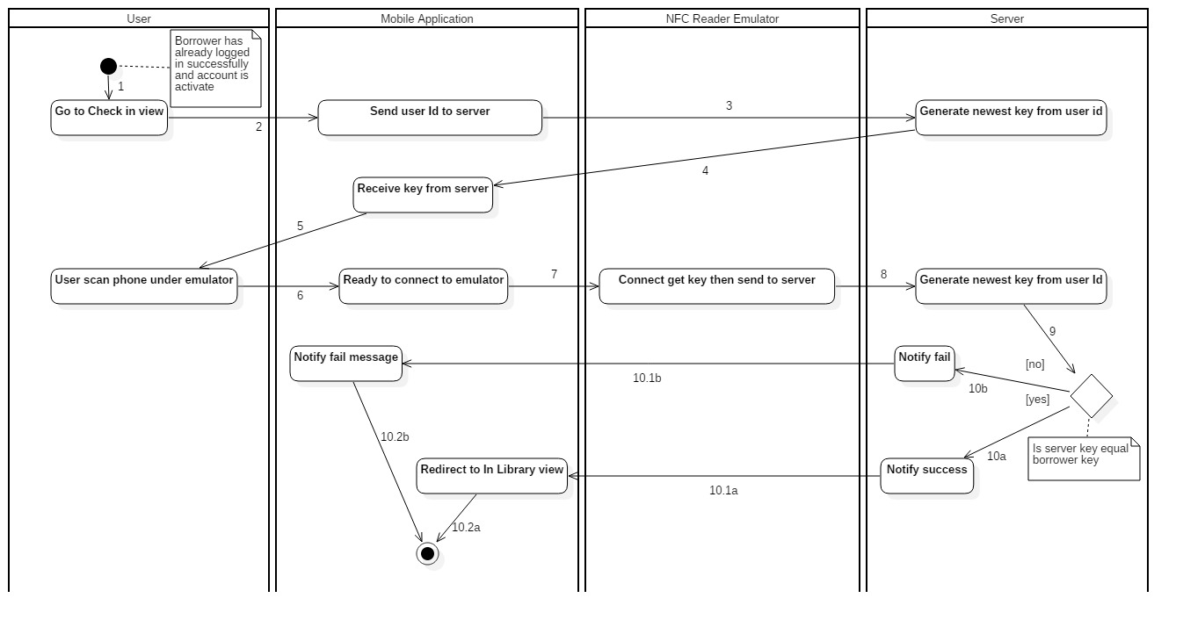

Figure : Activity Diagram - <Borrower> Check in with NFC

|  |  |  |
| --- | --- | --- |
| 1. Start. | 2. Go to Check in view. | 3. Send user Id to server. |
| 4. Generate newest key from user id. | 5. Receive key from server. | 6. User scan phone under emulator. |
| 7. Borrower phone is ready to connect to emulator. | 8. Emulator connect, get key then send to server. | 9. Generate newest key from user Id. |
| 10b. Key from user and server are not equal. | 10.1b. Notify check in fail to borrower. | 10a. Key from user and server are equal. |
| 10.1a. Borrower phone redirect to In Library view. |  |  |

Table : <Borrower> Check in with NFC

###### <Borrower> Check in with QR Code

Summary: This diagram shows the process of borrower checking in the library by QR Code.

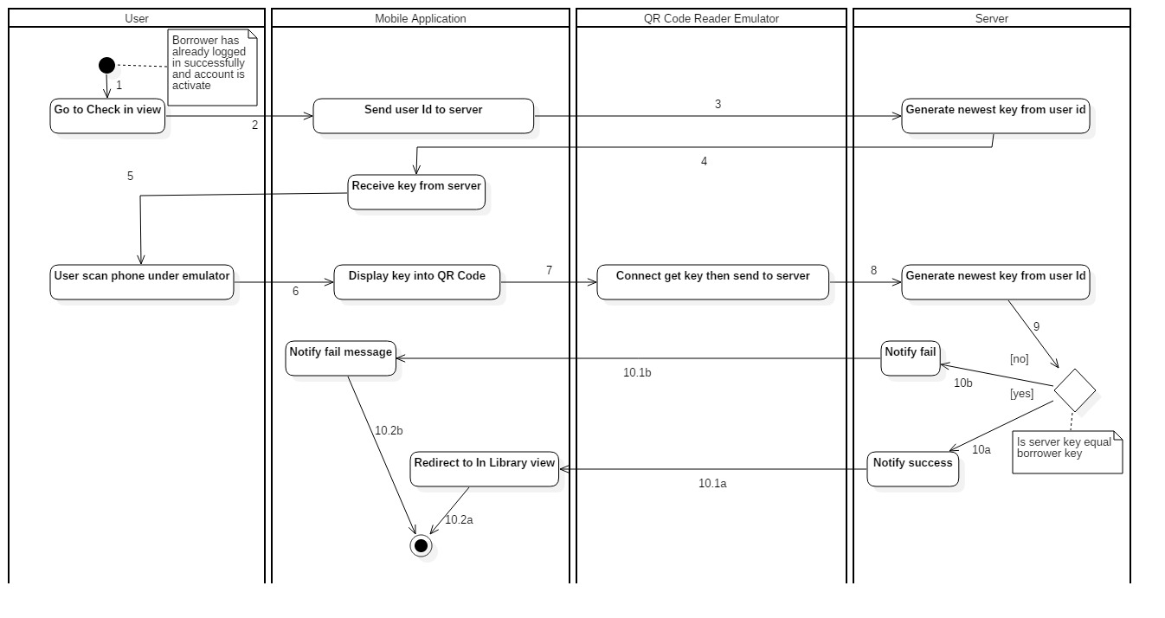

Figure : Activity Diagram - <Borrower> Check in with QR Code

|  |  |  |
| --- | --- | --- |
| 1. Start. | 2. Go to Check in view. | 3. Send user Id to server. |
| 4. Generate newest key from user id. | 5. Receive key from server. | 6. User scan phone under emulator. |
| 7. Borrower phone display key into QR Code. | 8. Emulator connect, get key then send to server. | 9. Generate newest key from user Id. |
| 10b. Key from user and server are not equal. | 10.1b. Notify check in fail to borrower. | 10a. Key from user and server are equal. |
| 10.1a. Borrower phone redirect to In Library view. |  |  |

Table : <Borrower> Check in with QR Code

#### Web Application

##### Librarian Borrow Copies for Borrower

Summary: The diagrams show the process of librarian helping borrower to borrow book copies.

###### <Librarian> Init borrow book copy

Summary: This diagram shows the process of librarian initiating the borrow book copy procedure.

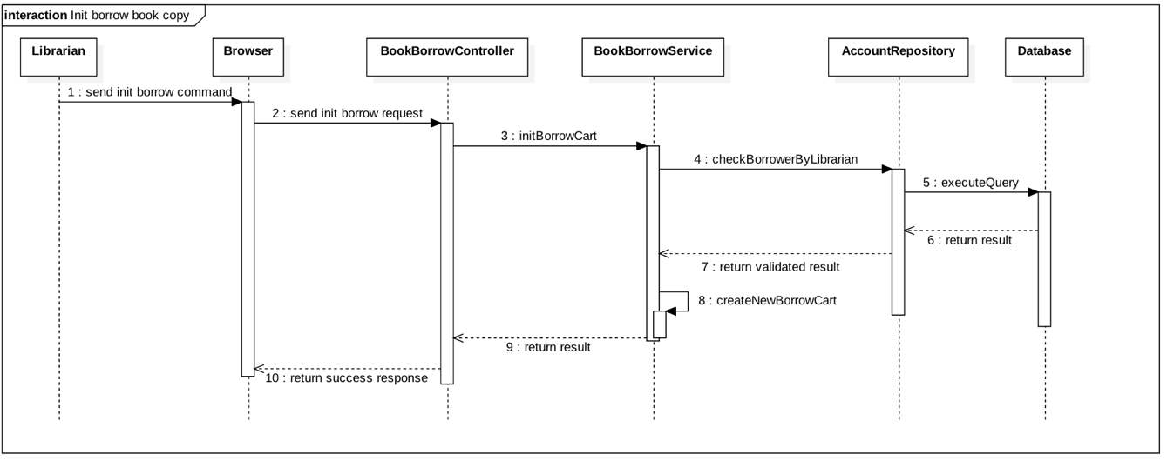

Figure : <Librarian> Init borrow book copy

###### <Librarian> Scan borrow copy

Summary: This diagram shows the process of librarian scanning borrow book copies for borrower.

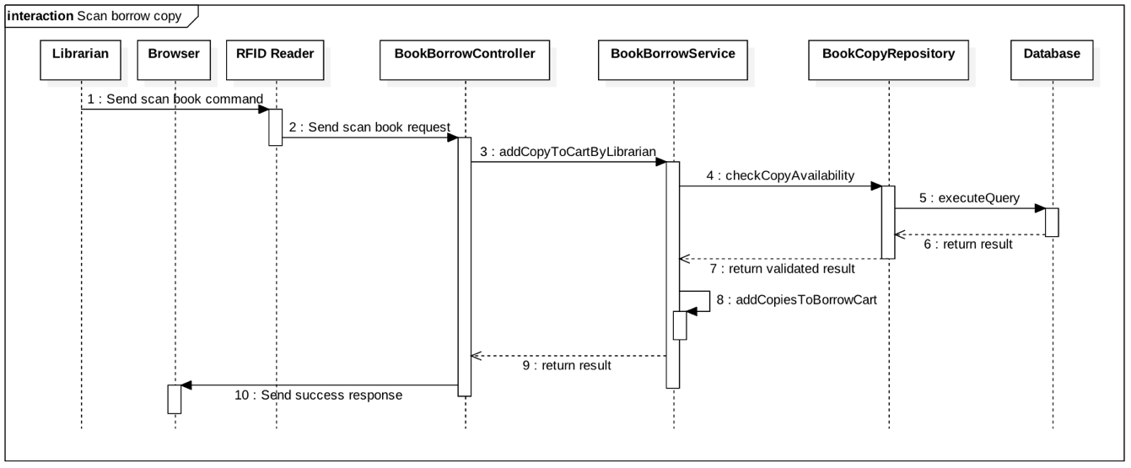Figure : <Librarian> Scan borrow copy

###### <Librarian> Submit borrow copy

Summary: This diagram shows the process of librarian submitting the borrow copies for borrower.

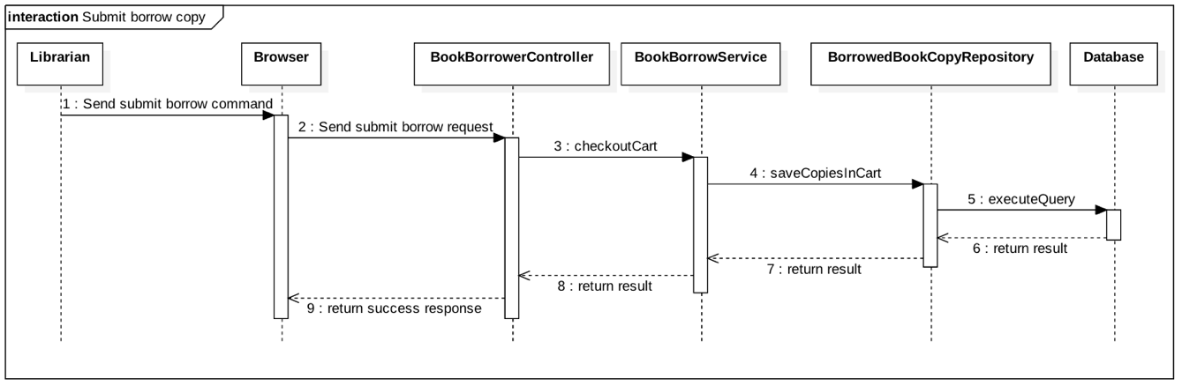Figure : <Librarian> Submit borrow copy

##### Librarian Borrow Copies for Borrower

Summary: The diagrams show the process of librarian returning book copies from borrower to the library.

###### *<Librarian> Scan return copy*

Summary: This diagram shows the process of librarian scanning return book copies from borrower.

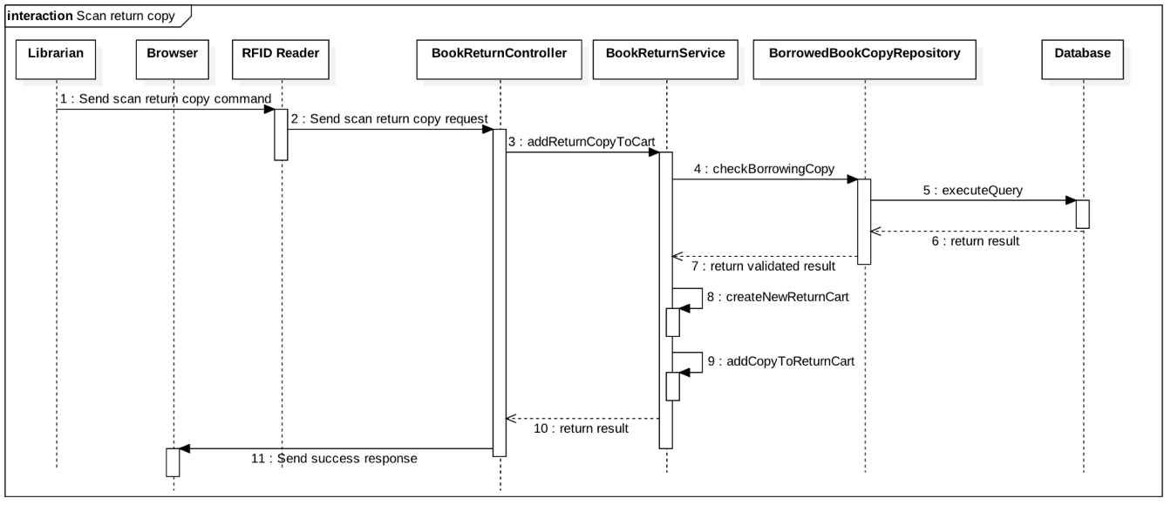Figure : <Librarian> Scan return copy

###### *<Librarian> Submit return copy*

Summary: This diagram shows the process of librarian submitting the return copies from borrower.

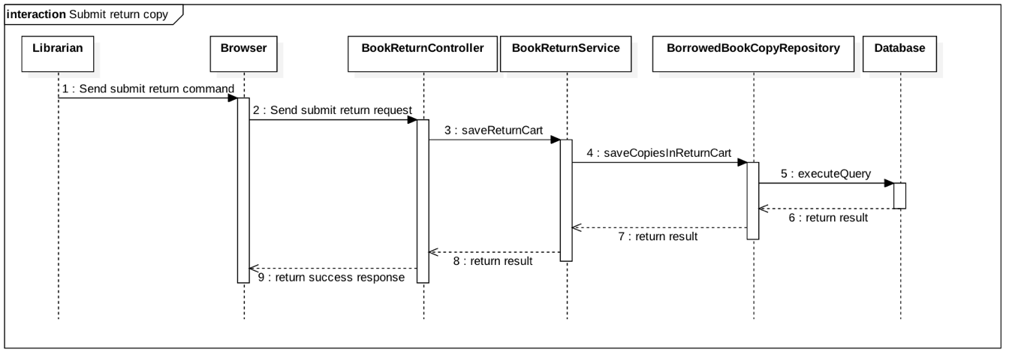Figure : <Librarian> Submit return copy

## Interface

### Component interface

#### Modula of Book Borrow API

|  |  |  |  |  |  |
| --- | --- | --- | --- | --- | --- |
| **Signature** | **Description** | **Input** | **Output** | **Output Format** | **Exception** |
| /init/borrow | Automated handler initiates book borrowing process for a borrower by giving him/her a borrow cart | BorrowerDto object contains IBeaconId and userId | RestServiceModel contains success or fail status and message | Json | JsonProcessingException |
| /librarian/init/borrow | Librarian initiates book borrowing process for a borrower by giving him/her a borrow cart | BorrowerDto object contains librarianId and userId | RestServiceModel contains success or fail status and message | Json | JsonProcessingException |
| /add/copy | Add a borrower’s borrow book copy to his/her borrow cart | RfidDto object contains iBeaconId and a book copy’s rfid | RestServiceModel contains rfids of successfully added book copies | Json | JsonProcessingException |
| /librarian/add/copy | Add a borrower’s borrow book copy to his/her borrow cart by librarian | RfidDto object contains librarianId and a book copy’s rfid | RestServiceModel contains rfids of successfully added book copies | Json | JsonProcessingException |
| /checkout | Automatic handler saves a borrower’s scanned book copies, and checkout the library for him/her | BorrowerDto object contains IBeaconId and userId | RestServiceModel contains list of detail of the borrower’s borrowed book copies | Json | JsonProcessingException |
| /librarian/checkout | Librarian saves a borrower’s scanned book copies, and checkout the library for him/her | BorrowerDto object contains librarianId and userId | RestServiceModel contains list of detail of the borrower’s borrowed book copies | Json | JsonProcessingException |
| /librarian/cancel | Librarian cancels the book borrowing process of a borrower | BorrowerDto object contains librarianId and userId | RestServiceModel contains list of rfids of canceled book copies | Json | JsonProcessingException |
| /getBorrowedBooks | Get all borrowed book copies of a borrower | AccountDto object contains userId | RestServiceModel contains list of detail of the borrower’s borrowed book copies | Json | JsonProcessingException |
| /delete/copy | Delete a borrowing book copy of a borrower | BorrowedBookCopyDto object contains userId and the book copy’s rfid | RestServiceModel contains list of detail of the borrower’s remaining borrowed book copies | Json | JsonProcessingException |
| /renew/:rfid | Renew the borrow time of a book copy | Rfid of the book copy | RestServiceModel contains detail of the renewed book copy | Json | JsonProcessingException |
| Table : Book Borrow API | | | | | |

#### Modula of Book Return API

|  |  |  |  |  |  |
| --- | --- | --- | --- | --- | --- |
| **Signature** | **Description** | **Input** | **Output** | **Output Format** | **Exception** |
| /librarian/add/return | Add a return book copy from borrower to return cart | RfidDto object contains librarianId and the book copy’s rfid | RestServiceModel object contains detail of the return book copy | Json | JsonProcessingException |
| /librarian/:librarianId/commit /return | Save return book copies in return cart to database | librarianId | RestServiceModel object contains list of detail of the returned book copies | Json | JsonProcessingException |
| /librarian/:librarianId/cancel /return | Cancel the current book return process | librarianId | RestServiceModel object contains cancel success/fail status and message | Json | JsonProcessingException |
| Table 66: Book Return API | | | | | |

#### Modula of Book API

|  |  |  |  |  |  |
| --- | --- | --- | --- | --- | --- |
| **Signature** | **Description** | **Input** | **Output** | **Output Format** | **Exception** |
| /books | Get all books in the library |  | RestServiceModel object contains list of books | Json | JsonProcessingException |
| /books/:id | Get detail of a book | bookId | RestServiceModel object contains detail of a book | Json | JsonProcessingException |
| /books/:id/borrowing\_copies | Get all borrowing copies of a book | bookId | RestServiceModel object contains list of borrowing copies of a book | Json | JsonProcessingException |
| /books/search | Search book | Params search\_term and user\_id | RestServiceModel object contains list of search result | Json | JsonProcessingException |
| Table 67: Book API | | | | | |

#### Modula of History API

|  |  |  |  |  |  |
| --- | --- | --- | --- | --- | --- |
| **Signature** | **Description** | **Input** | **Output** | **Output Format** | **Exception** |
| /history/borrowed\_books/:userId | Get list of all book copies that a borrower borrowed | userId | RestServiceModel object contains list of detail of borrowed book copies | Json | JsonProcessingException |
| Table 68: History API | | | | | |

#### Modula of User API

|  |  |  |  |  |  |
| --- | --- | --- | --- | --- | --- |
| **Signature** | **Description** | **Input** | **Output** | **Output Format** | **Exception** |
| /users | Get all accounts of the library |  | RestServiceModel object contains list of accounts | Json | JsonProcessingException |
| /borrowers | Get all borrower accounts of the library |  | RestServiceModel object contains list of borrower accounts | Json | JsonProcessingException |
| /users | Create a new account | UserDto object contain detail information of the new account | RestServiceModel object contains information of the newly created account | Json | JsonProcessingException |
| /user/login | Login an account. | AccountDto object contain userId and password | RestServiceModel object contains some information of the logged in account (not including password) | Json | JsonProcessingException |
| /staff/login | Login a librarian/admin account. | AccountDto object contain userId and password | RestServiceModel object contains some information of the logged in account (not including password) | Json | JsonProcessingException |
| /users/search | Search account in the library | Param term | RestServiceModel object contains list of search result | Json | JsonProcessingException |
| /borrowers/search | Search borrowers in the library | Param term | RestServiceModel object contains list of search result | Json | JsonProcessingException |
| /users/:id | Get detail information of an account | userId | RestServiceModel object contains detail of an account | Json | JsonProcessingException |
| /users/:id/status | Get status of an account: in library or not | userId | RestServiceModel object contains the account’s wanted status | Json | JsonProcessingException |
| /users/updateToken | Update an account’s Google token | Params userId and googleToken | void | Json | JsonProcessingException |
| /users/:id/requestKey | Generate a unique key of an account to use in checking in the library | userId | RestServiceModel object contains the wanted requestKey string | Json | JsonProcessingException |
| /users/:id/checkin | Checkin an account | userId,  and param key (the account’s unique key) | RestServiceModel object contains checkin successful result (true/false) | Json | JsonProcessingException |
| /getSystemDate | Get the current date of the system |  | RestServiceModel object contains the string date | Json | JsonProcessingException |
| Table 69: User API | | | | | |

#### Modula of WishBook API

|  |  |  |  |  |  |
| --- | --- | --- | --- | --- | --- |
| **Signature** | **Description** | **Input** | **Output** | **Output Format** | **Exception** |
| /wishlist/add | Add a book to an account’s wishlist | Params user\_id and book\_id | RestServiceModel object contains the added book | Json | JsonProcessingException |
| /wishlist/remove | Remove a book from an account’s wishlist | Params user\_id and book\_id | RestServiceModel object contains the removed book | Json | JsonProcessingException |
| Table 70: WishBook API | | | | | |

### User Interface Design

#### Mobile Application Design

##### Unauthorized User

###### <Unauthorized User> Login

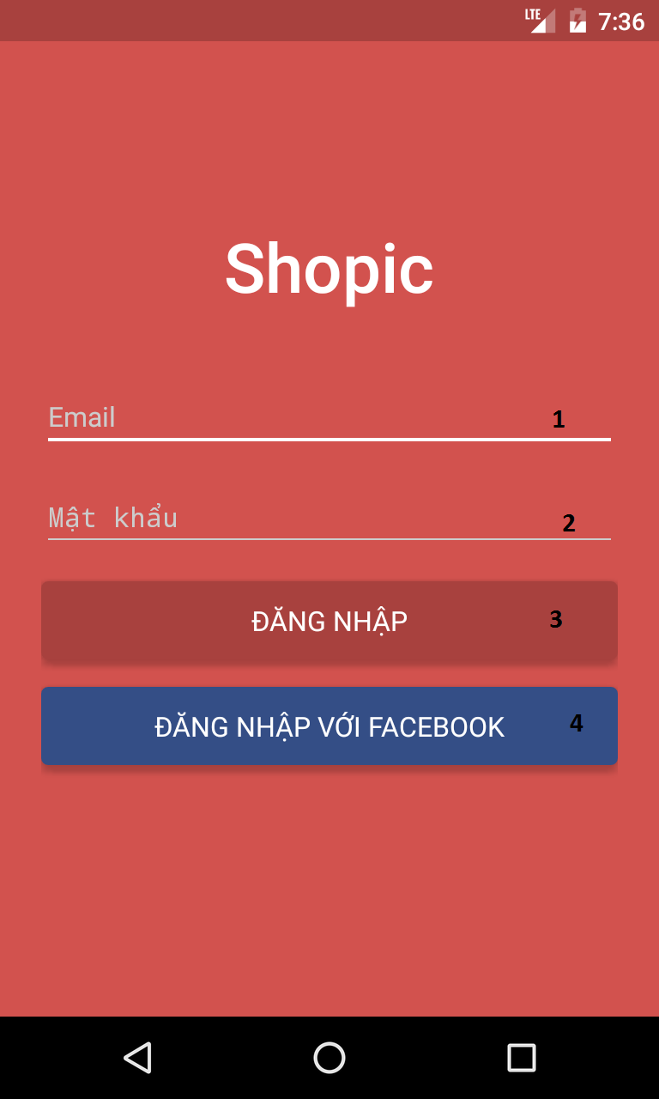

Figure 48: Mobile application UI - <Unauthorized User> Login

**Fields**

|  |  |  |  |  |  |  |  |
| --- | --- | --- | --- | --- | --- | --- | --- |
| **No** | **Field name** | **Description** | **Read only** | **Mandatory** | **Control type** | **Data type** | **Length** |
| 1 | Email | Fill in Email | No | Yes | Textbox | String | N/A |
| 2 | Mật Khẩu | Fill in password | No | Yes | Password | String | N/A |
|  | | | | | |  |  |

**Buttons/Hyperlinks**

|  |  |  |  |  |
| --- | --- | --- | --- | --- |
| **No** | **Function** | **Description** | **Validation** | **Outcome** |
| 3 | Đăng nhập | Log-in to the system | Email and Mật khẩu không được trống | Transfer to specific page with specific account |
| 4 | Đăng nhập với Facebook | Log-in to the system via Facebook account | N/A | Redirect user to Facebook login page. |

##### Authorized User

###### <Authorized User> Home Page

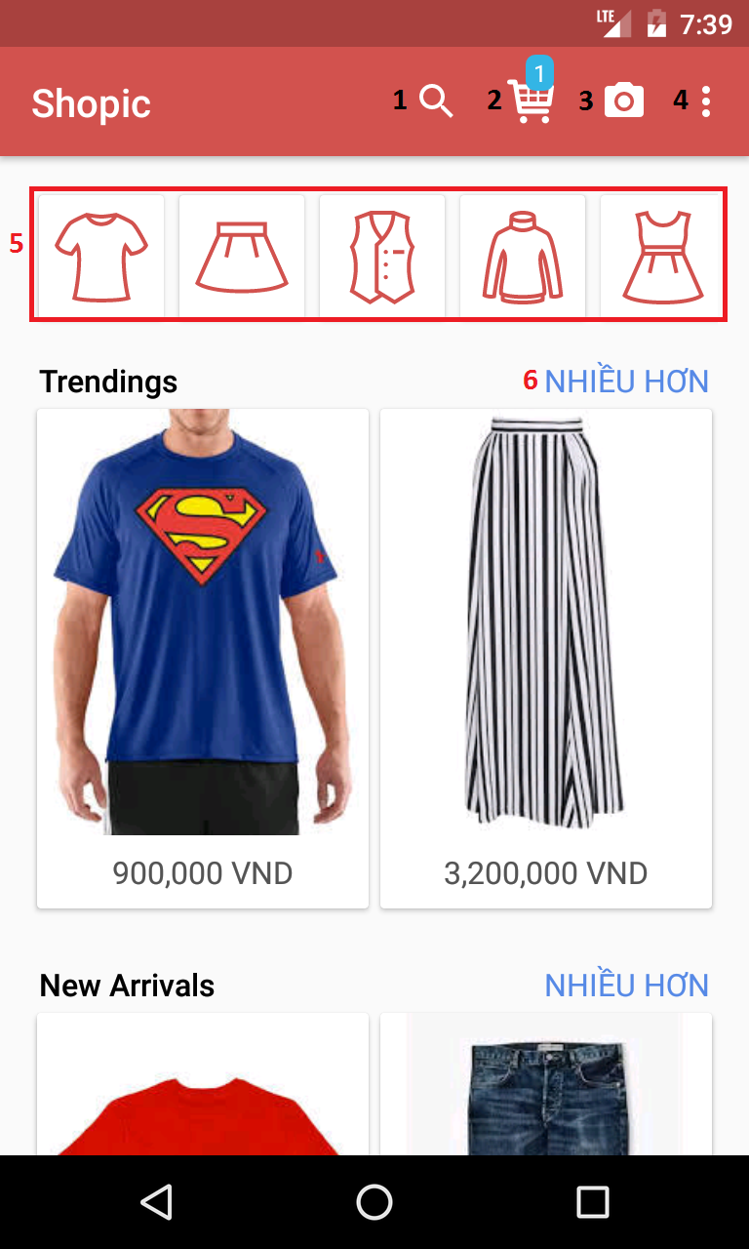

Figure 49: Mobile application UI - <Authorized User> Home Page

**Buttons/Hyperlink**

|  |  |  |  |  |
| --- | --- | --- | --- | --- |
| **No** | **Function** | **Description** | **Validation** | **Outcome** |
| **1** | Search | Search for product | N/A | Display search bar |
| **2** | Cart | View cart | N/A | Transfer to view cart page |
| **3** | Camera | Open camera to capture image | N/A | Open device camera |
| **4** | More options | Display more options | N/A | Drop down list with following options:   * Đăng xuất * Lịch sử thanh toán |
| **5** | Category | Types of clothes | N/A | Display list of products based on specific category in grid view |
| **6** | NHIỀU HƠN | Display more similar products. | N/A | Display list of similar products in grid view |

###### <Authorized User> Taking Picture

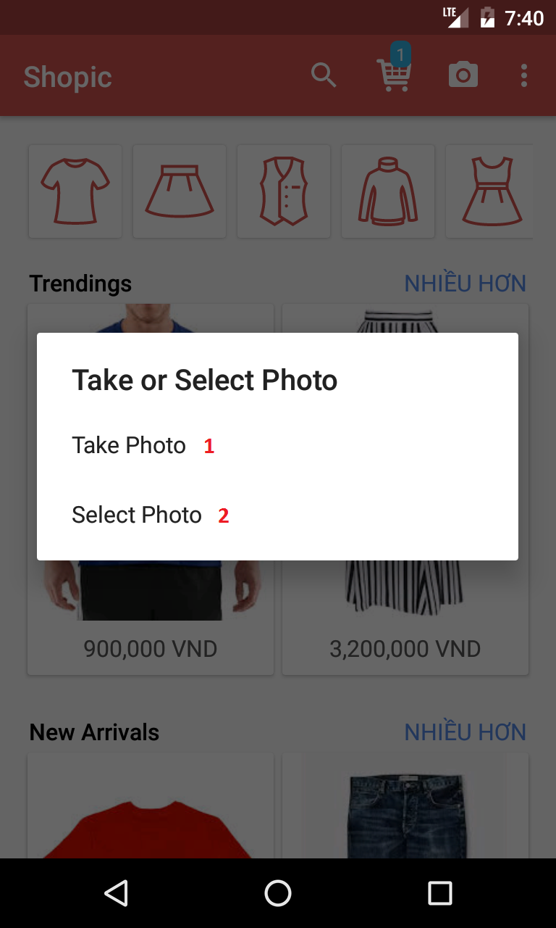

Figure 50: Mobile application UI - <Authorized User> Taking Picture

**Buttons/Hyperlinks**

|  |  |  |  |  |
| --- | --- | --- | --- | --- |
| **No** | **Function** | **Description** | **Validation** | **Outcome** |
| **1** | Take Photo | Take new pictures using device camera | N/A | Open device camera |
| **2** | Select Photo | Select photos in device | N/A | Open photo album |

###### <Authorized User> Crop photo

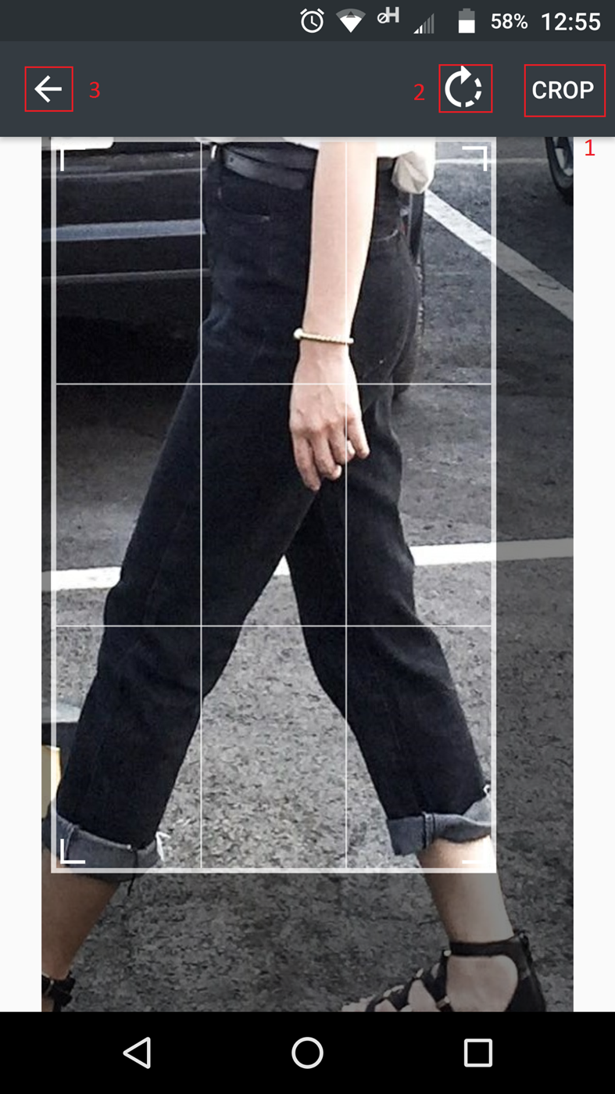

Figure 51: Mobile application UI - <Authorized User> Crop photo

**Buttons/Hyperlinks**

|  |  |  |  |  |
| --- | --- | --- | --- | --- |
| **No** | **Function** | **Description** | **Validation** | **Outcome** |
| **1** | Crop | Crop the photo | N/A | Transfer to select category view |
| **2** | Rotate | Rotate photo | N/A | Photo is rotated clockwise |
| **3** | Back | Return to previous step | N/A | Return to device camera or album |

###### <Authorized User> Choose category

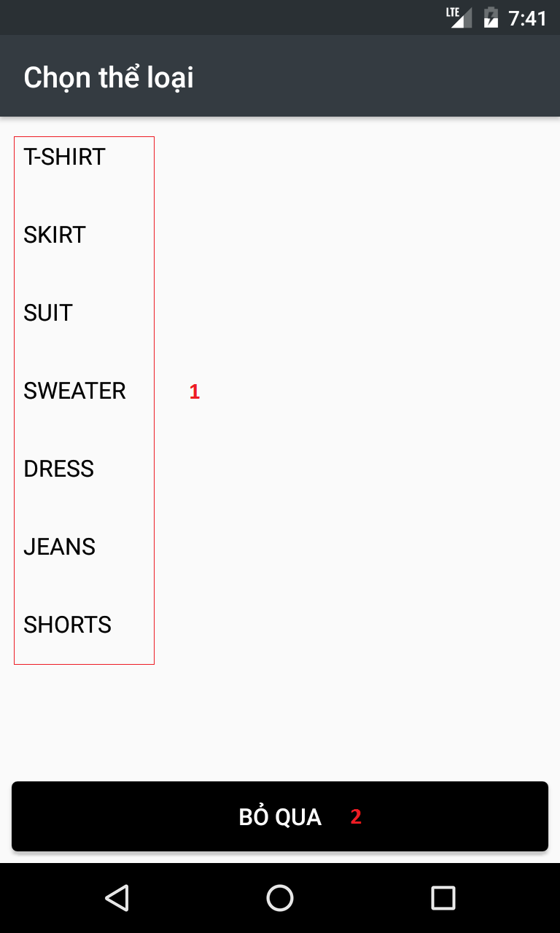

Figure 52: Mobile application UI - <Authorized User> Choose category

**Buttons/Hyperlinks**

|  |  |  |  |  |
| --- | --- | --- | --- | --- |
| **No** | **Function** | **Description** | **Validation** | **Outcome** |
| **1** | Category | Select product based on category | N/A | Display products result based on selected category |
| **2** | BỎ QUA | Skip to result view | N/A | Display products result based on image recognition service. |

###### <Authorized User> View search result

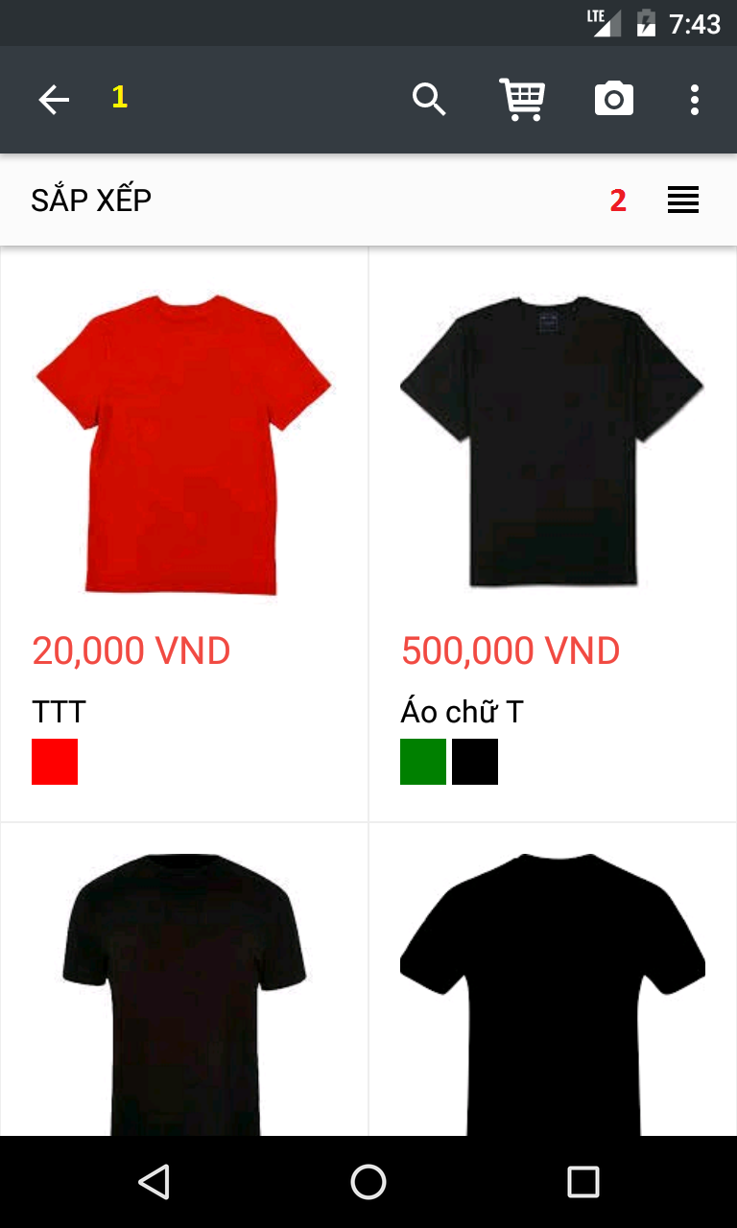

Figure 53: Mobile application UI - <Authorized User> View search result

**Buttons/Hyperlinks**

|  |  |  |  |  |
| --- | --- | --- | --- | --- |
| **No** | **Function** | **Description** | **Validation** | **Outcome** |
| **1** | Back | Return to previous step | N/A | Return to select category view |
| **2** | Filter | Filter product based on user choice | N/A | Filter products with the following options:   * Trending * Newest * Price |

###### <Authorized User> View Product detail

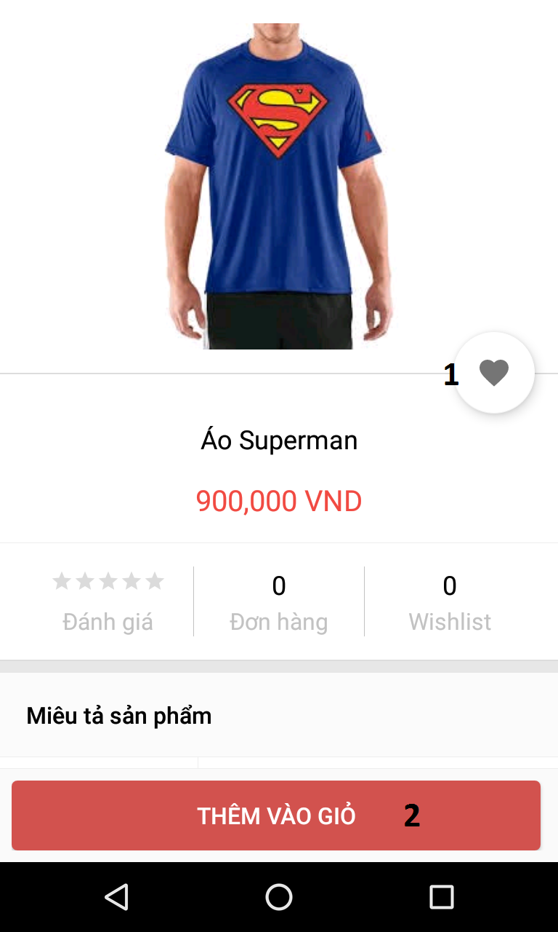

Figure 54: Mobile application UI - <Authorized User> View Product detail

**Buttons/Hyperlinks**

|  |  |  |  |  |
| --- | --- | --- | --- | --- |
| **No** | **Function** | **Description** | **Validation** | **Outcome** |
| **1** | Add to Wishlist | Add selected product to Wishlist | N/A | Wishlist icon will be highlighted |
| **2** | Thêm vào giỏ | Add selected product to cart | N/A | Go to choose option view |

###### <Authorized User> Choose Product option

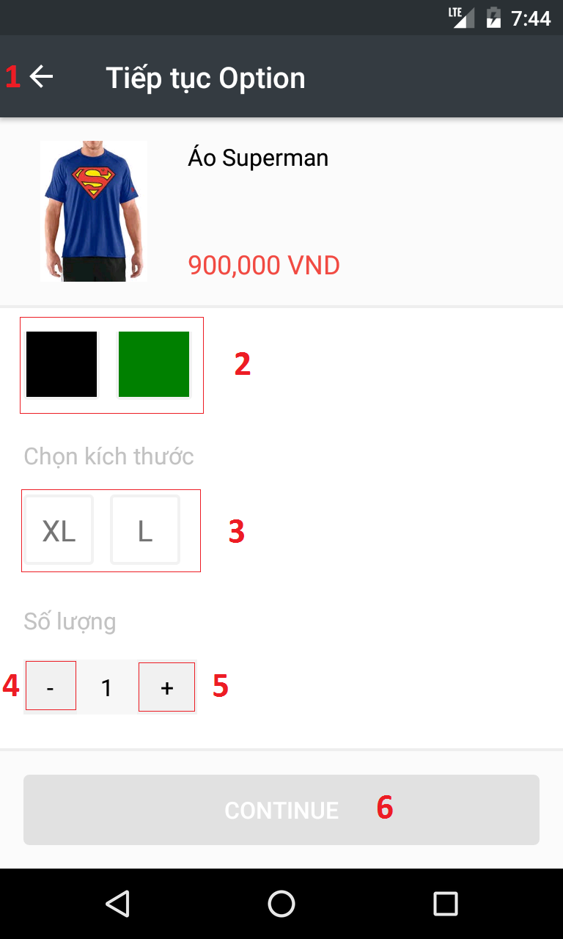

Figure 55: Mobile application UI - <Authorized User> Choose Product option

**Buttons/Hyperlinks**

|  |  |  |  |  |
| --- | --- | --- | --- | --- |
| **No** | **Function** | **Description** | **Validation** | **Outcome** |
| **1** | Back | Return to previous step | N/A | Return to product detail view |
| **2** | Choose color | Choose color based on user choice | N/A | Highlight selected color |
| **3** | Choose size | Choose size based on user choice | N/A | Highlight selected size |
| **4** | Reduce quantity | Reduce product quantity | N/A | Decrease quantity number by 1 |
| **5** | Increase quantity | Increase product quantity | N/A | Increase quantity number by 1 |
| **6** | Continue | Proceed to next step | Color and size must be chosen | Go to cart view |

###### <Authorized User> Cart detail

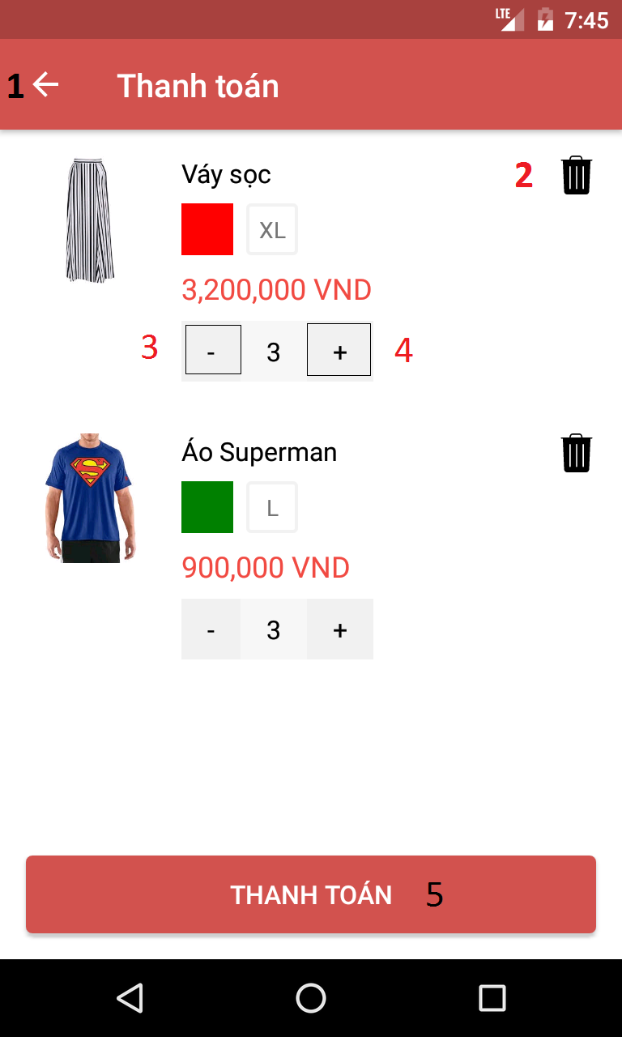

Figure 56: Mobile application UI - <Authorized User> Cart detail

**Buttons/Hyperlinks**

|  |  |  |  |  |
| --- | --- | --- | --- | --- |
| **No** | **Function** | **Description** | **Validation** | **Outcome** |
| **1** | Back | Return to previous step | N/A | Return to select option view |
| **2** | Remove from cart | Remove specific product | N/A | Selected product will be removed from cart detail |
| **3** | Reduce quantity | Reduce product quantity | N/A | Decrease quantity number by 1 |
| **4** | Increase quantity | Increase product quantity | N/A | Increase quantity number by 1 |
| **5** | THANH TOÁN | Checkout order | N/A | Go to payment view |

###### <Authorized User> Check out

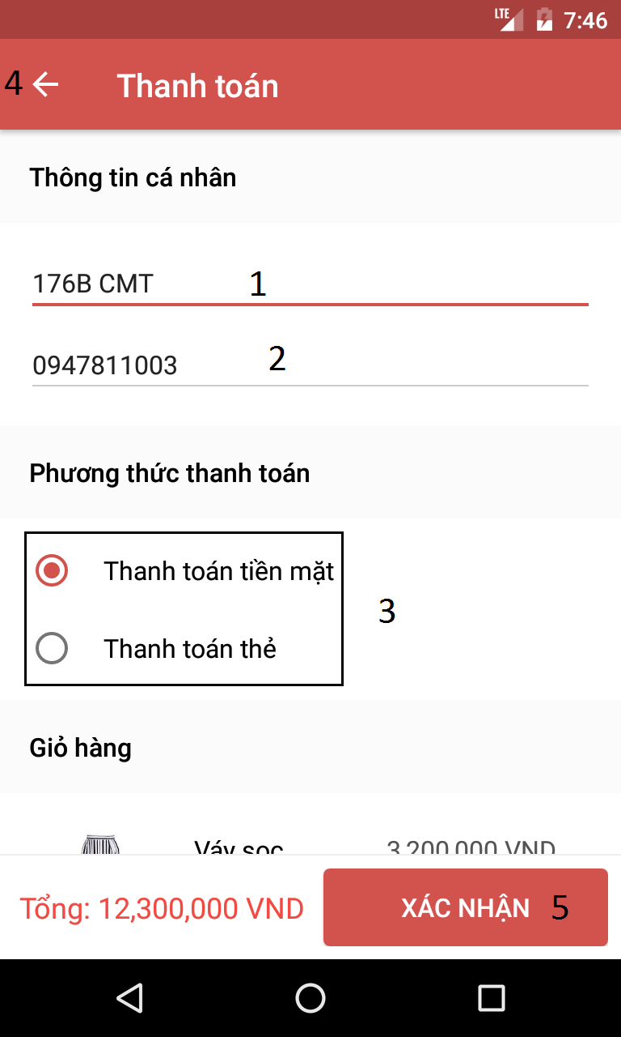

Figure 57: Mobile application UI - <Authorized User> Check out

**Fields**

|  |  |  |  |  |  |  |  |
| --- | --- | --- | --- | --- | --- | --- | --- |
| **No** | **Field Name** | **Description** | **Read Only** | **Mandatory** | **Control Type** | **Data Type** | **Length** |
| **1** | Địa chỉ | Fill in address | No | Yes | Text box | String | N/A |
| **2** | Số điện thoại | Fill in phone number | No | Yes | Text box | String | N/A |
| **3** | Phương thức thanh toán | Select payment method | No | Yes | Radio button | String | N/A |

**Buttons/Hyperlinks**

|  |  |  |  |  |
| --- | --- | --- | --- | --- |
| **No** | **Function** | **Description** | **Validation** | **Outcome** |
| **4** | Back | Return to previous step | N/A | Return to cart detail view |
| **5** | Xác nhận | Confirm checkout | N/A | Finish check out process and return to home page |

#### Web Application Design

##### Admin

###### <Admin> Manage Accounts

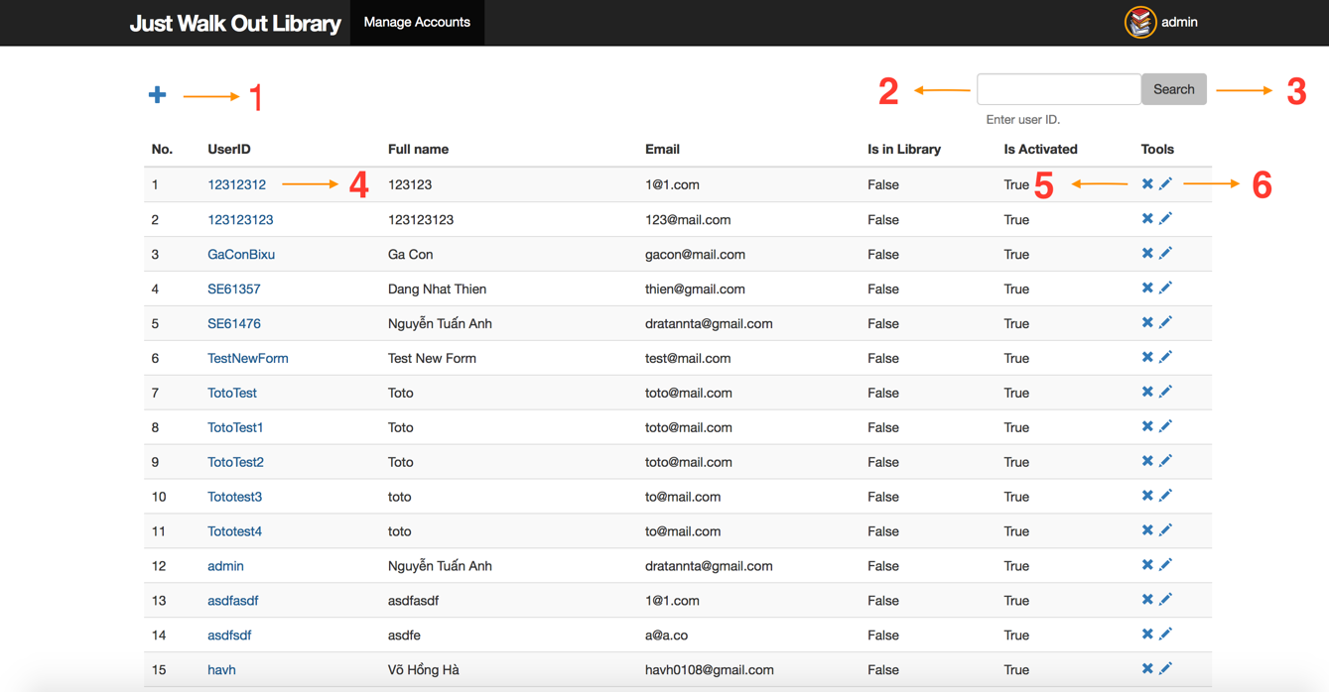

Figure 57: Web application UI - <Admin> Manage Accounts

**Fields**

|  |  |  |  |  |  |  |  |
| --- | --- | --- | --- | --- | --- | --- | --- |
| **No** | **Field Name** | **Description** | **Read Only** | **Mandatory** | **Control Type** | **Data Type** | **Length** |
| **2** | Search Input | Take search term as user ID | No | Yes | Textbox | String | N/A |

Table : Web application UI - <Admin> Manage Accounts Fields

**Buttons/Hyperlinks**

|  |  |  |  |  |
| --- | --- | --- | --- | --- |
| **No** | **Function** | **Description** | **Validation** | **Outcome** |
| **1** | showNewAccountView | Go to create new account view | N/A | Redirect to create new account view |
| **3** | searchAccounts | Search accounts by search term | N/A | Call search accounts api |
| **4** | showAccountDetailView | Go to account detail view | N/A | Redirect to account detail view |
| **5** | deleteAccount | Delete chosen account | N/A | Call delete account api |
| **6** | showEditAccountView | Go to edit account view | N/A | Redirect to edit account view |

Table : Web application UI - <Admin> Manage Accounts Buttons/links

###### <Admin> Create New Account

**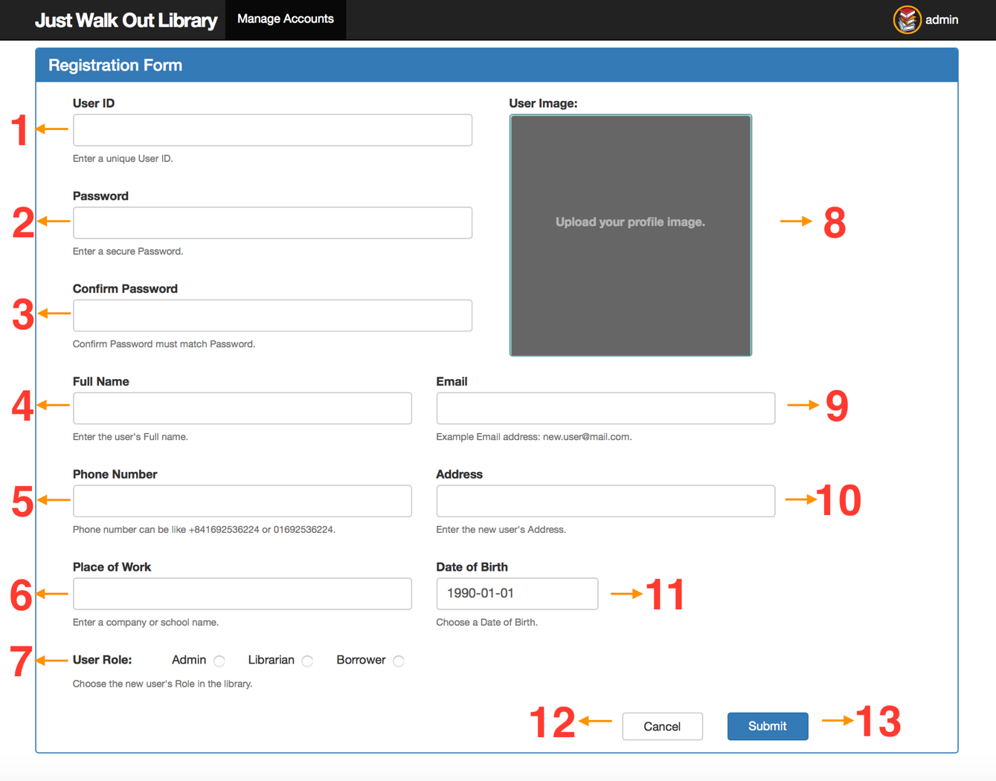**

Figure 58: Web application UI - <Admin> Create New Account

**Fields**

|  |  |  |  |  |  |  |  |
| --- | --- | --- | --- | --- | --- | --- | --- |
| **No** | **Field Name** | **Description** | **Read Only** | **Mandatory** | **Control Type** | **Data Type** | **Length** |
| **1** | User ID input | Fill in the unique user ID of the new account | No | Yes | Textbox | String | N/A |
| **2** | Password input | Fill in the password of the new account | No | Yes | Textbox | String | N/A |
| **3** | Confirm password input | Fill in the confirm password | No | Yes | Textbox | String | N/A |
| **4** | Full name input | Fill in the full name of the new account | No | Yes | Textbox | String | N/A |
| **5** | Phone number input | Fill in the phone number of the new account | No | Yes | Textbox | String | N/A |
| **6** | Place of work input | Fill in the work place of the new account | No | Yes | Textbox | String | N/A |
| **7** | Role input | Choose one of the available user roles for the new account | No | Yes | Radio button | String | N/A |
| **8** | User image input | Choose the profile image of the new account | No | Yes | Image input | String | N/A |
| **9** | Email input | Fill in the email of the new account | No | Yes | Textbox | String | N/A |
| **10** | Address input | Fill in the address of the new account | No | Yes | Textbox | String | N/A |
| **11** | Date of birth input | Fill in the date of birth of the new account | No | Yes | Date picker | String | N/A |

Table : Web application UI - <Admin> Create New Account Fields

**Buttons/Hyperlinks**

|  |  |  |  |  |
| --- | --- | --- | --- | --- |
| **No** | **Function** | **Description** | **Validation** | **Outcome** |
| **12** | cancelCreate | Discard changes and go back to the manage accounts page | N/A | Redirect to the manage accounts page |
| **13** | submitNewAccount | Save new account’s information to the system | Check for each input’s validation before saving information to the system | Create a new account and redirect to the manage accounts view |

Table : Web application UI - <Admin> Create New Account Buttons/links

###### <Admin> Get Account Detail

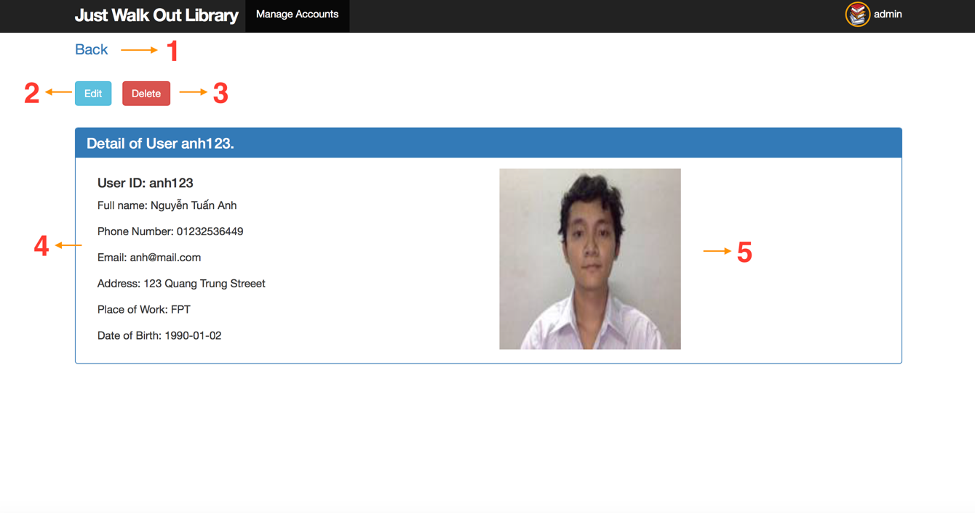

Figure 59: Web application UI - <Admin> Get Account Detail

**Fields**

|  |  |  |  |  |  |  |  |
| --- | --- | --- | --- | --- | --- | --- | --- |
| **No** | **Field Name** | **Description** | **Read Only** | **Mandatory** | **Control Type** | **Data Type** | **Length** |
| **4** | Account’s detail information | Show all the detail information of the account | Yes | Yes | Textbox | String | N/A |
| **4** | Account’s profile image | Show the account’s profile image | Yes | Yes | Image | String | N/A |

Table : Web application UI - <Admin> Get Account Detail Fields

**Buttons/Hyperlinks**

|  |  |  |  |  |
| --- | --- | --- | --- | --- |
| **No** | **Function** | **Description** | **Validation** | **Outcome** |
| **1** | back | Go back to the last visited link | N/A | Redirect to the last visited link |
| **2** | showEditAccountPage | Go to the edit account view | N/A | Redirect to the edit account view |
| **3** | deleteAccount | Delete current account | N/A | Delete the account and redirect to manage accounts view |

Table : Web application UI - <Admin> Get Account Detail Buttons/links

##### Librarian

###### <Librarian> Get Account Detail

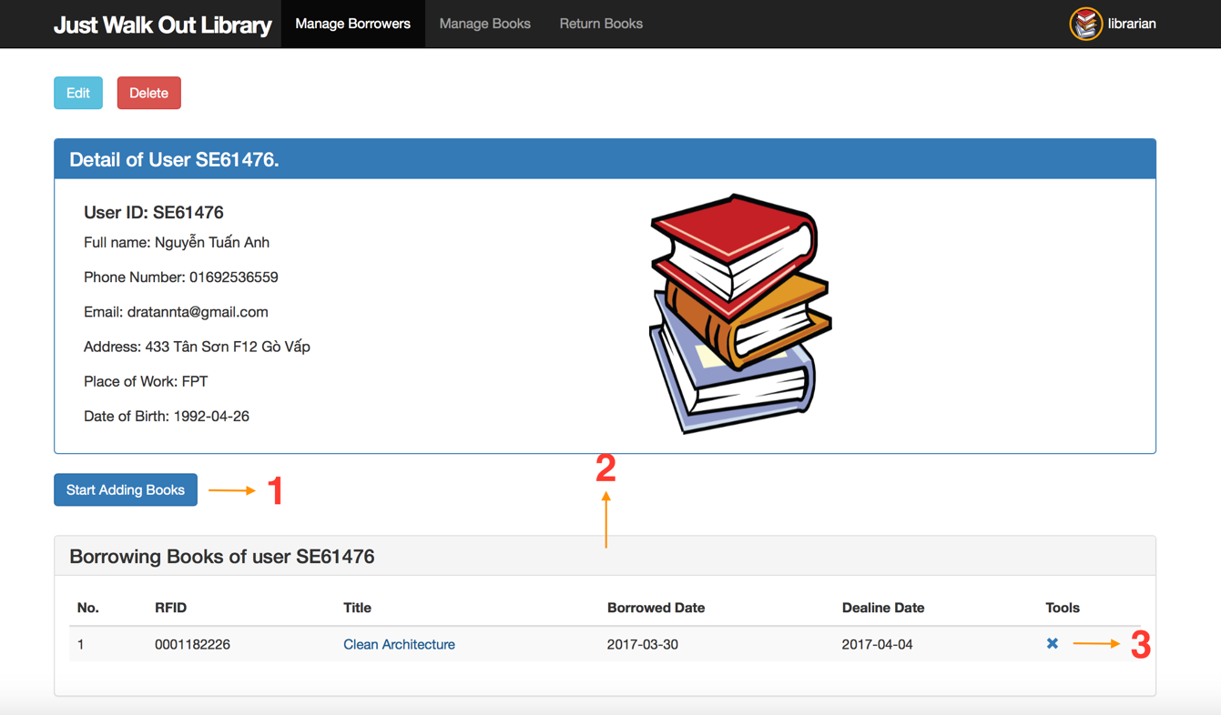

Figure 62: Web application UI - <Librarian> Get Account Detail

**Buttons/Hyperlinks**

|  |  |  |  |  |
| --- | --- | --- | --- | --- |
| **No** | **Function** | **Description** | **Validation** | **Outcome** |
| **1** | startBookBorrowProcess | Start book borrow process for the viewed account | N/A | Librarian can scan books for the viewed account. The book scanned will be updated in the borrowing books table Show the “Cancel” and “Stop Adding Books” button, and hide the current button |
| **3** | deleteBorrowingBook | Delete the borrowing book copy of the viewed account | N/A | Delete the borrowing book copy in the system, and update the table |

Table : Web application UI - <Librarian> Get Account Detail Fields

**Table**

|  |  |  |  |  |  |  |  |
| --- | --- | --- | --- | --- | --- | --- | --- |
| **No** | **Table Name** | **Description** | **Read Only** | **Mandatory** | **Control Type** | **Data Type** | **Length** |
| **2** | Borrowing books table | Show borrowing book copies for the viewed account | N/A | Yes | Table | N/A | N/A |

Table : Web application UI - <Librarian> Get Account Detail table

###### <Librarian> Borrow Book Copies

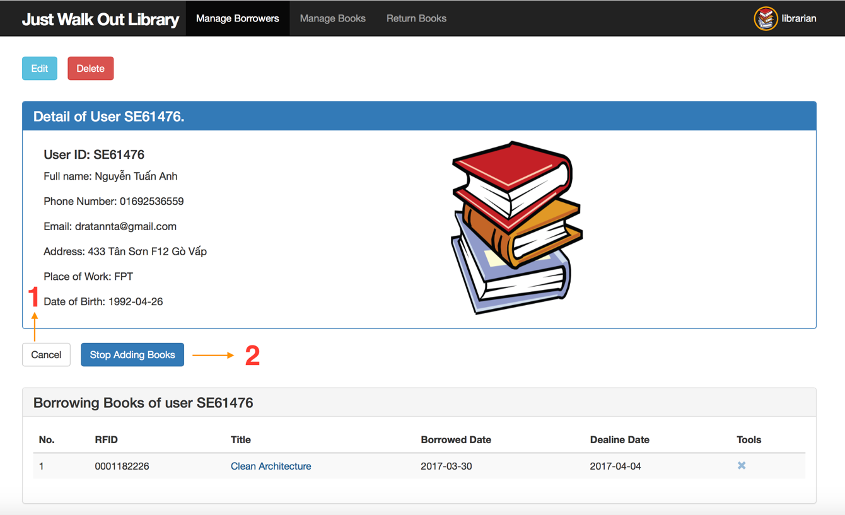

Figure 63: Web application UI - <Librarian> Borrow Book Copies

**Buttons/Hyperlinks**

|  |  |  |  |  |
| --- | --- | --- | --- | --- |
| **No** | **Function** | **Description** | **Validation** | **Outcome** |
| **1** | Cancel | Discard all changes | N/A | Refresh the borrowing books table to the before-scanned state Hide the “Cancel” and “Stop Adding Books” buttons, and show the “Start Adding Books” button |
| **3** | submitBorrowBookCopies | Submit all scanned book copies to the system | N/A | Save the scanned book copies to the system for the viewed account Hide the “Cancel” and “Stop Adding Books” buttons, and show the “Start Adding Books” button |

Table : Web application UI - <Librarian> Borrow Book Copies Buttons/links

###### <Librarian> Return Book Copies

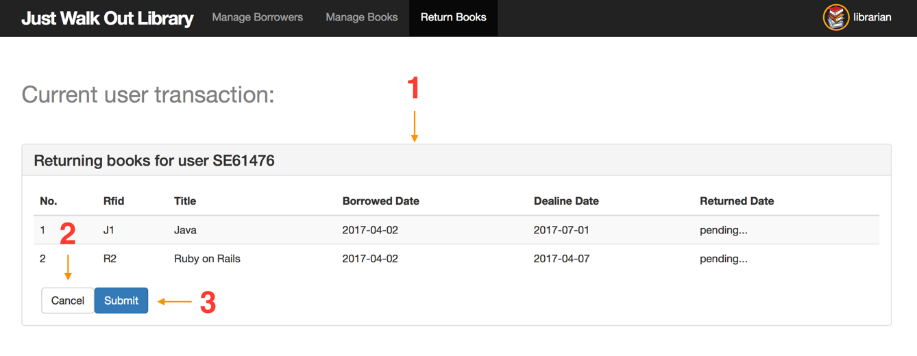

Figure 64: Web application UI - <Librarian> Return Book Copies

**Table**

|  |  |  |  |  |  |  |  |
| --- | --- | --- | --- | --- | --- | --- | --- |
| **No** | **Table Name** | **Description** | **Read Only** | **Mandatory** | **Control Type** | **Data Type** | **Length** |
| **1** | Returning books table | Show returning book copies information | N/A | Yes | Table | N/A | N/A |

Table : Web application UI - <Librarian> Return Book Copies table

**Buttons/Hyperlinks**

|  |  |  |  |  |
| --- | --- | --- | --- | --- |
| **No** | **Function** | **Description** | **Validation** | **Outcome** |
| **2** | Cancel | Discard all changes | N/A | Discard pending change to returning books table Hide the “Cancel” and “Submit” buttons |
| **3** | submitReturnBookCopies | Submit all scanned return book copies to the system | N/A | Save the scanned return book copies to the system Hide the “Cancel” and “Submit” buttons |

Table : Web application UI - <Librarian> Return Book Copies Buttons/links

#### RFID Reader GUI

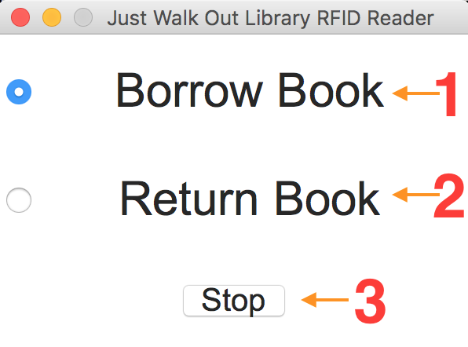

Figure 65: RFID Reader GUI

**Buttons/Hyperlinks**

|  |  |  |  |  |
| --- | --- | --- | --- | --- |
| **No** | **Function** | **Description** | **Validation** | **Outcome** |
| **1** | switchBorrowBookMode | Switch the RFID Reader to borrow books mode | N/A | Librarian can scan book copies for book borrowing process |
| **2** | switchReturnBookMode | Switch the RFID Reader to return books mode | N/A | Librarian can scan book copies for book returning process |
| **2** | stop | Stop the application | N/A | The application is closed |

Table : RFID Reader GUI Buttons/links

## Database Design

### Entity Relationship Diagram (ERD)

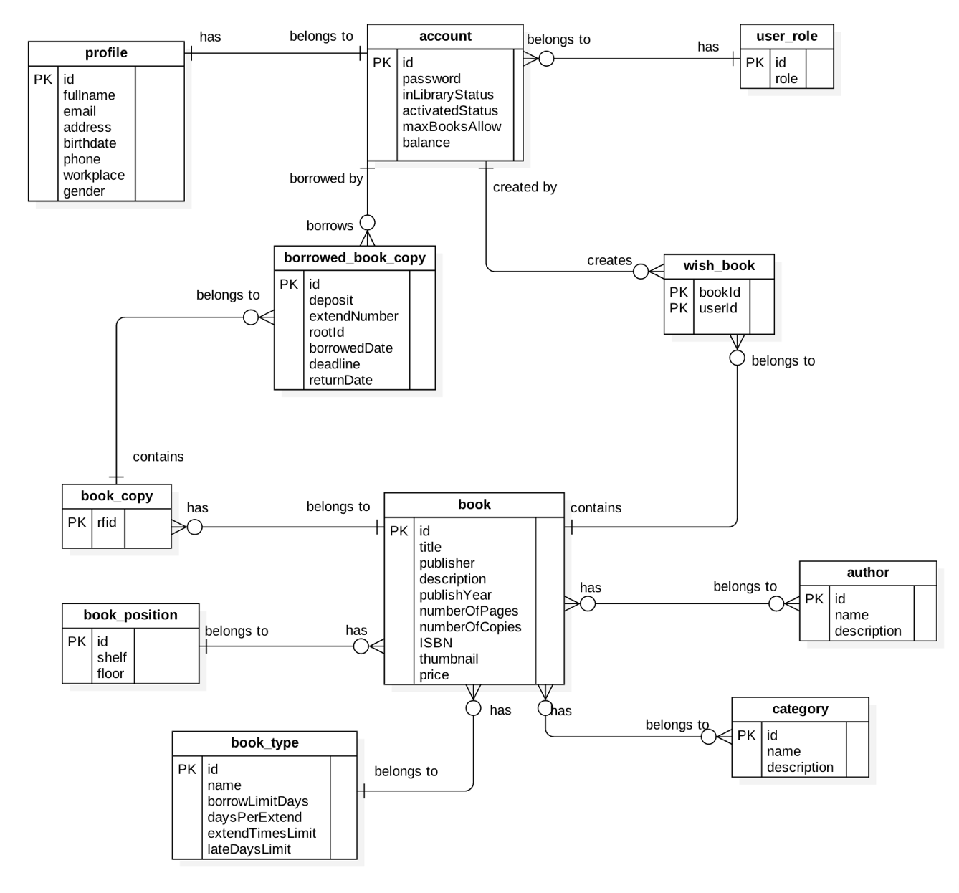

Figure 64: Entity Relationship Diagram (ERD)

### Data Dictionary

|  |  |
| --- | --- |
| **Entity Data Dictionary: describe contents of all entities** | |
| **Entity Name** | **Description** |
| Account | Contains frequently accessed information of all accounts in the system. |
| Profile | Contains information of detail profile of accounts in the system. |
| UserRole | Contains information of all role in the system. |
| WishBook | Contains a list of books that the accounts in the system put in their wishlist. |
| BorrowedBookCopies | Contains a list of borrowed book copies that the accounts in the system borrowed. |
| BookCopy | Contains information of all book copies of books in the system. |
| Book | Contains information of all books in the system. |
| BookPosition | Contains information of all book positions in the system. |
| BookType | Contains information of all book types in the system. |
| Category | Contains information of all book categories in the system. |
| Author | Contains information of all book authors in the system. |

Table : Data Dictionary

## Algorithms

### Check in Algorithms

#### Definition

Token authentication is a technique to prove that the borrower is who he/she claims to be. Requests which have the right token will be processed.

#### Define the problem

When the borrower use mobile application to check in. Mobile application sends some information to emulator for verification, we have to make sure that the information only valid in a specific time for checking in.

#### Solution

To solve this problem, we should follow these steps:

* Mobile application send a request for private key before checking – in.
* Server generate key base on user id and time then send to mobile application.
* When borrower check-in, emulator get user and key from mobile application.

Server generate key base on user id then compare with key sent from emulator, if it matchs current server token, request will be processed.

#### Image Recognizer Concepts

* **Concept:** is a definition that be attached to an image. It could be understood as tags of an image. A concept belongs to a model.
* **Non-Concept:** is a definition that be attached to an image. It tells that the image does not have this tag. This is useful to increase accuracy of Image Recognizer.
* **Model:** is a set of concepts (or tags), it could be customized to predict a given image. An output of a model is percent of each concept in that model. For example: a food model contains: pizza, noodle and hamburger can have an output like: 20% pizza, 10% noodle and 1% of hamburger.
* **Input:** is an image used to feed a model. It could be an url or a raw file

#### Solution

To make Image Recognizer to be useful we decided to create two custom models.

* **Category:** used to detect a category of an image. For example: detect if a cloth is t-shirt, skirt or dress
* **Concept:** used to detect the definition of design of a cloth. For example: detect if a cloth is stripe, plain, modern, classic or having superman

When creating a new product, staff will add images, concepts and non-concepts to make the system aware of the product. The training process includes:

* Step 1: Staff creates a new product with basic information includes: an image, name, price, description and category
* Step 2: Staff inputs multiple images that best describes the new product
* Step 3: Staff then inputs concepts that best describes the product. He or she also input non-concepts to tell that those concepts do not belong to this product
* Step 4: Staff then adds options to the product. For example, a cloth can have many color and variety of sizes
* Step 5: Staff publishes the product. The system then wraps all necessary data (images, concepts and non-concepts) and submits them to Image Recognizer System in a separate background thread. The system will start training process
* Step 6: After successful training the system then notify users about new product

#### Complexity

In total, the complexity of this algorithm based on the image recognizer. They do not publish summary algorithms or any descriptions. As the result, we spend time testing the algorithm complexity.

|  |  |
| --- | --- |
| **Network** | **Time (s)** |
| Wi-Fi (Download: 35.91M, Upload: 22.08M, Ping: 2ms) | 17.066 |
| 3G (Download: 24.44M, Upload: 2.55M, Ping: 20ms) | 18.882 |

#### Accuracy

* From testing result image recognition rate is more than 80%. The testing process:
* Step 1: train a product with multiple images
* Step 2: send those images one by one to the predict API
* Step 3: collect data and analyze
* From the result to optimize the training we process we should input at least 5 images. From the document adding more images we increase the accuracy of training process. We recommend input 10 images for each product

#### Flow chart



### Timsort Algorithms

#### Definition

- The algorithms used to sort a given array

#### Define the problem

- The system can sort the search result base on color difference. As the result, we need an algorithm to solve it

#### Complexity

- The complexity of the algorithm is 

#### References

- References: <https://en.wikipedia.org/wiki/Timsort>

### Color Distance Algorithms

#### Definition

- The algorithms used to determine the similarity of two colors

#### Define the problem

- The system can find the best color match the image. It can also sort the clothes based on color. This lead to the need of calculate a score between a detected color and a color of a cloth

#### Solution

- We will use CIEDE2000 algorithm for calculating the distance between two given colors

#### Complexity

- The algorithm has complexity 

#### References

- References: <https://en.wikipedia.org/wiki/Color_difference>

### Detect Best Color Algorithms

#### Definition

- The algorithms used to find the best color available in the system the match the color results from Image Recognizer

#### Define the problem

- Users would like to have search results sorted by color. As the result, we need an algorithm to find the best color in the system that match the input image

#### Solution

- Step 1: User input an image

- Step 2: System send image to Image Recognizer to detect colors

- Step 3: Sort the result from Image Recognizer and take only the first half of them. The formula is:

 

(n is the number of colors return by Image Recognizer, a is hex color of a color return from Image Recognizer, b is the percent of a from the input image, D is the max color difference, and c is a color in the system

- Step 4: System iterates through all colors available and calculates the score between them and finds the best result

#### Complexity

- Given N is number of colors return from Image Recognizer

- The sort algorithm takes 

- Calculate the score takes 

- Given M is number of colors in the system (M is less then 20)

🡪 The complexity of the algorithm is 

#### Comparing to other methods

<https://drive.google.com/open?id=0B67tFOgiGX6YUzNBaE01dXBsU2s>

#### Flow chart



### Search with Picture Algorithms

#### Definition

- The algorithms used to get products from the system that match the picture taken by users

#### Define the problem

- Users can search for products via pictures, so we need an algorithm that can make our system able to detect the pictures and return the best possible result. It can also detect pictures based on users’ choice of categories.

#### Solution

When searching for products, users can either select pictures from device or take a new one. The process includes:

* Step 1: Users input picture
* Step 2: System will scale and save picture
* Step 3: Users continue to select category from the list provided by the system (ex: Shirts, T-Shirt, Jeans or Shorts) or chooses to skip
* Step 4: System send image url to Image Recognizer
* Step 5: If Image Recognizer unable to detect the image (result concept and category must be >= 50%), system will write a log file to record it
* Step 6: Otherwise return data for user

#### Complexity

The complexity of this algorithm is depended on the image recognition service for which they do not provide any summary or description; therefore, we spend time testing the algorithm complexity.

|  |  |
| --- | --- |
| **Network** | **Time (s)** |
| Wi-Fi (Download: 35.91M, Upload: 22.08M, Ping: 2ms) | 4.039 |
| 3G (Download: 24.44M, Upload: 2.55M, Ping: 20ms) | 5.633 |

#### Accuracy

* From testing, result rate returned from Image Recognition service is more than 80%.
* Test result:
* Category: <https://drive.google.com/open?id=0B0EgBSrhB9kfUFA3RVVoSnoyRlU>
* Concept:

<https://drive.google.com/open?id=0B0EgBSrhB9kfSzNqMzBNMldILXM>

* The testing process:
* Step 1: Search for new products that do not already exist in the system
* Step 2: Start training for the new products
* Step 3: Search for those products again and collect data

#### Flow chart



### Suggest T-Shirt Size Algorithms

#### Definition

* The algorithms propose method to determine the T-shirt size suitable for a person.

#### Define the problem

* Some users do not know their correct T-shirt sizes so we need an algorithm to help users by suggesting the suitable sizes based on their gender, height and weight.

#### Solution

|  |  |  |  |
| --- | --- | --- | --- |
| **Female** | **Body figures** | **Male** | **Body figures** |
| **Size S** | 1m48 – 1m53  37kg – 41kg | **Size S** | 1m60 – 1m67  48kg – 53kg |
| **Size M** | 1m54 – 1m58  42kg – 46kg | **Size M** | 1m68 – 1m74  54kg – 60kg |
| **Size L** | 1m59 – 1m56  47kg – 52kg | **Size L** | > 1m75  61kg – 66kg |
| **Size XL** | 52kg – 56kg | **Size XL** | 67kg – 72kg |
| **Size XXL** | > 56kg | **Size XXL** | > 72kg |

References:

<http://shopbonny.mov.mn/bvct/s/4/cach-chon-size-ao-dua-vao-chieu-cao-can-nang-.html>

### Suggest Shirt Size Algorithms

#### Definition

* The algorithms propose method to determine the shirt size suitable for a person.

#### Define the problem

* Some users do not know their correct shirt sizes so we need an algorithm to help users by suggesting the suitable sizes based on the sizes of their neck and chest.

#### Solution

|  |  |  |
| --- | --- | --- |
| Neck size | Chest size | Clothe size (US) |
| 37 | 78 – 81 | S |
| 38 | 82 – 85 | S |
| 39 | 86 – 89 | M |
| 40 | 90 – 93 | M |
| 41 | 94 – 97 | L |
| 42 | 98 – 101 | L |
| 43 | 102 – 105 | XL |
| 44 | 105 – 108 | XL |

References:

<http://infonet.vn/cach-chon-size-ao-so-mi-nam-nu-phu-hop-chieu-cao-can-nang-post162780.info>

# Report No. 5 System Implementation & Test

## Introduction

### Overview

This section describes the approach and methodologies used by group to plan, organize and manage the testing of GBTS system. It provides in the detail all necessary information about the implementation and testing procedure of the system included test plans, test cases, test result, test environments, pass/fail criteria and risks estimations as well as a checklist to cover all possible cases.

### Test Approach

* Goal: Test all features in the whole GBTS system based on the core flow.
* Method: black-box testing
* Technique: check list

The testing for this project will consists of Integration System test level. Testing the program which was integrated and as a complete system to ensure that the software requirements have been met.

* Integration testing would be performed by all member of team and approved by team leader.

System testing is focused on assessing the system’s reliability. This process is concerned with finding errors that result from unanticipated interactions between components and component interface problems.

## Database Relationship Diagram

### Physical Diagram



### Data Dictionary

Figure 62: <Database Relation Diagram> Physical Diagram

|  |  |  |
| --- | --- | --- |
| Data dictionary: describe content of all tables | | |
| Table Name | **Mapping column with Conceptual diagram** | **Description** |
| User | User | Contain the user information. |
| Role | N/A | Contain the role information. |
| BusRoute | BusRoute | Contain the bus route information |
| Card | Card | Contain the card information |
| Credit Plan | Credit Plan | Contain the credit plan which is used to add credit to card in the system. |
| Offer Subscription | Subscription | Contain the offer subscription information. |
| Payment Transaction | Payment Transaction | Contain the payment transaction information. |
| Promotion | Promotion | Contain the promotion information. |
| ScratchCard | ScratchCard | Contain the scratch card information. |
| Ticket | Ticket | Contain the bought ticket information for a card on a bus route or via cash. |
| Ticket Type | Ticket Type | Contain the type of ticket information |
| Token | N/A | Contain the server token information for verifying ticket bought by phone. |
| UserSubscription | Subscription | Contain the subscription information of user who subscribe an offer. |

|  |  |  |  |  |
| --- | --- | --- | --- | --- |
| Table Name | Attributes | Description | Domain | Null |
| BusRoute | ID{PK} | Unique identifier of a bus route | Integer | No |
| Code | Unique code for each bus route | String | No |
| Name | Name of a bus route | String | No |
| Card | Id{PK} | Unique identifier of a card | Integer | No |
| UniqueIdentifier | Manufacturer ID of a card | String | No |
| CardName | Name of a card | String | Yes |
| RegistrationDate | Registration date of a card | Date Time | No |
| Balance | Balance of a card | Float | No |
| Status | Status of a card | String | No |
| UserId | Unique identifier of an user | Integer | Yes |
| DataVersion | Data version of a card | Big integer | Yes |
| CreditPlan | Id{PK} | Unique identifier of a credit plan | Integer | No |
| Name | Name of a credit plan | String | No |
| Price | Price of a credit plan | Integer | No |
| Status | Status of a credit plan | Integer | No |
| PaymentTransaction | Id{PK} | Unique identifier of a payment transaction | Integer | No |
| CardId | Unique identifier of a card | Integer | No |
| CreditPlanId | Unique identifier of a credit plan | Integer | No |
| TransactionCode | Unique code of a transaction | String | No |
| Total | Total payment amount of a transaction | Integer | No |
| PaymentDate | Date and time of a transaction | Date Time | No |
| Promotion | Id{PK} | Unique identifier of a promotion | Integer | No |
| Name | Name of a promotion | String | No |
| Status | Status of a description | Integer | No |
| CreateDate | Created date of a promotion | Date Time | No |
| ExpireDate | Expired date of a promotion | Date Time | No |
| Role | Id{PK} | Unique identifier of a role | Integer | No |
| Name | Name of a role | String | No |
| ScratchCards | Id{PK} | Unique identifier of a scratch card | Integer | No |
| Code | Code of a scratch card | String | No |
| Price | Price of a scratch card | Integer | No |
| Status | Status of a scratch card | Integer | No |
| ExpiredDate | Expired date of a scratch card | Date Time | No |
| Subscription | Id | Unique identifier of a subscription | Integer | No |
| Name | Name of a subscription | String | No |
| Code | Code of a subscription | String | No |
| Price | Price of a subscription | Integer | No |
| DiscountPercent | Discount percent to ticket price of a subscription | Float | No |
| TicketNumber | Number of ticket can be use in a subscription | Integer | No |
| Status | Status of a subscription | Integer | No |
| Ticket | Id{PK} | Unique identifier of a ticket | Integer | No |
| CardId | Unique identifier of a card | Integer | No |
| BusRouteId | Unique identifier of a bus route | Integer | No |
| Total | Total payment amount for a ticket | Integer | No |
| BoughtDated | Date of ticket bought | Date Time | No |
| IsNoCard | Bought ticket using phone | Boolean | No |
| TicketType | Id{PK} | Unique identifier of a ticket | Integer | No |
| Name | Name of a ticket type | String | No |
| Description | Description of a ticket type | String | Yes |
| Price | Price of a ticket type | Integer | No |
| Status | Status of a ticket type | Integer | No |
| User | UserId{PK} | Unique identifier of a user | Integer | No |
| PhoneNumber | Phone number of a user’s account | String | No |
| Password | Password for a user’s account | String | No |
| Fullname | Fullname of a user | String | Yes |
| Status | Status of a user | Integer | No |
| RoleId | Unique identifier of a user’s role | Integer | No |
| DeviceToken | Device token of user’s device | String | Yes |
| MinBalance | Minimum balance to get notification | Integer | Yes |
| UserSubScription | Id | Unique identifier of a user subscription | Integer | No |
| UserId | Unique identifier of a user | Integer | No |
| SubscriptionId | Unique identifier of a subscription | Integer | No |
| ExpiredDate | Expired date of user subscription | Date Time | No |
| IsActive | Activity of user subscription | Boolean | No |
| TicketRemaining | Number of ticket remain of user subscription | Integer | No |

Table 73: Data dictionary: Describe content of all tables

## Performance Measures

### 3.1 Web Application Loading Speed

* + 1. Definition

This section tests the speed of loading some page of the web application.

* + 1. Test Environment
    - Server: Shared Windows Hosting on server:
      * Operating System: Windows Server 2012 R2
      * Network: 100 Mbps
    1. Test Cases

|  |  |  |
| --- | --- | --- |
| Test case | Role | Page |
| 1 | Unauthorize User | * Login |
| 2 | Passenger | * Get card list |
| 3 | Passenger | * Get outcome report |
| 4 | Staff | * Publish scratch card |
| 5 | Manager | * Get income report |

* + 1. Test Results

The test is run 100 times. Each time we run all the listed test cases and record the average time of web services responding.

|  |  |
| --- | --- |
| Test case | Average Loading Time (second) |
| 1 | 1.15 |
| 2 | 1.38 |
| 3 | 1.96 |
| 4 | 2.16 |
| 5 | 2.23 |

Test report: <https://github.com/dnhoang/GBTS/blob/master/Documents/Test_Report/GBTS_Performance_Test_Report.xlsx>

### Mobile API Speed

1. Definition

This section shows the testing speed results of some mobile application functions when connection to server through API

1. Test Environment
   * + Server: Shared Windows Hosting on server:
       - Operating System: Windows Server 2012 R2
       - Network: 100 Mbps
2. Test Cases

|  |  |  |
| --- | --- | --- |
| Test case | Role | Function |
| 1 | Unauthorize User | * Login |
| 2 | Passenger | * Get card list |
| 3 | Passenger | * Get outcome report |
| 4 | Passenger | * Topup card |

1. Test Results

The test is run 100 times. Each time we run all the listed test cases and record the average time of web services responding.

|  |  |
| --- | --- |
| Test case | Average Response Time (second) |
| 1 | 1.44 |
| 2 | 1.95 |
| 3 | 2.05 |
| 4 | 1.34 |

Test report: <https://github.com/dnhoang/GBTS/blob/master/Documents/Test_Report/GBTS_Performance_Test_Report.xlsx>

## Test Plans

### Features to be tested

* 1. **Manager**:
     + Add/update credit plans
     + Add/update ticket types
     + Add/update promotion packages
     + Add/delete promotions
  2. **Staff**:
     + Add/update passengers’ cards
     + Update passengers’ information
     + Publish scratch cards
  3. **Passenger**:
     + Top up card
     + Update card’s name
  4. **Admin**:
     + Insert account
     + Activate/deactivate account
  5. **Auto handler**:
     + Predict usage
     + Generate token
     + Crawl bus route data
     + Auto extend subcription
  6. Login, logout, update profile
  7. **Mobile application**:
     + Login, logout
     + Top up card
     + Add credit
     + Activate card
     + Update passenger’s profile
  8. **Emulator application**:
     + Verify ticket
     + Top up card
     + Publish card

### Features not to be tested

1. **Manager**:

* View income report

1. **Passenger**:

* View cards’ information
* Search bus routes by bus code
* Find buses by lacations

1. **Mobile** **application**

* View cards’ information
* View outcome report

## System Testing Test Case

### Communication Diagram



Figure 63: <Testcase> System Test



### System Test Cases

#### Web Application Test Cases

* + - 1. <Unauthorized User> Login

|  |  |  |  |  |  |  |
| --- | --- | --- | --- | --- | --- | --- |
| ID | Test Case Description | Test case procedure | Expected output | Inter-test case dependence | Result | Test Date |
| LG01 | Login with valid phone number and password | 1. Go to login page 2. Input valid phone and password 3. Press “Đăng nhập” button | Show target main page. |  | Pass | From 20/9/16  To 12/12/16 |
| LG02 | Login with invalid phone number or password | 1. Go to login page 2. Input invalid phone and password 3. Press “Đăng nhập” button | Show message “Sai số điện thoại hoặc mật khẩu” |  | Pass | From 20/9/16  To 12/12/16 |
| LG03 | Login with blocked account | 1. Go to login page 2. Input blocked account phone number and password 3. Press “Đăng nhập” button | Show message “Tài khoản đã bị khóa” |  | Pass | From 20/9/16  To 12/12/16 |

Table 75: <Unauthorized> Login

* + - 1. <Manager> Add card

|  |  |  |  |  |  |  |
| --- | --- | --- | --- | --- | --- | --- |
| ID | Test Case Description | Test case procedure | Expected output | Inter-test case dependence | Result | Test Date |
| AC01 | Add card successful | 1. Go to card page 2. Press “Thêm thẻ mới” button 3. Tap new card on the emulator 4. Input initial card balance 5. Press “Lưu” button | Updated card page with new promotion added |  | Pass | From 1/10/16  To 12/12/16 |

Table 76: <Manager> Add Card

* + - 1. <Staff> Activate/Deactivate card

|  |  |  |  |  |  |  |
| --- | --- | --- | --- | --- | --- | --- |
| ID | Test Case Description | Test case procedure | Expected output | Inter-test case dependence | Result | Test Date |
| AD01 | Activate card successful | 1. Go to card page 2. Press “Mở khóa thẻ” button | “Mở khóa thẻ” button change to “Khóa thẻ” button |  | Pass | From 1/10/16  To 12/12/16 |
| AC02 | Deactivate card successful | 1. Go to card page 2. Press “Mở khóa thẻ” button | “Khóa thẻ” button change to “Mở khóa thẻ” button |  | Pass | From 1/10/16  To 12/12/16 |

Table 77: <Staff> Add Card

* + - 1. <Passenger> Add credit

|  |  |  |  |  |  |  |
| --- | --- | --- | --- | --- | --- | --- |
| ID | Test Case Description | Test case procedure | Expected output | Inter-test case dependence | Result | Test Date |
| CR01 | Add credit successfully | 1. Go to card page 2. Press “Nạp tiền” button 3. Select a credit plan 4. Input valid PayPal account 5. Press “Continue” button | Updated “Thẻ của bạn” panel with updated balance |  | Pass | From 25/9/16  To 12/12/16 |
| CR02 | Add credit using invalid PayPal account | 1. Go to card page 2. Press “Nạp tiền” button 3. Select a credit plan 4. Input invalid PayPal account 5. Press “Continue” button | Show error message “Check your email address and password and try again.” |  | Pass | From 25/9/16  To 12/12/16 |

Table 78: <Passenger> Add Credit

#### Mobile Application Test Cases

* + - 1. <Passenger> Login

|  |  |  |  |  |  |  |
| --- | --- | --- | --- | --- | --- | --- |
| ID | Test Case Description | Test case procedure | Expected output | Inter-test case dependence | Result | Test Date |
| LI01 | Login successfully | 1. Open “GBTS” application 2. Input valid phone number and password 3. Press “Login” button | Show main screen |  | Pass | From 1/10/16  To 12/12/16 |
| LI02 | Login with invalid phone number or password | 1. Open “GBTS” application 2. Input invalid phone number and password 3. Press “Login” button | Show message “Sai điện thoại hoặc mật khẩu” |  | Pass | From 1/10/16  To 12/12/16 |
| LI03 | Login with blocked account | 1. Open “GBTS” application 2. Input with blocked account 3. Press “Login” button | Show message “Tài khoản đã bị khóa” |  | Pass | From 1/10/16  To 12/12/16 |

Table 79: <Passenger> Login

* + - 1. <Passenger> Add credit

|  |  |  |  |  |  |  |
| --- | --- | --- | --- | --- | --- | --- |
| ID | Test Case Description | Test case procedure | Expected output | Inter-test case dependence | Result | Test Date |
| CR01 | Add credit successful | 1. Open “GBTS” application 2. Input valid phone number and password 3. Press “Login” button 4. Select card panel 5. Choose a card 6. Press “Nạp tiền” button 7. Select credit package 8. Press “Thanh toán” button 9. Press “Pay with” PayPal” button 10. Input valid email and password 11. Press “Login” button 12. Press “Pay with PayPal” button 13. Press “Pay” button | Updated “Thẻ của bạn” panel with updated balance |  | Pass | From 5/10/16  To 12/12/16 |
|  | Add credit using wrong PayPal account | 1. Open “GBTS” application 2. Input valid phone number and password 3. Press “Login” button 4. Select card panel 5. Choose a card 6. Press “Nạp tiền” button 7. Select credit package 8. Press “Thanh toán” button 9. Press “Pay with” PayPal” button 10. Input invalid account 11. Press “Login” button 12. Press “Pay with PayPal” button 13. Press “Pay” button | Show error message “Check your email address and password and try again.” |  | Pass | From 5/10/16  To 12/12/16 |

Table 80: <Passenger> Add Credit

* + - 1. <Passenger> Buy ticket by phone

|  |  |  |  |  |  |  |
| --- | --- | --- | --- | --- | --- | --- |
| ID | Test Case Description | Test case procedure | Expected output | Inter-test case dependence | Result | Test Date |
| PT01 | Buy ticket by phone successfully | 1. Open “GBTS” application 2. Input valid phone number and password 3. Press “Login” button 4. Tap phone on the emulator | Show successful message |  | Pass | From 7/11/16  To 12/12/16 |

Table 81: <Passenger> Buy ticket by phone

* + - 1. <Passenger> Top up card

|  |  |  |  |  |  |  |
| --- | --- | --- | --- | --- | --- | --- |
| ID | Test Case Description | Test case procedure | Expected output | Inter-test case dependence | Result | Test Date |
| TU01 | Top up card successfully | 1. Open “GBTS” application 2. Input valid phone number and password 3. Press “Login” button 4. Select card panel 5. Choose a card 6. Press “Nạp tiền” button 7. Press “Nạp tiền bằng thẻ cào” button 8. Input valid scratch card’s code 9. Press “Nạp” button | Show main screen |  | Pass | From 10/10/16  To 12/12/16 |
| TU02 | Top up card using wrong code | 1. Open “GBTS” application 2. Input valid phone number and password 3. Press “Login” button 4. Select card panel 5. Choose a card 6. Press “Nạp tiền” button 7. Press “Nạp tiền bằng thẻ cào” button 8. Input valid scratch card’s code 9. Press “Nạp” button | Show message “Mã nạp tiền không hợp lệ hoặc hết hạn” |  | Pass | From 10/10/16  To 12/12/16 |
| TU03 | Top up card without a code | 1. Open “GBTS” application 2. Input valid phone number and password 3. Press “Login” button 4. Select card panel 5. Choose a card 6. Press “Nạp tiền” button 7. Press “Nạp tiền bằng thẻ cào” button 8. Leave scratch card’s code space blank 9. Press “Nạp” button | Show message “Mã nạp tiền không hợp lệ hoặc hết hạn” |  | Pass | From 10/10/16  To 12/12/16 |

Table 82: <Passenger> Top up card

* + - 1. <Emulator> Verify ticket

|  |  |  |  |  |  |  |
| --- | --- | --- | --- | --- | --- | --- |
| ID | Test Case Description | Test case procedure | Expected output | Inter-test case dependence | Result | Test Date |
| TU01 | Verify ticket successfully | 1. Tap GBTS card on the emulator | Show success screen |  | Pass | From 20/9/16  To 12/12/16 |

Table 82: <Emulator> Verify ticket

* + - 1. <Emulator> Verify mobile ticket

|  |  |  |  |  |  |  |
| --- | --- | --- | --- | --- | --- | --- |
| ID | Test Case Description | Test case procedure | Expected output | Inter-test case dependence | Result | Test Date |
| TU01 | Verify ticket with token successfully | 1. Open GBTS application on passenger’s phone 2. Tap passenger’s phone on the emulator to confirm | Show success screen |  | Pass | From 1/10/16  To 12/12/16 |

Table 83: <Emulator> Verify mobile ticket

# Software User’s Manual

## Installation Guide

### Setting up environment at server side

#### Hardware Requirement

|  |  |
| --- | --- |
| Hardware Specification | |
| Internet Connection | 100 Mbps |
| Server type | Shared Windows Hosting on Window Server |

#### Software Requirement

|  |  |
| --- | --- |
| Software | Application name/version |
| Operating System | Windows Server 2012 R2 |
| Visual Studio | 2013 or 2015 |
| Web Server | IIS 8.1 |
| Database | Microsoft SQL Server 2012 R2 |
| Control Panel | Plesk 11 |

### Deployment at server side

#### Prepare deployment package

* + Publish web application.
  + Step by step:

1. Click right into web package. Click to “Publish”



1. Publish web with steps bellows:









#### Deploy web application on server

* Step 1 : Go to Plesk Control Panel and login
* Step 2 : Click “File Manager” feature



* Step 3: Upload all published files from Visual Studio to httpdocs folder



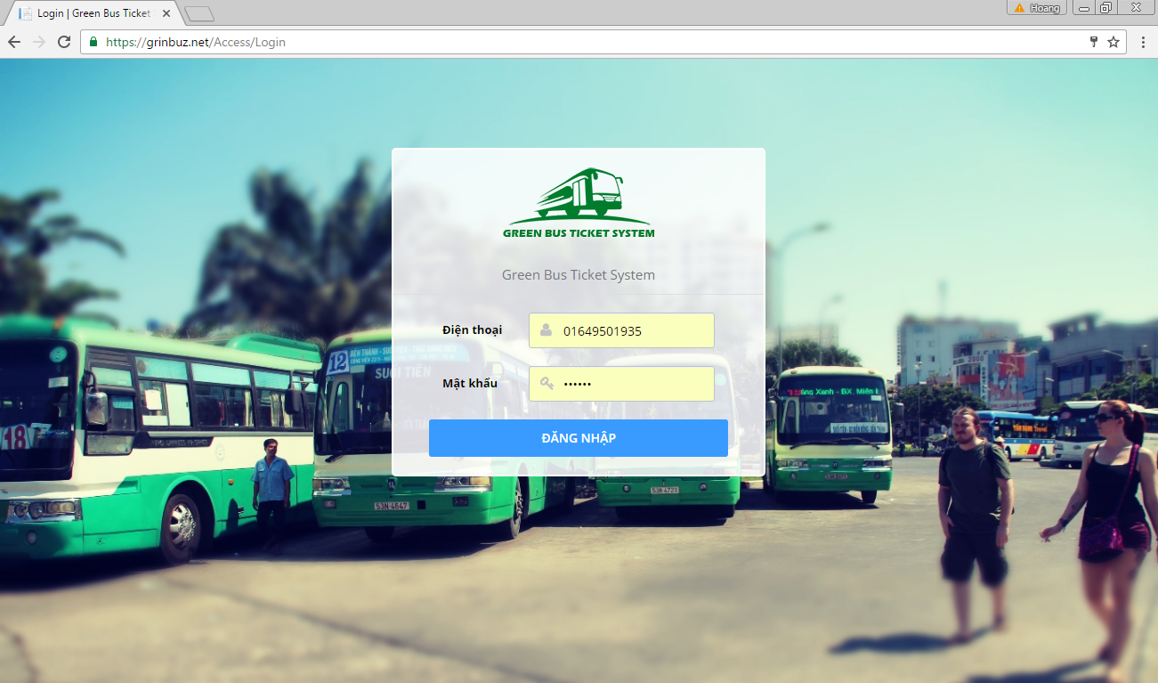

### Deployment at Client Side

* On mobile device, install one of the application from the GBTS package application apk from our attachment on the CD.

*For Bus Emulator:*

* + Install “GBTS Emulator”

*For Customer:*

* + Install “GBTS”

*For Staff:*

* + Install “Máy nạp tiền”
  + Install “CardPublisherStaff” for staff use
  + Install “GBTS Card Publisher” for web use

## User Guide

### Web application

* + 1. <Unauthorized user>Login



|  |  |
| --- | --- |
| Step | Description |
| 1 | Click “ĐĂNG NHẬP” button |

* + 1. <Passenger> Get NFC cards

|  |  |
| --- | --- |
| **Step** | **Description** |
| **1** | Click “Thẻ của bạn” button |

* + 1. <Passenger> Edit card name

|  |  |
| --- | --- |
| Step | Description |
| 1 | Click “Thẻ của bạn” button |
| 2 | Input new card name |
| 3 | Click save button |

<Passenger> Add credit



|  |  |
| --- | --- |
| Step | Description |
| 1 | Click “Thẻ của bạn” button |
| 2 | Click “Nạp tiền” button |
| 3 | Select a credit plan |
| 4 | Click “Thanh toán” button |
| 5 | Confirm the payment by clicking “Continue” |

* + 1. <Passenger> Get outcome report

|  |  |
| --- | --- |
| Step | Description |
| 1 | Click “Báo cáo chi tiêu” button |

* + 1. <Passenger> Look up bus route



|  |  |
| --- | --- |
| Step | Description |
| 1 | Click “Tìm xe buýt” button |
| 2 | Input “Nơi khởi hành” and “Nơi đến” |
| 3 | Click search button |

* + 1. <Passenger> Find bus

|  |  |
| --- | --- |
| Step | Description |
| 1 | Click “Tra cứu tuyến” button |
| 2 | Choose a bus route in a list or input bus route name or code into “Mã số tuyến hoặc tên tuyến” |

* + 1. <Administrator> Search account



|  |  |
| --- | --- |
| Step | Description |
| 1 | Click “Quản lý tài khoản” button |
| 2 | Input a phone number |
| 3 | Click search button |

* + 1. <Administrator> Add account





|  |  |
| --- | --- |
| Step | Description |
| 1 | Click “Quản lý tài khoản” button |
| 2 | Click Thêm tài khoản” button |
| 3 | Input phone number and select one of the roles |
| 4 | Click “Lưu” button |

* + 1. <Administrator> Activate/Deactivate account





|  |  |
| --- | --- |
| Step | Description |
| 1 | Click “Quản lý tài khoản” button |
| 2 | Input a phone number |
| 3 | Click “Khóa tài khoản” or “Mở khóa tài khoản” button |

* + 1. <Staff> Publish scratch cards



|  |  |
| --- | --- |
| Step | Description |
| 1 | Click “Phát hành thẻ cào” button |
| 2 | Click “Phát hành mới” button |
| 3 | Input all information |
| 4 | Click “Phát hành” button |

* + 1. <Staff> Search card



|  |  |
| --- | --- |
| Step | Description |
| 1 | Click “Quản lý thẻ” button |
| 2 | Input card ID |
| 4 | Click search button |

* + 1. <Staff> Add card





|  |  |
| --- | --- |
| Step | Description |
| 1 | Click “Quản lý thẻ” button |
| 2 | Click “Thêm thẻ mới” button |
| 3 | Tap new NFC card on the NFC reader or enter card ID by hand |
| 4 | Input initial balance |
| 5 | Click “Lưu” button |

* + 1. <Staff> Activate/Deactivate card





|  |  |
| --- | --- |
| Step | Description |
| 1 | Click “Quản lý thẻ” button |
| 2 | Input card ID or a phone number |
| 3 | Click “Khóa thẻ” button or “Mở khóa thẻ” button |

* + 1. <Staff> Search passenger



|  |  |
| --- | --- |
| Step | Description |
| 1 | Click “Quản lý hành khác” button |
| 2 | Input phone number or name |
| 3 | Click search button |

* + 1. <Manager> Add ticket type





|  |  |
| --- | --- |
| Step | Description |
| 1 | Click “Quản lý giá vé” button |
| 2 | Input phone number or name |
| 3 | Click “Lưu” button |

* + 1. <Manager> Edit ticket type





|  |  |
| --- | --- |
| Step | Description |
| 1 | Click “Quản lý giá vé” button |
| 2 | Click edit button on a ticket type |
| 3 | Click “Lưu” button |

* + 1. <Manager> Delete ticket type





|  |  |
| --- | --- |
| Step | Description |
| 1 | Click “Quản lý giá vé” button |
| 2 | Click delete button on a ticket type |
| 3 | Confirm by clicking “Xóa” button |

* + 1. <Manager> Add credit plan





|  |  |
| --- | --- |
| Step | Description |
| 1 | Click “Quản lý gói nạp tiền” button |
| 2 | Click “Thêm gói” button |
| 3 | Input new credit plan information |
| 4 | Click “Lưu” button |

* + 1. <Manager> Edit credit plan





|  |  |
| --- | --- |
| Step | Description |
| 1 | Click “Quản lý gói nạp tiền” button |
| 2 | Click edit button on a credit plan |
| 3 | Edit credit plan information |
| 4 | Click “Lưu” button |

* + 1. <Manager> Delete credit plan





|  |  |
| --- | --- |
| Step | Description |
| 1 | Click “Quản lý gói nạp tiền” button |
| 2 | Click delete button on a credit plan |
| 3 | Confirm by clicking “Xóa” button |

* + 1. <Manager> Add subscription





|  |  |
| --- | --- |
| Step | Description |
| 1 | Click “Quản lý gói ưu đãi” button |
| 2 | Click “Thêm ưu đãi mới” button |
| 3 | Enter new promotion package information |
| 4 | Click save button |

* + 1. <Manager> Edit subscription



|  |  |
| --- | --- |
| Step | Description |
| 1 | Click “Quản lý gói ưu đãi” button |
| 3 | Edit promotion package information |
| 4 | Click save button |

* + 1. <Manager> Delete subscription





|  |  |
| --- | --- |
| Step | Description |
| 1 | Click “Quản lý gói ưu đãi” button |
| 3 | Click delete button on a promotion package |
| 4 | Confirm by click “Xóa” button |

* + 1. <Manager> Get income report



|  |  |
| --- | --- |
| Step | Description |
| 1 | Click “Báo cáo thu nhập” button |
| 3 | Input query information |
| 4 | Click search button |

* + 1. <Manager> Create promotion



|  |  |
| --- | --- |
| Step | Description |
| 1 | Click “Tạo quảng cáo” button |
| 3 | Input new advertisement information |
| 4 | Click “Gửi” button |

### Mobile application

* + 1. <Passenger> View Login



|  |  |
| --- | --- |
| Step | Description |
| 1 | Tab “ĐĂNG NHẬP” |
| 2 | Tap “KÍCH HOẠT “ |

* + 1. <Passenger> View Active Card

|  |  |
| --- | --- |
| Step | Description |
| 1 | Input your phone number, tap and hold to Active Card |

#### <Passenger> Function Overview



|  |  |
| --- | --- |
| Step | Description |
| 1 | Tap “THẺ CỦA TÔI”. |
| 2 | Tap “BÁO CÁO CHI TIÊU” |
| 3 | Tap “TRA CỨU TUYẾN” |
| 4 | Tap “TÌM XE BUÝT” |
| 5 | Tap “TÀI KHOẢN” |
| 6 | Tap “LIÊN HỆ “ |

#### <Passenger> THẺ CỦA TÔI





|  |  |
| --- | --- |
| Step | Description |
| 1 | Click one item of list card on fragment to view details and purchase. |
| 2 | Tap “ICON” to edit Name card. |
| 3 | Tap “NẠP THẺ TRỰC TUYẾN” purchase to recharge. |
| 4 | Tap “NẠP BẰNG THẺ CÀO”. |
| 5 | Click one item of list credit plan on fragment to recharge. |
| 6 | Tap “NẠP” to recharge. |

#### <Passenger> BÁO CÁO CHI TIÊU





|  |  |
| --- | --- |
| Step | Description |
| 1 | Click “TỪ NGÀY” to choose date. |
| 2 | Click “ĐẾN NGÀY” to choose date. |
| 3 | Click “ICON SEARCH” to get report. |

#### <Passenger> TRA CỨU TUYẾN



|  |  |
| --- | --- |
| Step | Description |
| 1 | Filler to fine bus routes |
| 2 | Click one item of list bus routes to find direction and bus routes. |

#### <Passenger> TÌM XE BUÝT



|  |  |
| --- | --- |
| Step | Description |
| 1 | Choose origin direction |
| 2 | Choose destination direction |
| 3 | Tap “TÌM KIẾM” to find bus routes |

#### <Passenger > TÀI KHOẢN



|  |  |
| --- | --- |
| Step | Description |
| 1 | Click “LƯU” to change profile. |

### Emulator application

#### Verify ticket



|  |  |
| --- | --- |
| Step | Description |
| 1 | Open Bus Emulator application |
| 2 | Tap and hold NFC card or NFC-enabled phone on the NFC reader |

#### Configure emulator



|  |  |
| --- | --- |
| Step | Description |
| 1 | Open Bus Emulator application |
| 2 | Tap driver’s NFC card on the NFC reader |
| 3 | Press on Bus floating button |
| 4 | Input a bus code and select a ticket type |
| 5 | Press “Lưu cài đặt” button |

#### C:\Users\Duc\AppData\Local\Microsoft\Windows\Temporary Internet Files\Content.Word\Screenshot_20161120-212352.pngSell cash ticket

|  |  |
| --- | --- |
| Step | Description |
| 1 | Open Bus Emulator application |
| 2 | Tap driver’s NFC card on the NFC reader |
| 3 | Press on Cash floating button |

#### Publish card

|  |  |
| --- | --- |
| Step | Description |
| 1 | Open Card Publisher application |
| 2 | Open publish card panel on the web application |
| 3 | Tap and hold new NFC card on the NFC reader |



#### C:\Users\Duc\AppData\Local\Microsoft\Windows\Temporary Internet Files\Content.Word\Screenshot_20161120-212801.pngPublish card (Immediately publish a card without using the web application)

|  |  |
| --- | --- |
| Step | Description |
| 1 | Open Card Publisher application |
| 2 | Tap and hold new NFC card on the NFC reader |

# Appendix

1. UML Documentation of IBM <http://www.ibm.com/developerworks/rational/library/769.html?ca=drs->
2. AES encryption

[http://](http://www.ibm.com/developerworks/rational/library/769.html?ca=drs-)www.java2s.com/Code/Java/Security/EncryptionanddecryptionwithAESECBPKCS7Padding.htm

1. Android Developer Guide – Application Fundamentals

<https://developer.android.com/guide/components/fundamentals.html>

1. FPT Vietnamese Accentizer

[http://doc.openfpt.vn/services/vnaccent/documentation.html#/README](http://doc.openfpt.vn/services/vnaccent/documentation.html%23/README)

1. Google Firebase Api

<https://firebase.google.com/docs/reference/>